Perception Is Everything
Unit Overview
Unit 1 serves as an introduction to the idea that our perception of reality is often filtered through various perspectives, values, prejudices, and attitudes. In this level you will be introduced to multiple literary theories as filters through which to interpret literature. Literary theories are presented to examine the idea that the world is full of ideologies, theories, and biases through which we construct our understanding of our own and others’ experiences. Studying theory is a way to make us aware of competing visions of truth. Unit 1 begins by showing how point of view presents the reader with a filter or perspective from which to view incidents. This study of point of view anticipates the idea that perspective is reality. This unit introduces the literary theories of Reader Response Criticism and Cultural Criticism as the first two lenses through which we interpret literature and the world. You will have the opportunity to apply these literary theories to your own and others’ writing.
Unit
1
Essential Questions
How do writers and artists
organize or construct text
to convey meaning?
What does it mean to be a
stranger in the village?
?
?

Previewing the Unit . . . . . . . . . . . . . . . . . . . . . . . . . . . . . . . . . . . . . . 5
1.2 Perception Is Everything . . . . . . . . . . . . . . . . . . . . . . . . . . . . . . . . . . . 6
1.3 Importance of Perspective . . . . . . . . . . . . . . . . . . . . . . . . . . . . . . . . . 7
1.4 Different Ways of Seeing the World . . . . . . . . . . . . . . . . . . . . . . . . . 9
1.5 Different Ways of Reading the Text . . . . . . . . . . . . . . . . . . . . . . . . .11 Poetry: “My Papa’s Waltz,” by Theodore Roethke
1.6 Introducing Reader Response Critical Theory . . . . . . . . . . . . . . . .12
1.7 Applying Reader Response Criticism . . . . . . . . . . . . . . . . . . . . . . . .15
Poetry: “in Just-,” by E.E. Cummings
Poetry: “The Last Word,” by Peter Davison
Poetry: “Mushrooms,” by Sylvia Plath
1.8 Seeing the World from My Perspective . . . . . . . . . . . . . . . . . . . . .19 Poetry: “I Remember,” by Edward Montez
1.9 Another Perpective on the World . . . . . . . . . . . . . . . . . . . . . . . . . . .23 Novel: Prologue from Invisible Man, by Ralph Ellison
1.10 A Symbolic Perception of Self . . . . . . . . . . . . . . . . . . . . . . . . . . . . .29 Novel: “Four Skinny Trees,” vignette from The House on Mango Street, by Sandra Cisneros
Perception Is Everything
Contents
Learning Focus:

Perspective and the Individual
.................
4
Activities:

1.1
Goals
C
To understand the
relationship between
perspective and critical
theory
C
To apply critical theories
to various texts studied
and created
C
To control and
manipulate textual
elements in writing to
clearly and effectively
convey a controlling
idea or thesis
AcAdEmIc VocABuLAry
Reader Response
Criticism
Cultural Criticism
Unit
1
© 2011 College Board. All rights reserved.
1.11 Exploring Perspectives in Visual Art . . . . . . . . . . . . . . . . . . . . . . . .31
1.12 Exploring a Photo Essay . . . . . . . . . . . . . . . . . . . . . . . . . . . . . . . . . .34
1.13 Digging for Deeper Meaning . . . . . . . . . . . . . . . . . . . . . . . . . . . . . . .35 Essay: Excerpt from “On Seeing England for the First Time,” by Jamaica Kincaid
Embedded Assessment 1 Creating a Photo Essay . . . . . . . . . . . . .39
Learning Focus:

Perspective and Culture
.....................
44
1.14

What Is Cultural Criticism?
................................
45

Poetry:
“Speaking with Hands,” by Luis Rodriguez
1.15

Poetic Conversations
....................................
48

Poetry:
“The White Man’s Burden,” by Rudyard Kipling

Poetry:
“The Brown Man’s Burden,” by Henry Labouchère
1.16

A Deeper Understanding of Imperialism
.....................
54

Song:
“Rule Britannia!” by James Thomson and Thomas

Augustine Arne
1.17

Reading with a Cultural Criticism Lens
......................
57

reflective Essay:
“Shooting an Elephant,” by George Orwell
1.18
Being a Stranger
........................................
65

*Film:
Clips from
Edward Scissorhands
, directed

by Tim Burton
1.19
Two Different Worlds
. . . . . . . . . . . . . . . . . . . . . . . . . . . . . . . . . . . . .
66

Novel:
“Lindo Jong: Double Face,”

excerpt from
The Joy Luck Club,
by Amy Tan
1.20
Understanding the Stranger’s Perception of a Village
..........
69

reflective Essay:
“Stranger in the Village,” by James Baldwin
Embedded Assessment 2
Writing a Reflective Essay
...........
80
unit reflection
..............................................
84
*Texts not included in these materials .
© 2011 College Board. All rights reserved.
Until we realize the world is full of ideologies, theories, and biases through which we filter our understanding of our own and others’ experiences, we are blind to the real truths of the world. Consider the perspectives presented in the following quotes:
Learning Focus:
Perspective and the Individual
“If all you have is a hammer, everything looks like a nail.” Anonymous
“Until lions tell their stories, tales of hunting will glorify the hunter.” African proverb
“Theory is subversive because it puts authority in question.” Stephen Bonnycastle, In Search of Authority
Literary theory is just one example of how competing perspectives color the way literature and life are interpreted. Studying a variety of critical theories is a way to become aware of competing visions of truth, to learn that a text, like life, is seen through a filter of ideologies (beliefs), theories, and perspectives. Being able to apply different theories to a text expands the limits of a reader’s worldview and adds dimension to reading and understanding a text. Critical theory highlights the fact that there is no one, simple vision of the truth. Truth is a complicated product of multiple perspectives.
Reader Response Critical Theory is the first of six literary critical theories you will study. Reader Response Criticism focuses on a reader’s engagement with a specific text and the dynamics that emerge as meaning is created between the text presented by the author and the reader’s interpretation of it. This theory highlights the idea that individuals often read and interpret the same texts differently, allowing texts to be challenged, evaluated, and critiqued.
© 2011 College Board. All rights reserved.
See Appendix 1 in the back of your book for descriptions of all six literary critical theories. You will want to refer to this information for definitions, characteristics, and examples of different literary perspectives. This list is not intended to be an exhaustive representation of these complex theoretical perspectives, but rather a brief introduction. Your teacher may expect you to do further research on one or more of these literary theories.
Independent Reading: In this unit, you will be reading several texts with the primary focus of self-perception and the role that one’s culture plays in defining one’s sense of self. For independent reading, look for works of fiction that focus on multiple perspectives. Authors you may want to explore are Amy Tan, Albert Camus, Robert A. Heinlein, Jamaica Kincaid, and Barbara Kingsolver.

- How do writers and artists organize or construct text to convey meaning?
- What does it mean to be a stranger in the village?
ACtIvIty
1.1
Essential Questions
SUGGESTED LEARnInG STRATEGIES:
think-Pair-Share, Skimming/Scanning,
Close Reading, Marking the text, Summarizing/Paraphrasing, Graphic Organizer

th
e
Unit
e
vi
e
Pr
g
win
© 2011 College Board. All rights reserved.

Unit Overview and Learning Focus
Predict what you think this unit is about. Use the words or phrases that stood out to you when you read the Unit Overview and the Learning Focus.

Embedded Assessment 1
What knowledge must you have (what do you need to know) to succeed on Embedded Assessment 1? What skills must you have (what must you be able to do)?
Literary terms
Perception is a mental concept or point of view.
an aphorism is a succinct statement expressing an opinion, perception, or general truth. Choose five aphorisms that you especially like from the following list. in your group, paraphrase the quotes you have chosen, and explain how the quotes relate to the ideas of seeing and understanding.
- “What you see and hear depends a good deal on where you are standing; it also depends on what sort of person you are.”
— C. S. Lewis
- “The voyage of discovery is not in seeking new landscapes but in having new eyes.” — Marcel Proust
- “You can complain because roses have thorns, or you can rejoice because thorns have roses.” — Tom Wilson
- “all photographs are accurate. none of them is the truth.”
— richard avedon
- “There are things known and there are things unknown, and in between are the doors of perception.” — aldous Huxley
- “The eye sees only what the mind is prepared to comprehend.”
Activity
1.2
Perception Is Everything
SUGGESTED LEarninG STraTEGiES:
think-Pair-Share,

Summarizing/Paraphrasing, Quickwrite

© 2011 College Board.
a
ll rights reserved.
— Henri Bergson
- “Better keep yourself clean and bright; you are the window through which you must see the world.” — George Bernard Shaw
- “Whilst part of what we perceive comes through our senses from the object before us, another part (and it may be the larger part) always comes out of our own mind.” — William James
- “Language forces us to perceive the world as men present it to us.” — Julia Penelope
- “if we spoke a different language, we would perceive a somewhat different world.” — Ludwig Wittgenstein
timed Writing: Choose one quote from the list and write a response about the truth it conveys. You will have 15 minutes. Use prewriting strategies to structure your ideas quickly. remember to use appropriate rhetorical devices and effective transitions to maintain the flow of ideas and to convey meaning to your readers. Then create an original aphorism expressing your perception or a general truth about the world.
Literary terms
a scenario is an outline, a brief account, or a synopsis of events.
Everyone views the world with a unique perspective. That perspective can be influenced by a number of factors, including life experiences, education, significant people, occupations, political affiliations, and numerous other elements that serve to help shape individual attitudes.
Take something as simple as music. Think of one of your favorite songs. Why do you like that song? Does it address an issue that is important to you? Does it feature an instrument that you especially enjoy? Do you merely enjoy it for the rhythm it contains? Your answers to these questions depend on your unique perspective, a perspective that has been influenced in many ways over the course of your life. in order to illustrate this idea, consider the following scenario:
On your way to school, you see another student who has been pulled over by a police officer. You see the student’s frustration as the officer writes out what appears to be a traffic ticket.
Activity
1.3
Import
a
nc
e
of P
e
rsp
e
ct
i
v
e
SUGGESTED LEarninG STraTEGiES:
Graphic Organizer

© 2011 College Board.
a
ll rights reserved.
Complete the graphic organizer on the following page, imagining the response of each individual in the situation. Consider these points when responding:
- Each person described in the scenario will have a distinctly different perspective on the situation.
- Each person described in the scenario will have a different level of connection to the consequences of the situation, which in turn will influence the response. For example, someone will have to pay for the ticket.
- Each person described in the scenario will also be subject to a variety of factors unrelated to the ticket that will also influence the response. For example, if the traffic is moving more slowly due to the ticket distraction, someone may be late for work.
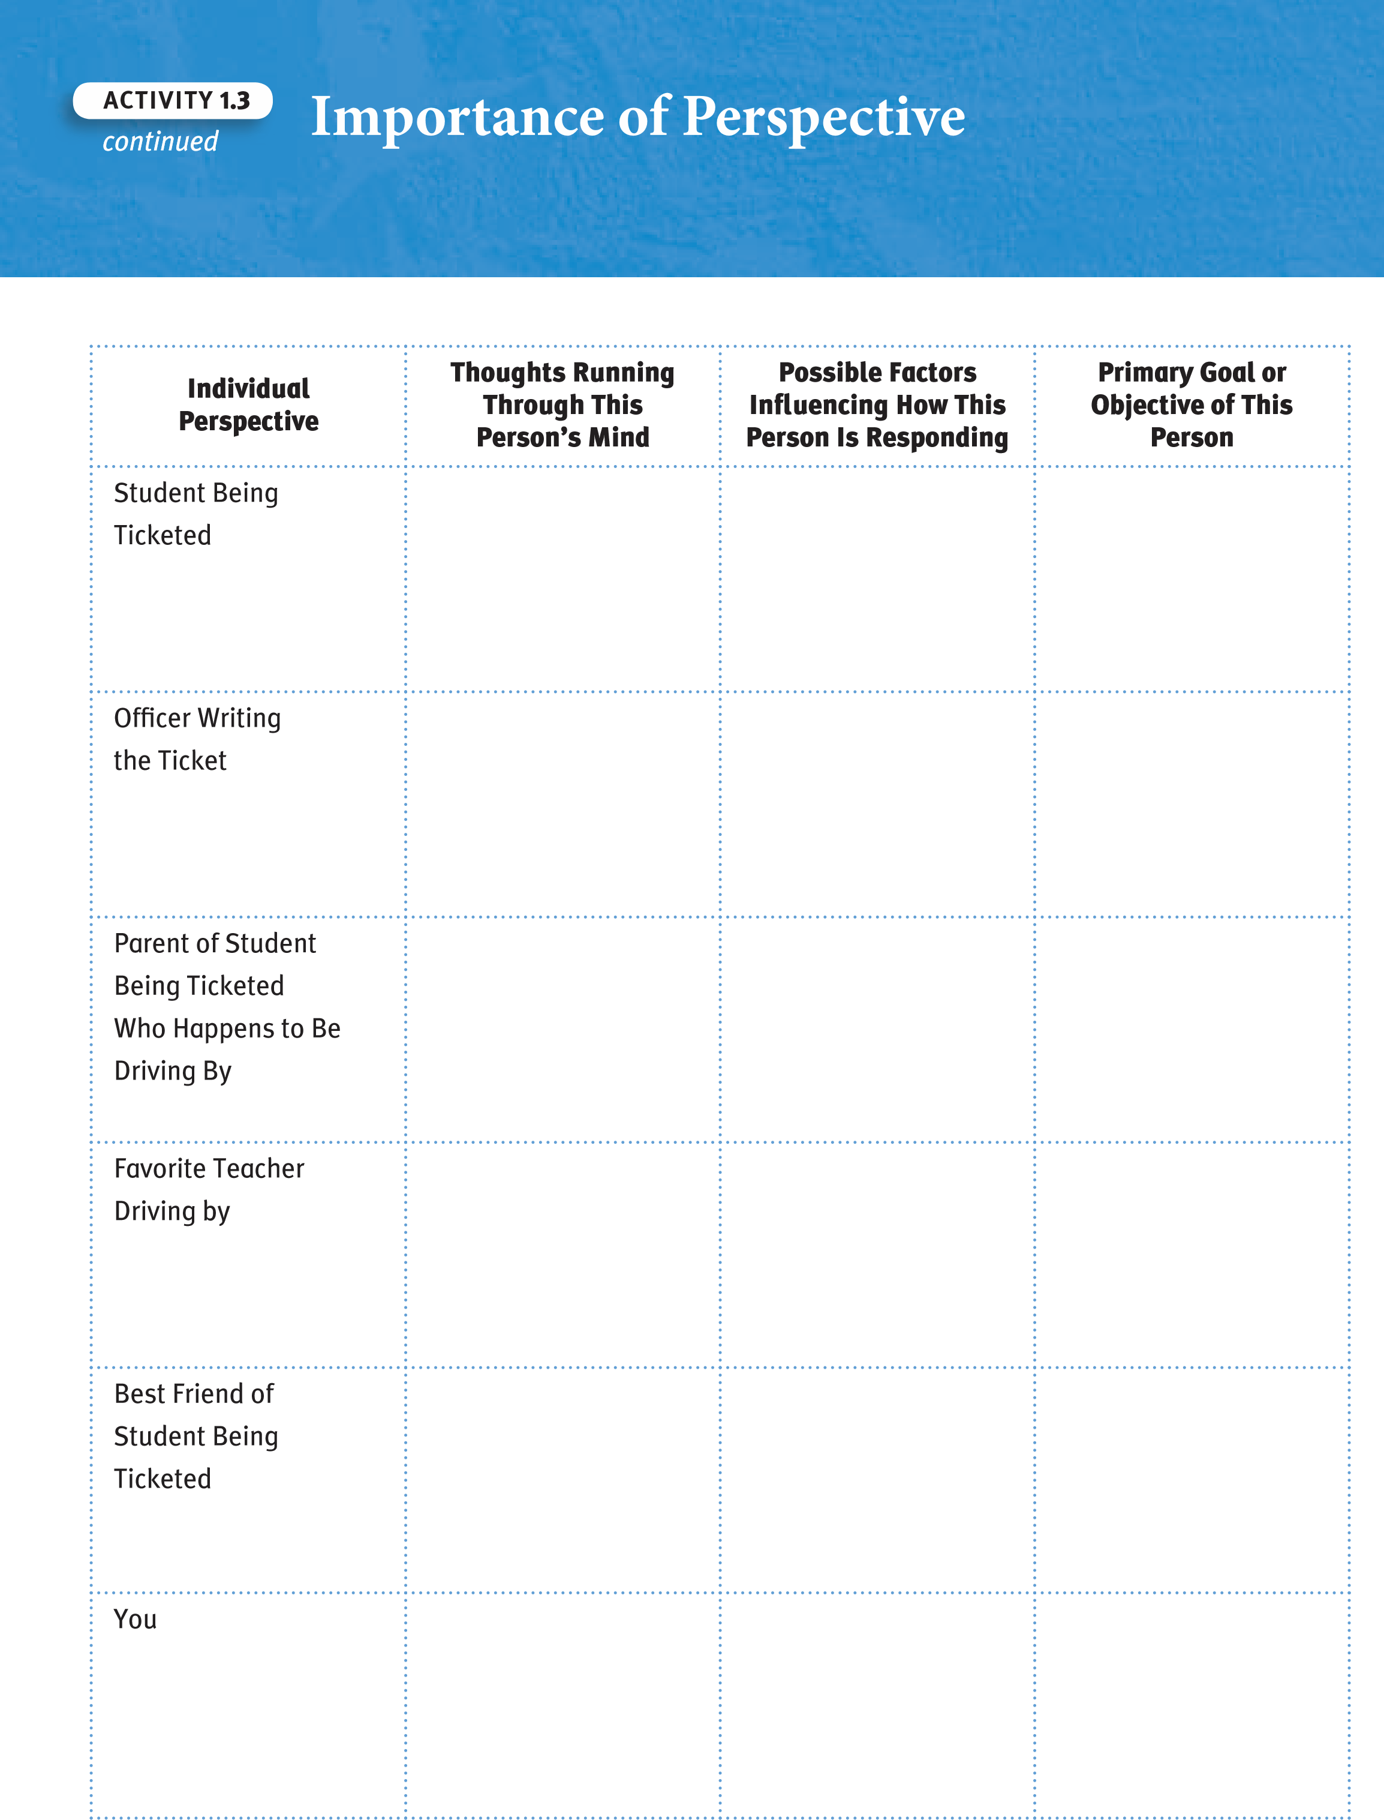
© 2011 College Board.
a
ll rights reserved.
  - Frame
  - Subject
  - Cropping 7. Space
Literary terms
The mise en scène is the composition, or setting, of an image.
  - Lighting
Consult your peers to discuss and gain meaning for unfamiliar words. For words you know (the “T” words), share examples and verify understanding. For words you have heard of (the “H” words), use words you know to describe your understanding. ask peers to share their knowledge of the meaning of words for which you have a question.
Activity
1.4
a
i
e
e
ys of S
D
i
ff
e
r
e
nt W
n
g
th
e
World
SUGGESTED LEarninG STraTEGiES:
QHt, Activating Prior Knowledge,
close Reading, think-Pair-Share

Scan the words listed below, and use the following coding system to
rate your level of understanding with the media production elements of
photography.
(
Q): Signals a question—i have never heard of this word before.
(
H): Signals familiarity—i have heard of the word before and here is the
context in which i have heard it.
(
T): Signals knowledge—i know what this word means, and here is an
example.

5. image

6. Composition
W
ord

ConneCtions
Choose the appropriate
response to complete the
analogy.
cropping : photograph ::
.
a. frame : oil painting

b. editing : film

c. baking : pie

d. chainsaw : timber
© 2011 College Board.
a
ll rights reserved.
Writing Prompt: Study the photograph suggested by your teacher, and use the space below to write a brief description that reflects the mise
en scène, or composition, of the image. Be sure to use newly acquired words in your response.

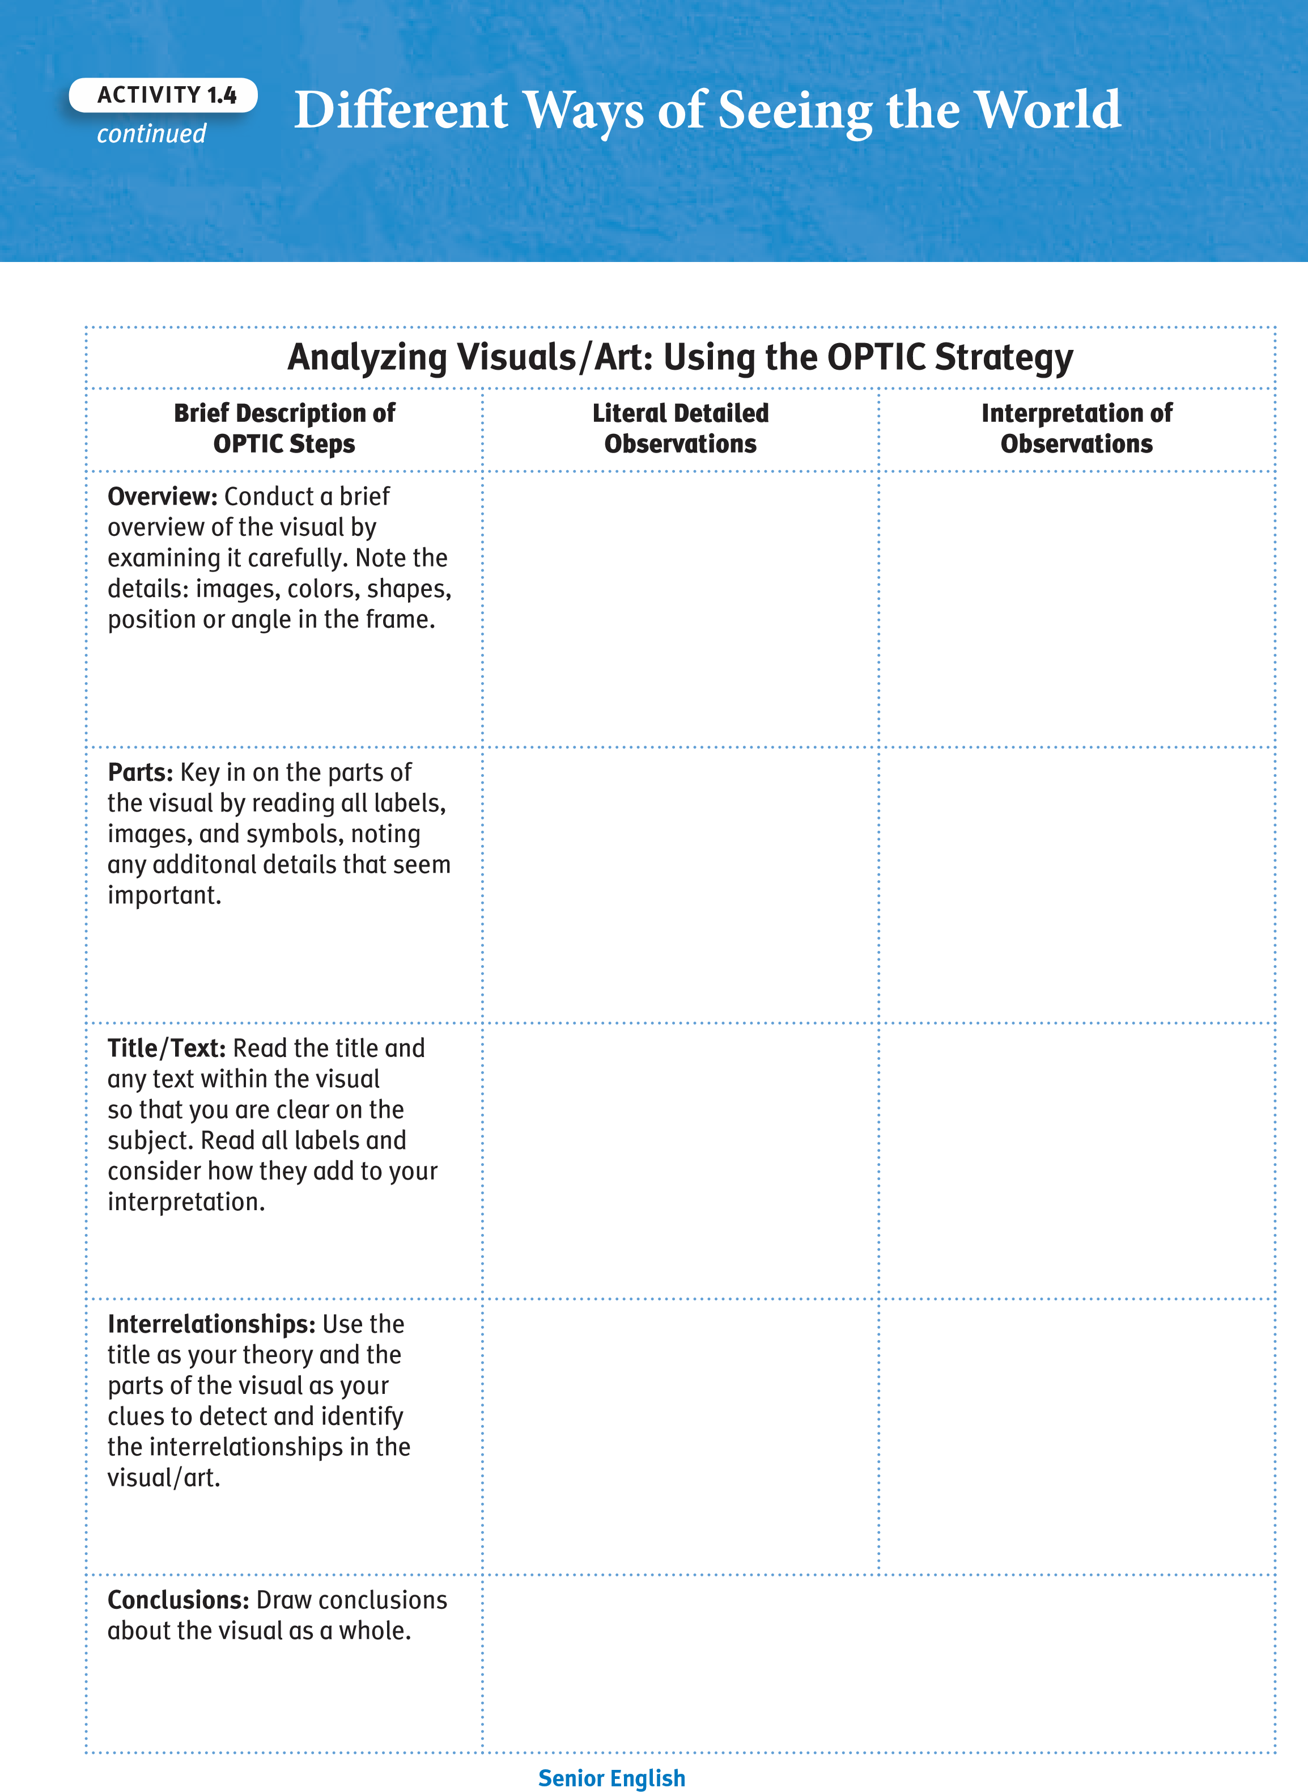
© 2011 College Board.
a
ll rights reserved.
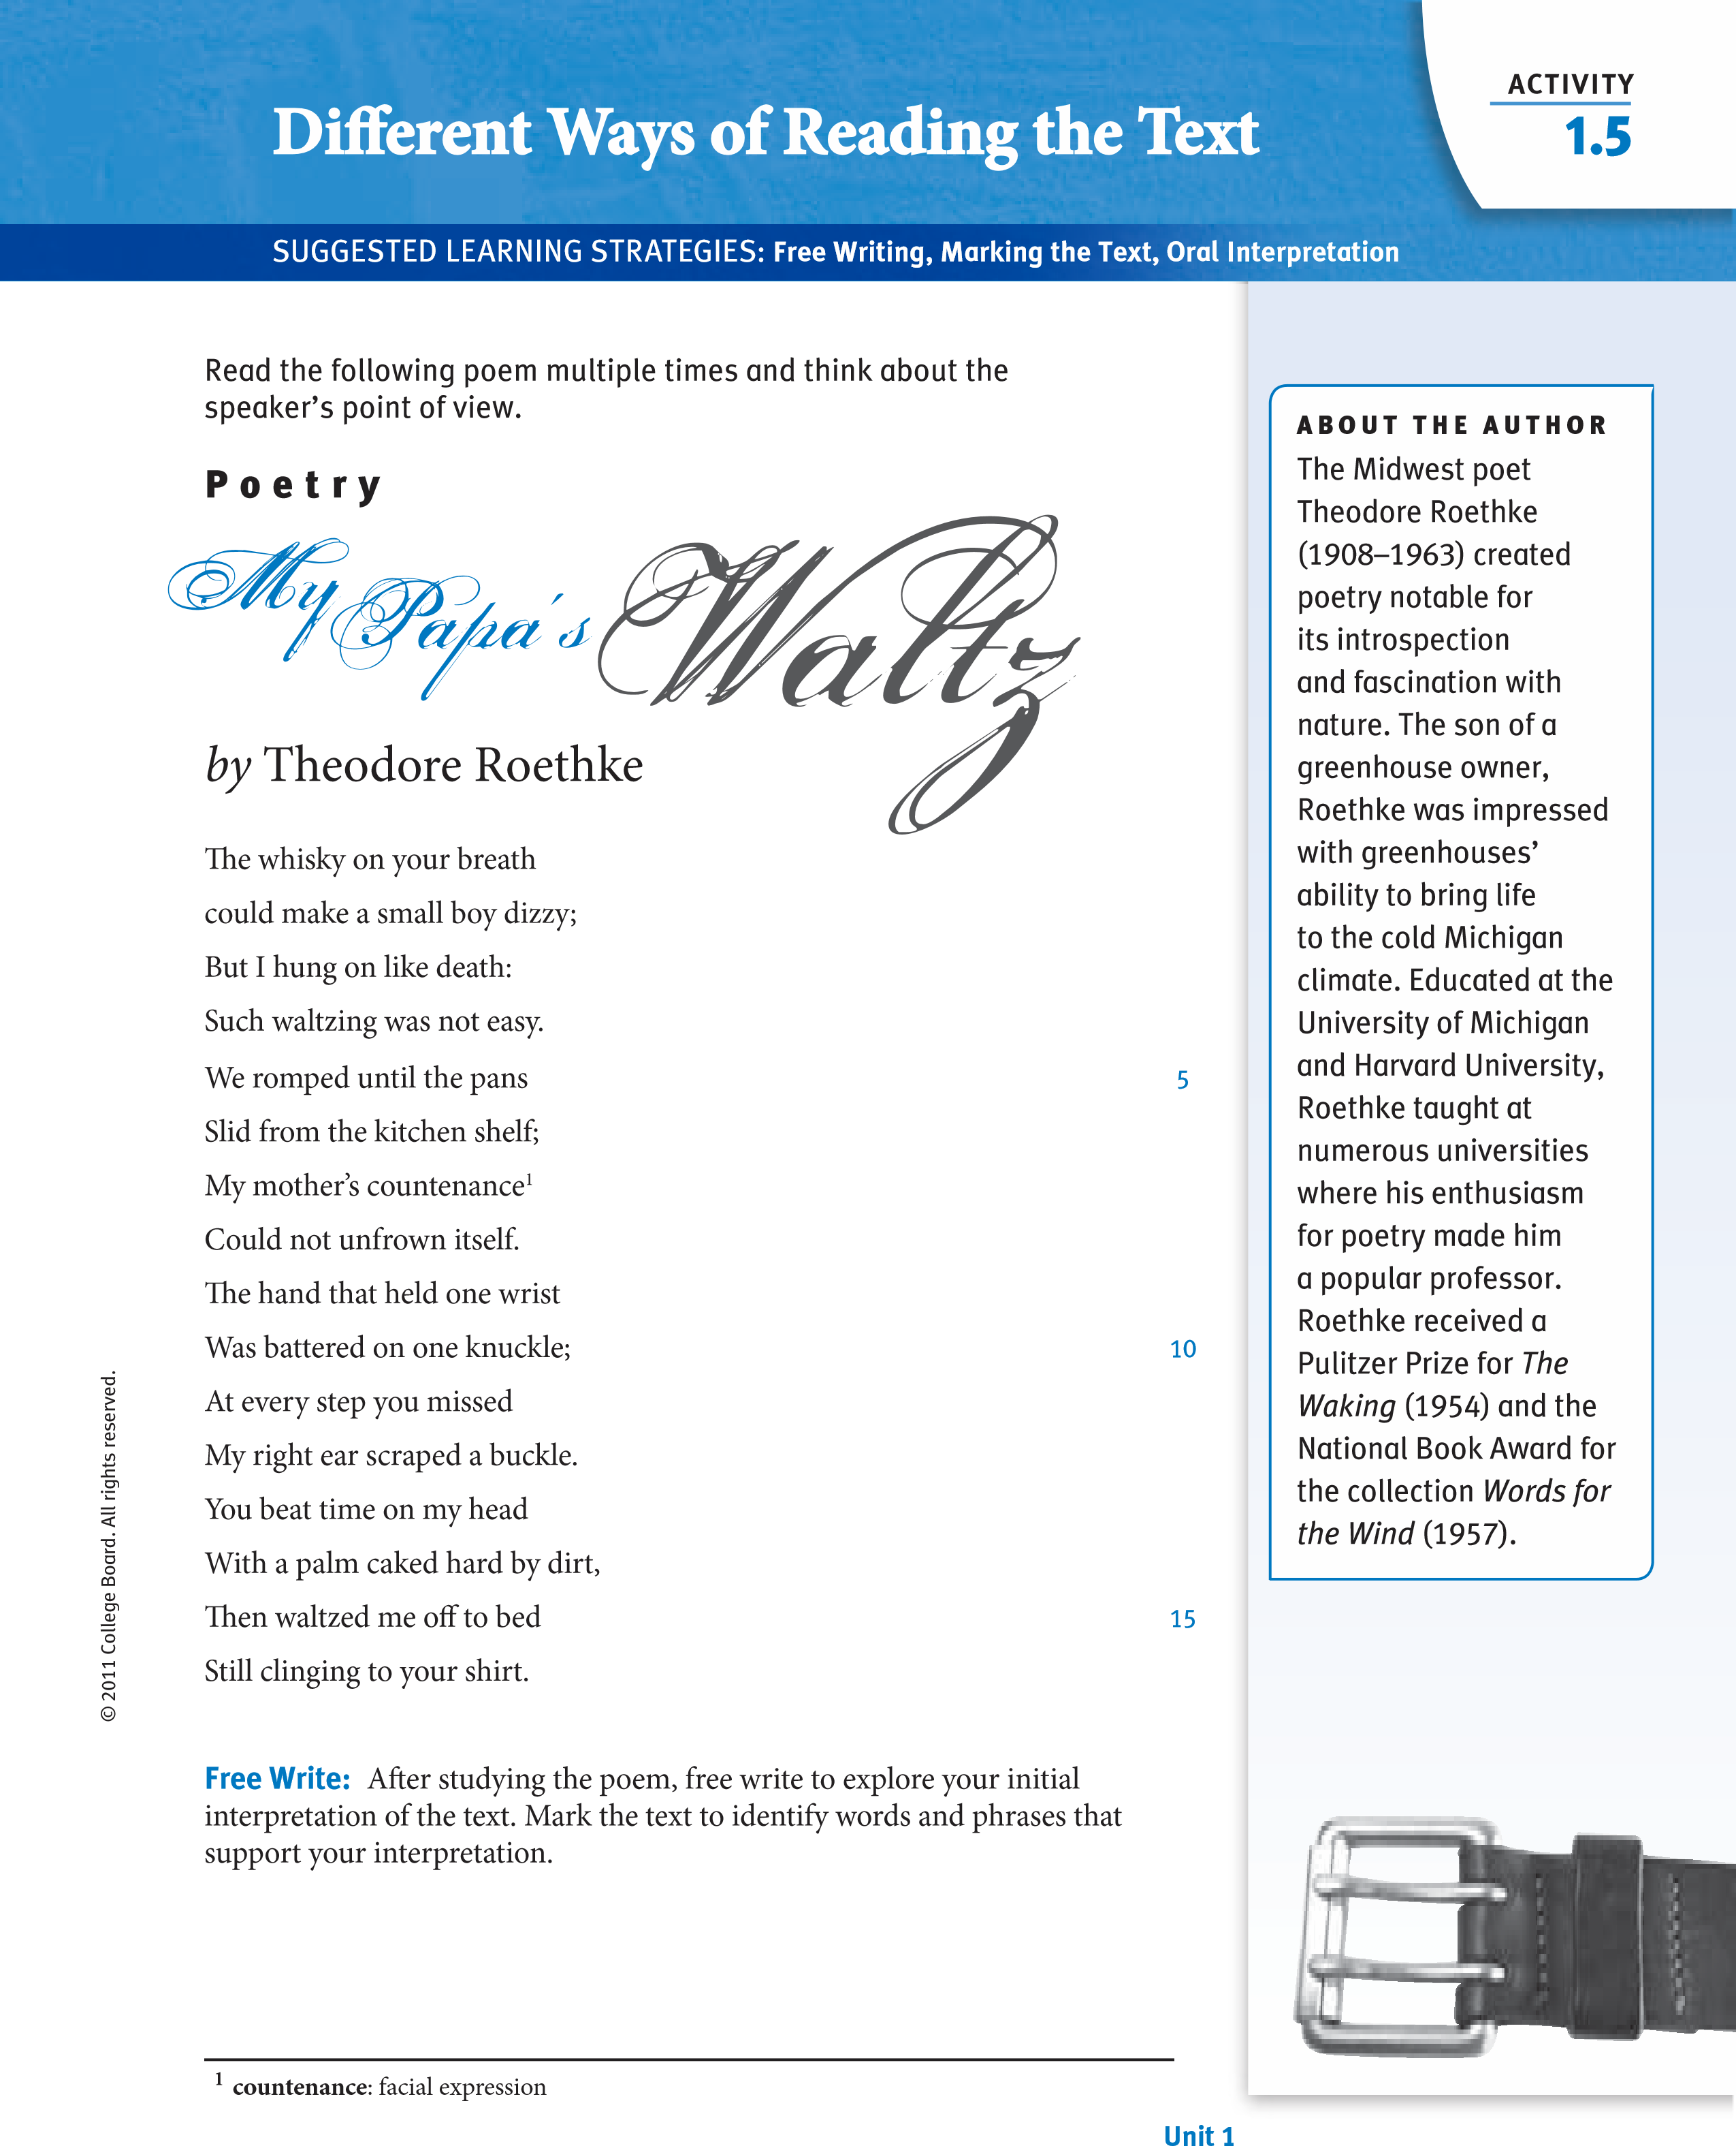

^{1.6Activity} IntroducCritical Thinegory Reader Response
SUGGESTED LEArninG STrATEGiES: Marking the text, Discussion
Groups, Brainstorming, Quickwrite
AcADeMic vocABulAry
Reader Response Criticism focuses on a reader’s active engagement with a piece of print or nonprint text. The reader’s response to any text is shaded by the reader’s own experiences, social ethics, moral values, and general views of the world.

Reader Response Critical Theory
Your personal attitudes, beliefs, and experiences influence how you derive meaning from text. Examining the way in which you understand text involves adopting critical lenses that affect your perception of a text. A critical lens, or theory, is a way of judging or analyzing a work of literature.
Much as putting on a pair of tinted lenses colors the way you look at the world, critical lenses influence how you study and perceive text. Reader Response Criticism asks you to think about your role as a reader whenever you look at text. The critical lens of Reader Response Critical Theory focuses on the relationship among the reader, the reader’s situation, and the text. The theory suggests that the process of making meaning relies not only on the text itself, but also on the qualities and motivations of the individual who is interacting with the text. See Appendix 1 for more information on this theory.
© 2011 College Board. All rights reserved.
The diagram below illustrates this idea.
reader
reading
Situation
text
Meaning
reading Situation: the circumstances surrounding the reading, including the purposes for reading
reader: the individual engaged in the reading process text: what is being read

Senior english

in the reading Situation – reader – Text model, the reader constructs meaning as a result of the interaction among all of these individual factors. Consider the following examples:
- Scenario 1: A senior is assigned to read a chapter from the book he is studying in English class. The senior has tickets to see a show that night but knows that there will be a quiz on the chapter the next day. He is a strong reader but has not enjoyed the book the class is studying. What factors are influential on the reader, situation, and text? How would these factors impact the student’s ability to make meaning of that chapter?
Literary terms
literary theory attempts to establish principles for interpreting and evaluating literary texts.
- Scenario 2: A senior is part of a group of four students preparing a presentation about optical illusions. She volunteered to do internet research to find information to bring back to the rest of the group. She is a computer whiz and fascinated by the topic, and spends several hours on the internet finding examples of optical illusions, but hasn’t done much real reading or investigating of the information about optical illusions. The next day in class the group is expecting some material to read, but the senior brings a collection of optical illusions to show them instead. How did the reader, situation, and text impact the ability to make meaning?
continued
Activity
1.6
© 2011 College Board. All rights reserved.
unit 1

The Reader
One significant factor in reader response Critical Theory is that it takes into account the person doing the reading. This model takes the reader into account in a number of ways, including, but not limited to, the individual’s opinions, attitudes, beliefs, and background knowledge. Consider some of the ways in which your personality, attitudes, and personal goals influence you every time you are looking at text. For example, what do you read on your own? Do you read novels, or do you read sports magazines? if you read quite a few novels, then being asked to read 30 pages in a single session might not seem difficult. This is just one way in which you influence the reading process.

The Reading Situation
The reading situation includes why you are engaged in reading, when you are reading, and where you are reading. Some of these factors are within your control, but others are not. Anytime that you read a text because someone else told you to read it, the choice has been made for you. How much you are supposed to read is also often decided for you. However, where and when you choose to read the text can be up to you. if you decide to sit in a comfortable stuffed chair at midnight to read your book, you might tend to lose concentration and drift off to sleep. The last few pages you read before falling asleep might be a little less clear than pages you read at your desk earlier in the evening.
continued
Introduc
i
n
R
e
a
d
e
g
e
spons
e

r R

Cr
i
t
i
c
a
l Th
e
ory
Activity
1.6
The Elements of Reader Response Criticism

The Text
© 2011 College Board. All rights reserved.
The text is defined as whatever is being read. Textual features vary, depending on the source. For example, a textbook will present text differently than a magazine or a pamphlet. numerous other factors influence the text, from level of difficulty to the typefaces and illustrations.
Quickwrite: With a small group, create a summary statement of all that you have learned about reader response Critical Theory. Share your responses and choose the clearest, most comprehensive summary statement.
Senior english
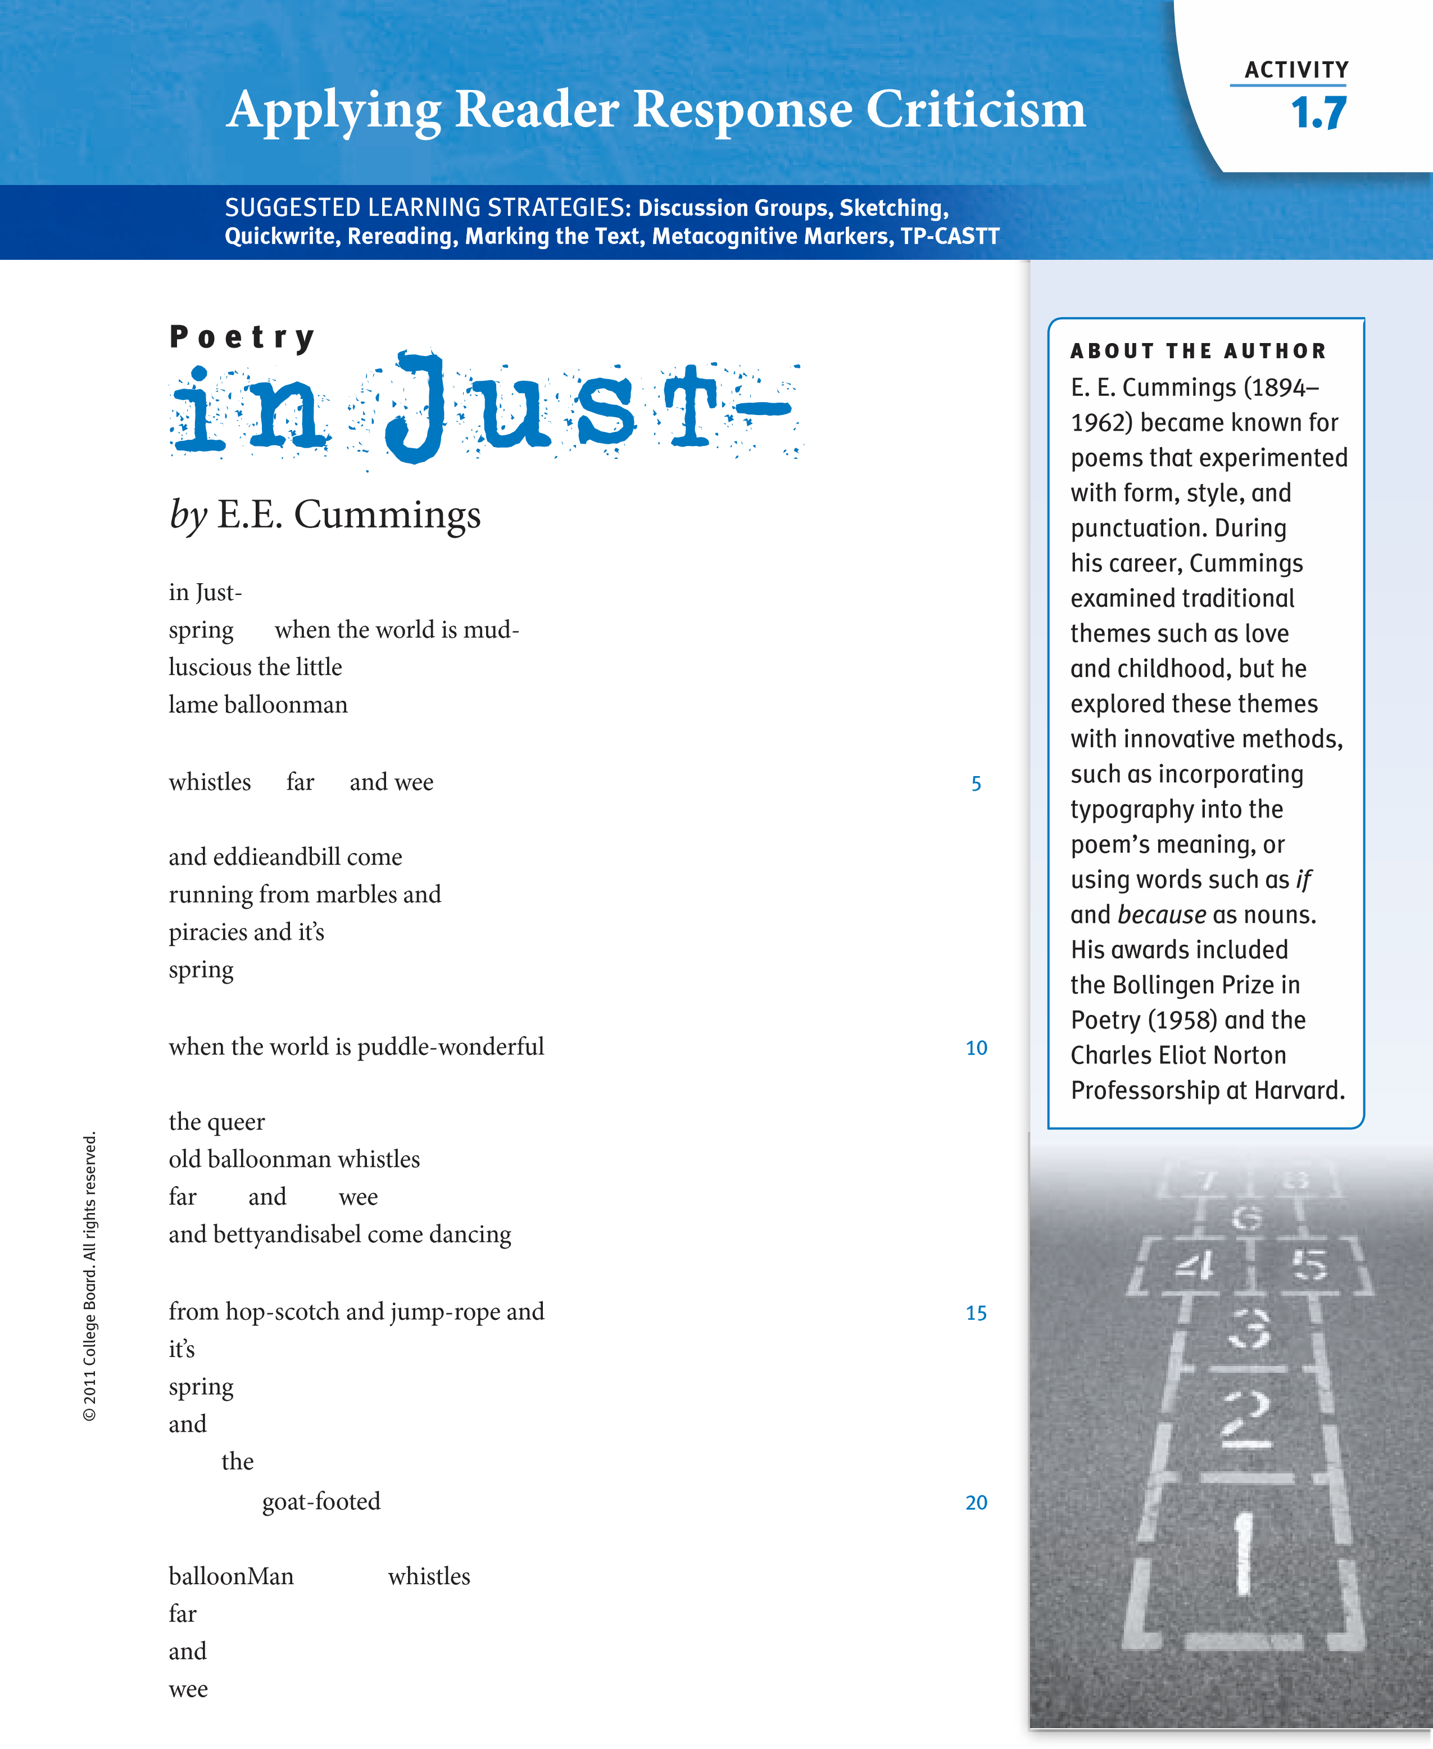

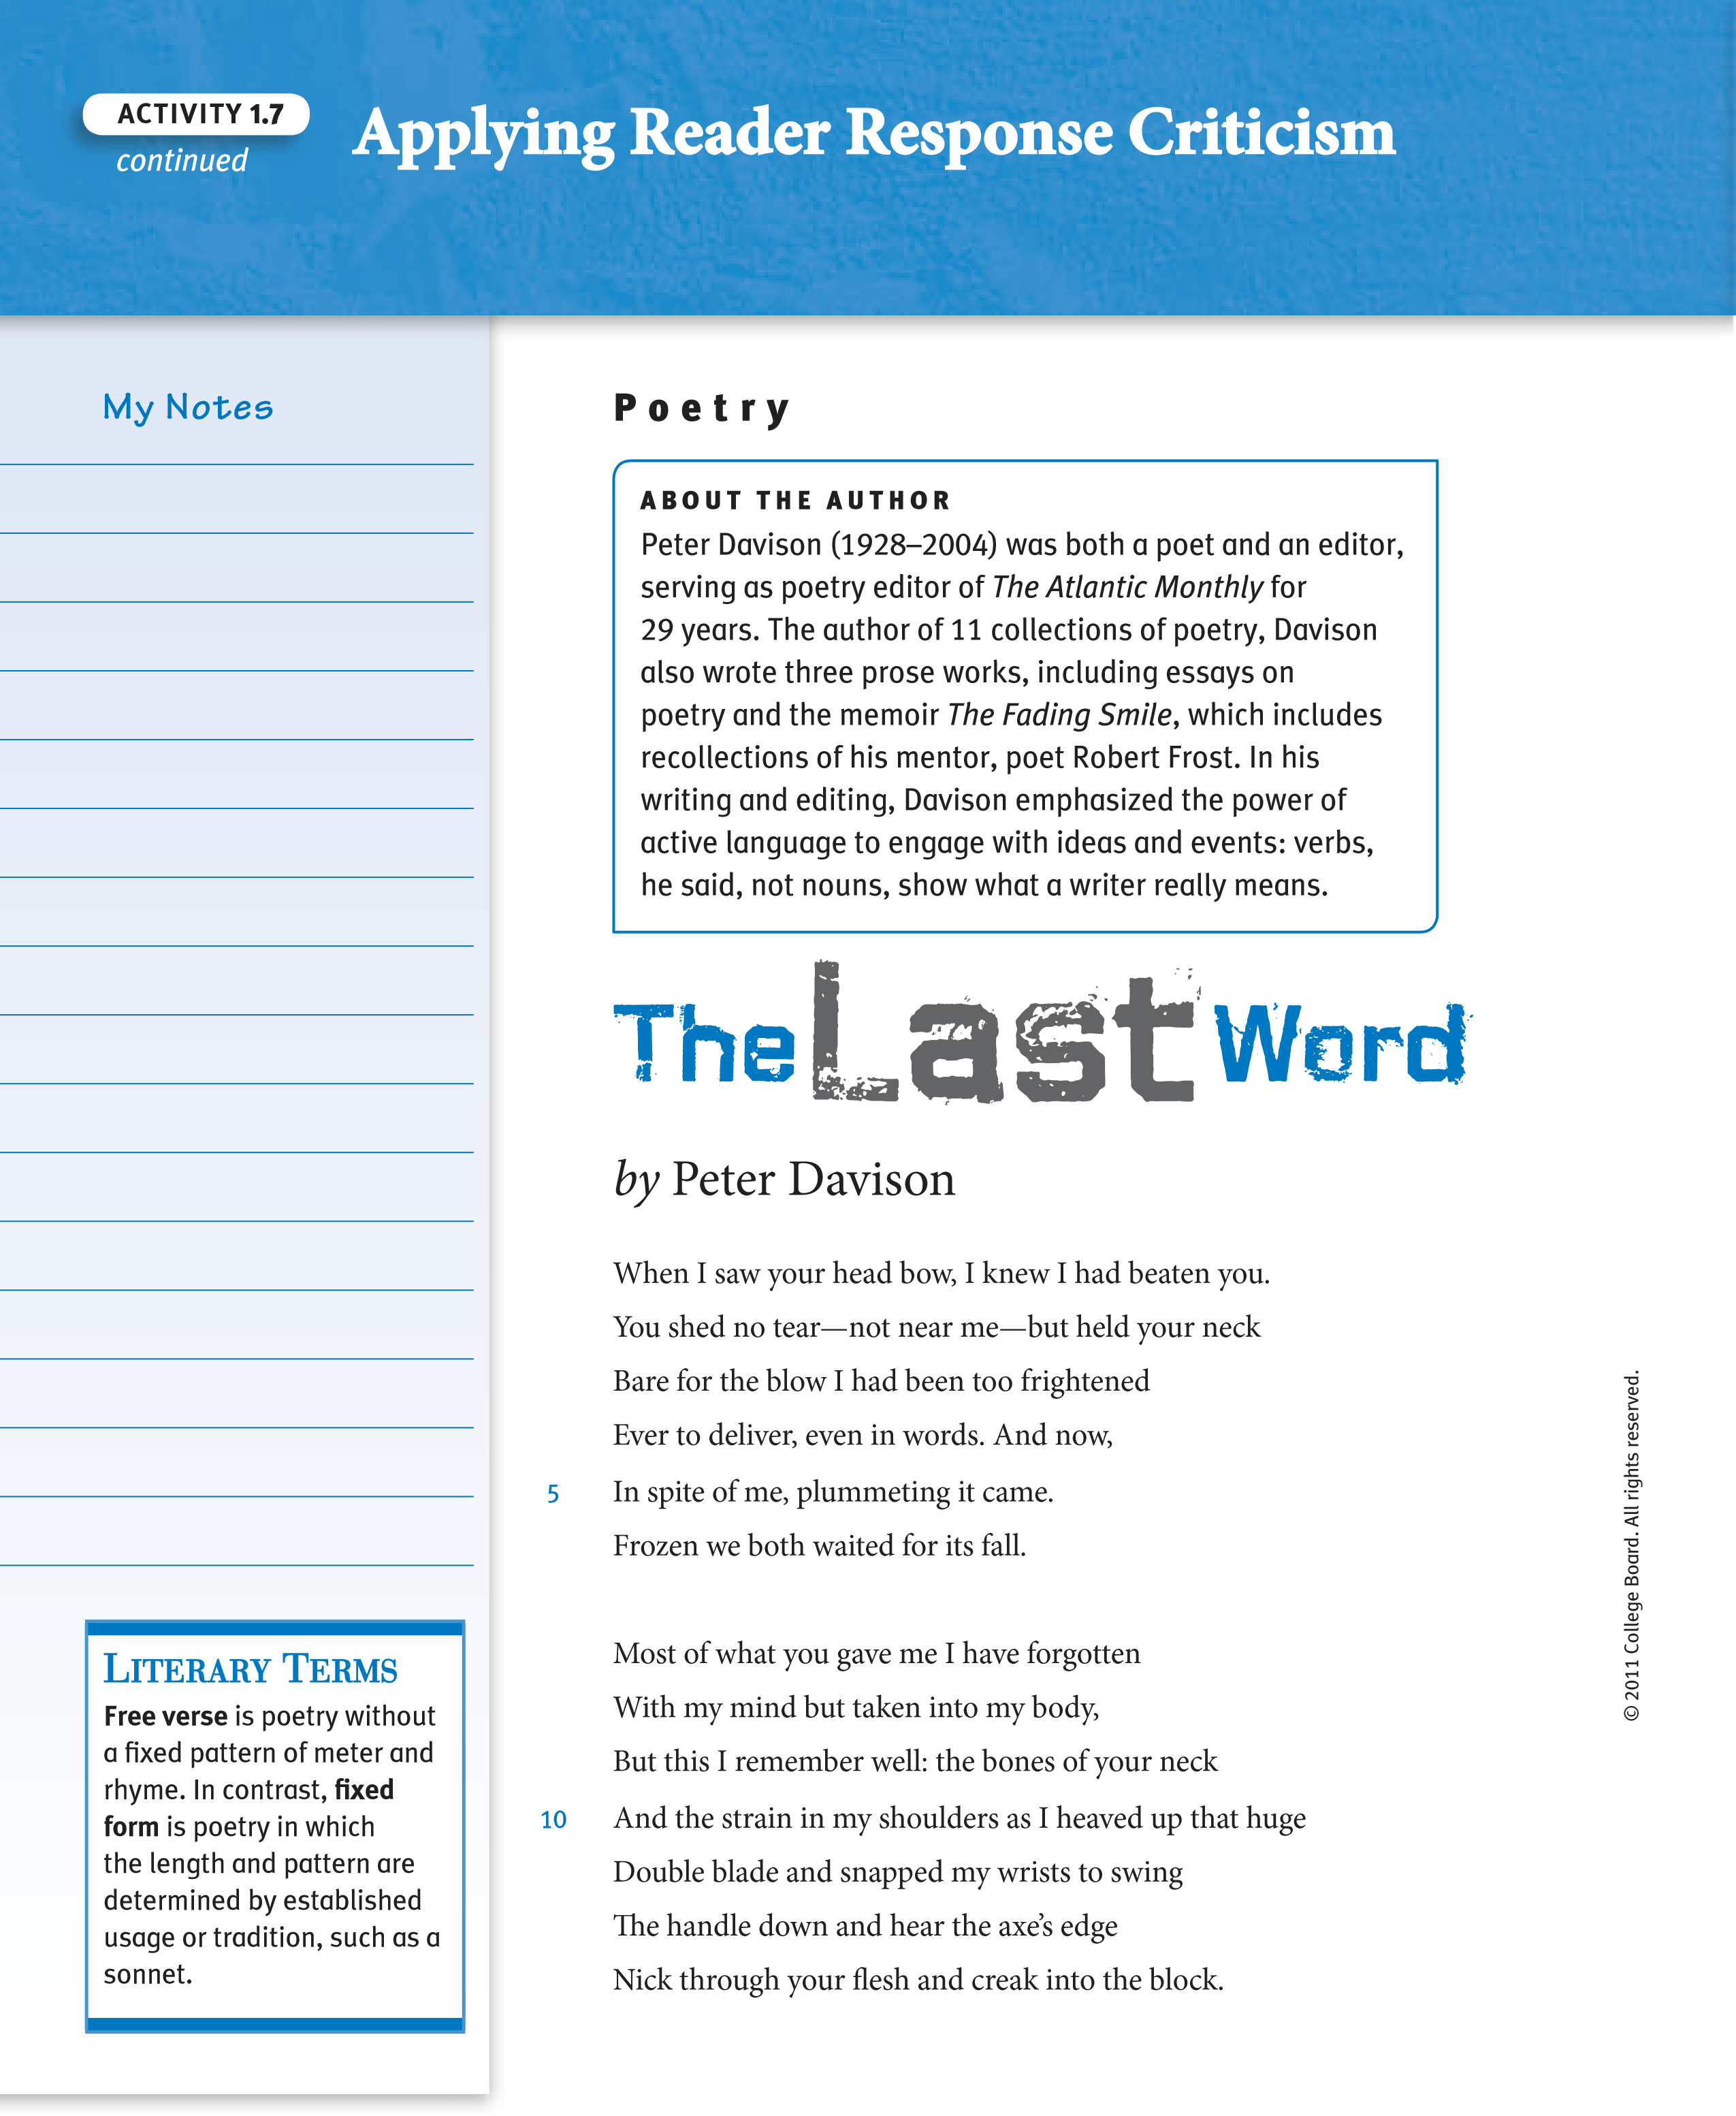
continued
Activity
1.7

Overnight, very
Whitely, discreetly,
Very quietly

Our toes, our noses
Take hold on the loam,
Acquire the air.

Nobody sees us,
Stops us, betrays us;
The small grains make room.

Soft fists insist on
Heaving the needles,
The leafy bedding,

Even the paving.
Our hammers, our rams,
Earless and eyeless,

Perfectly voiceless,
Widen the crannies,
Shoulder through holes. We

Diet on water,
On crumbs of shadow,
Bland-mannered, asking

Little or nothing.
So many of us!
So many of us!

We are shelves, we are
Tables, we are meek,
We are edible.

Nudgers and shovers
In spite of ourselves.
Our kind multiplies:

We shall by morning
Inherit the earth.
Our foot’s in the door.
5
10
15
20
25
30
by
Sylvia Plath
Poetry
About the Author
Sylvia Plath (1932–1963)
captured the intensity of
her turbulent life in an
autobiographical novel
and personal, revealing
poetry. an accomplished
scholar and writer,
Plath won many awards
as a young woman,
including a scholarship
to Smith College and
a Fulbright fellowship
to newnham College in
Cambridge University.
in 1956, she married
poet Ted Hughes. as
their marriage dissolved,
Plath produced poems
of striking pain and
power. These poems
were published in the
collection
Ariel
(1965),
which appeared after her
suicide in 1963.
© 2011 College Board.
a
ll rights reserved.
a symbol is something (a person, place, or thing) that stands for something else. a symbolic representation makes use of symbols to represent an idea or concept.
continued
a
A
pplyin
g
R
e
Criticism
d
e
r R
e
spons
e
Activity
1.7
© 2011 College Board.
a
ll rights reserved.
Use the following chart to sketch a symbolic representation of the poem you read in your small group. Your sketch should be in the form of a three-panel narrative.
Panel 1
Panel 2
Panel 3
your interpretation
Literary terms imagery is the verbal expression of sensory experience. Sensory details are details that appeal to or evoke one or more of the five senses: sight, touch, smell, hearing, and taste.
- Select a memory of a place, event, or time in your life of significance to you, and brainstorm a list of images that this memory generates for you. Try to evoke all five senses in your list.
- Free write on the memory you have chosen, using imagery to convey all the sensory details that it evokes.
Activity
1.8
Seeing the World from My Perspective
SUGGESTED LEarninG STraTEGiES:
Brainstorming, Free Writing,
Looping, think-Pair-Share, Marking the text
© 2011 College Board.
a
ll rights reserved.
- Expand on your writing by looping: circle key images in your free write above. Choose an image, and expand your ideas below by including sensory details to capture a vivid description of the image for your readers.
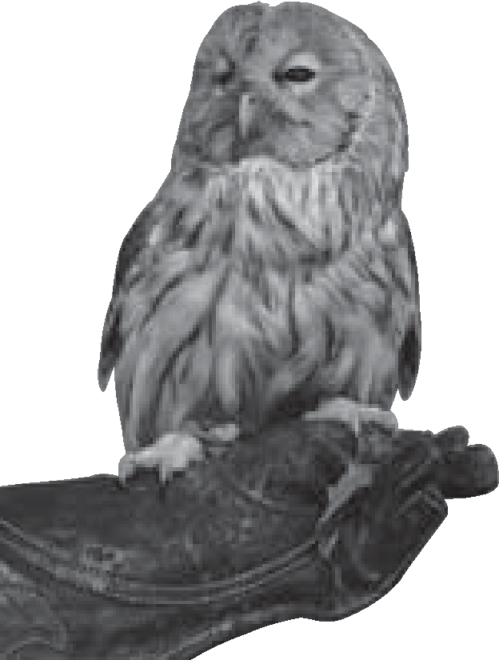
continued
My Notes
Activity
1.8
e
S
e
ctiv
e
rsp
e
World from My P
e
th
g
in
e
by
Edward Montez
From

Calafia: The California Poetry Projec t
Ishmael Reed, Project Director
I remember the scent of acorn soup cooking and deer meat frying in quiet
evenings of summer.
And shivering under thin blankets in winter and watching the wallpaper
dance to the force of the winter winds outside.
I remember the cry of an owl in the night and I knew it was an ominous
warning, a cry of death.
I remember running in the dust behind the medicine truck when it came to
the reservation, lifesavers was a free treat.
And grandpa sitting in his favorite resting chair under his favorite shade tree
with his dog “Oly” by his side.
I remember running naked and screaming with my aunt in hot pursuit, a
stick in her hand, she always caught me.
And every summer we would swim in the river and let the sun bake us until
we were a shade less than purple, basking on the riverbank, undisturbed, at
peace.
And I remember grandma toiling in the bean fields while I played with my
army truck on the fender of a “49” Plymouth.
I remember going to the movies in town on Saturday nights with fifty cents in
my pocket, thirty-five cents for the ticket and the rest was mine.
Eating popcorn and drinking water from a discarded coke cup and rooting
for the Indians to win, and they never did, but that was yesterday.
Poetry
© 2011 College Board.
a
ll rights reserved.

Analyzing Evidence of an Author’s Perspective
continued
Activity
1.8
© 2011 College Board.
a
ll rights reserved.
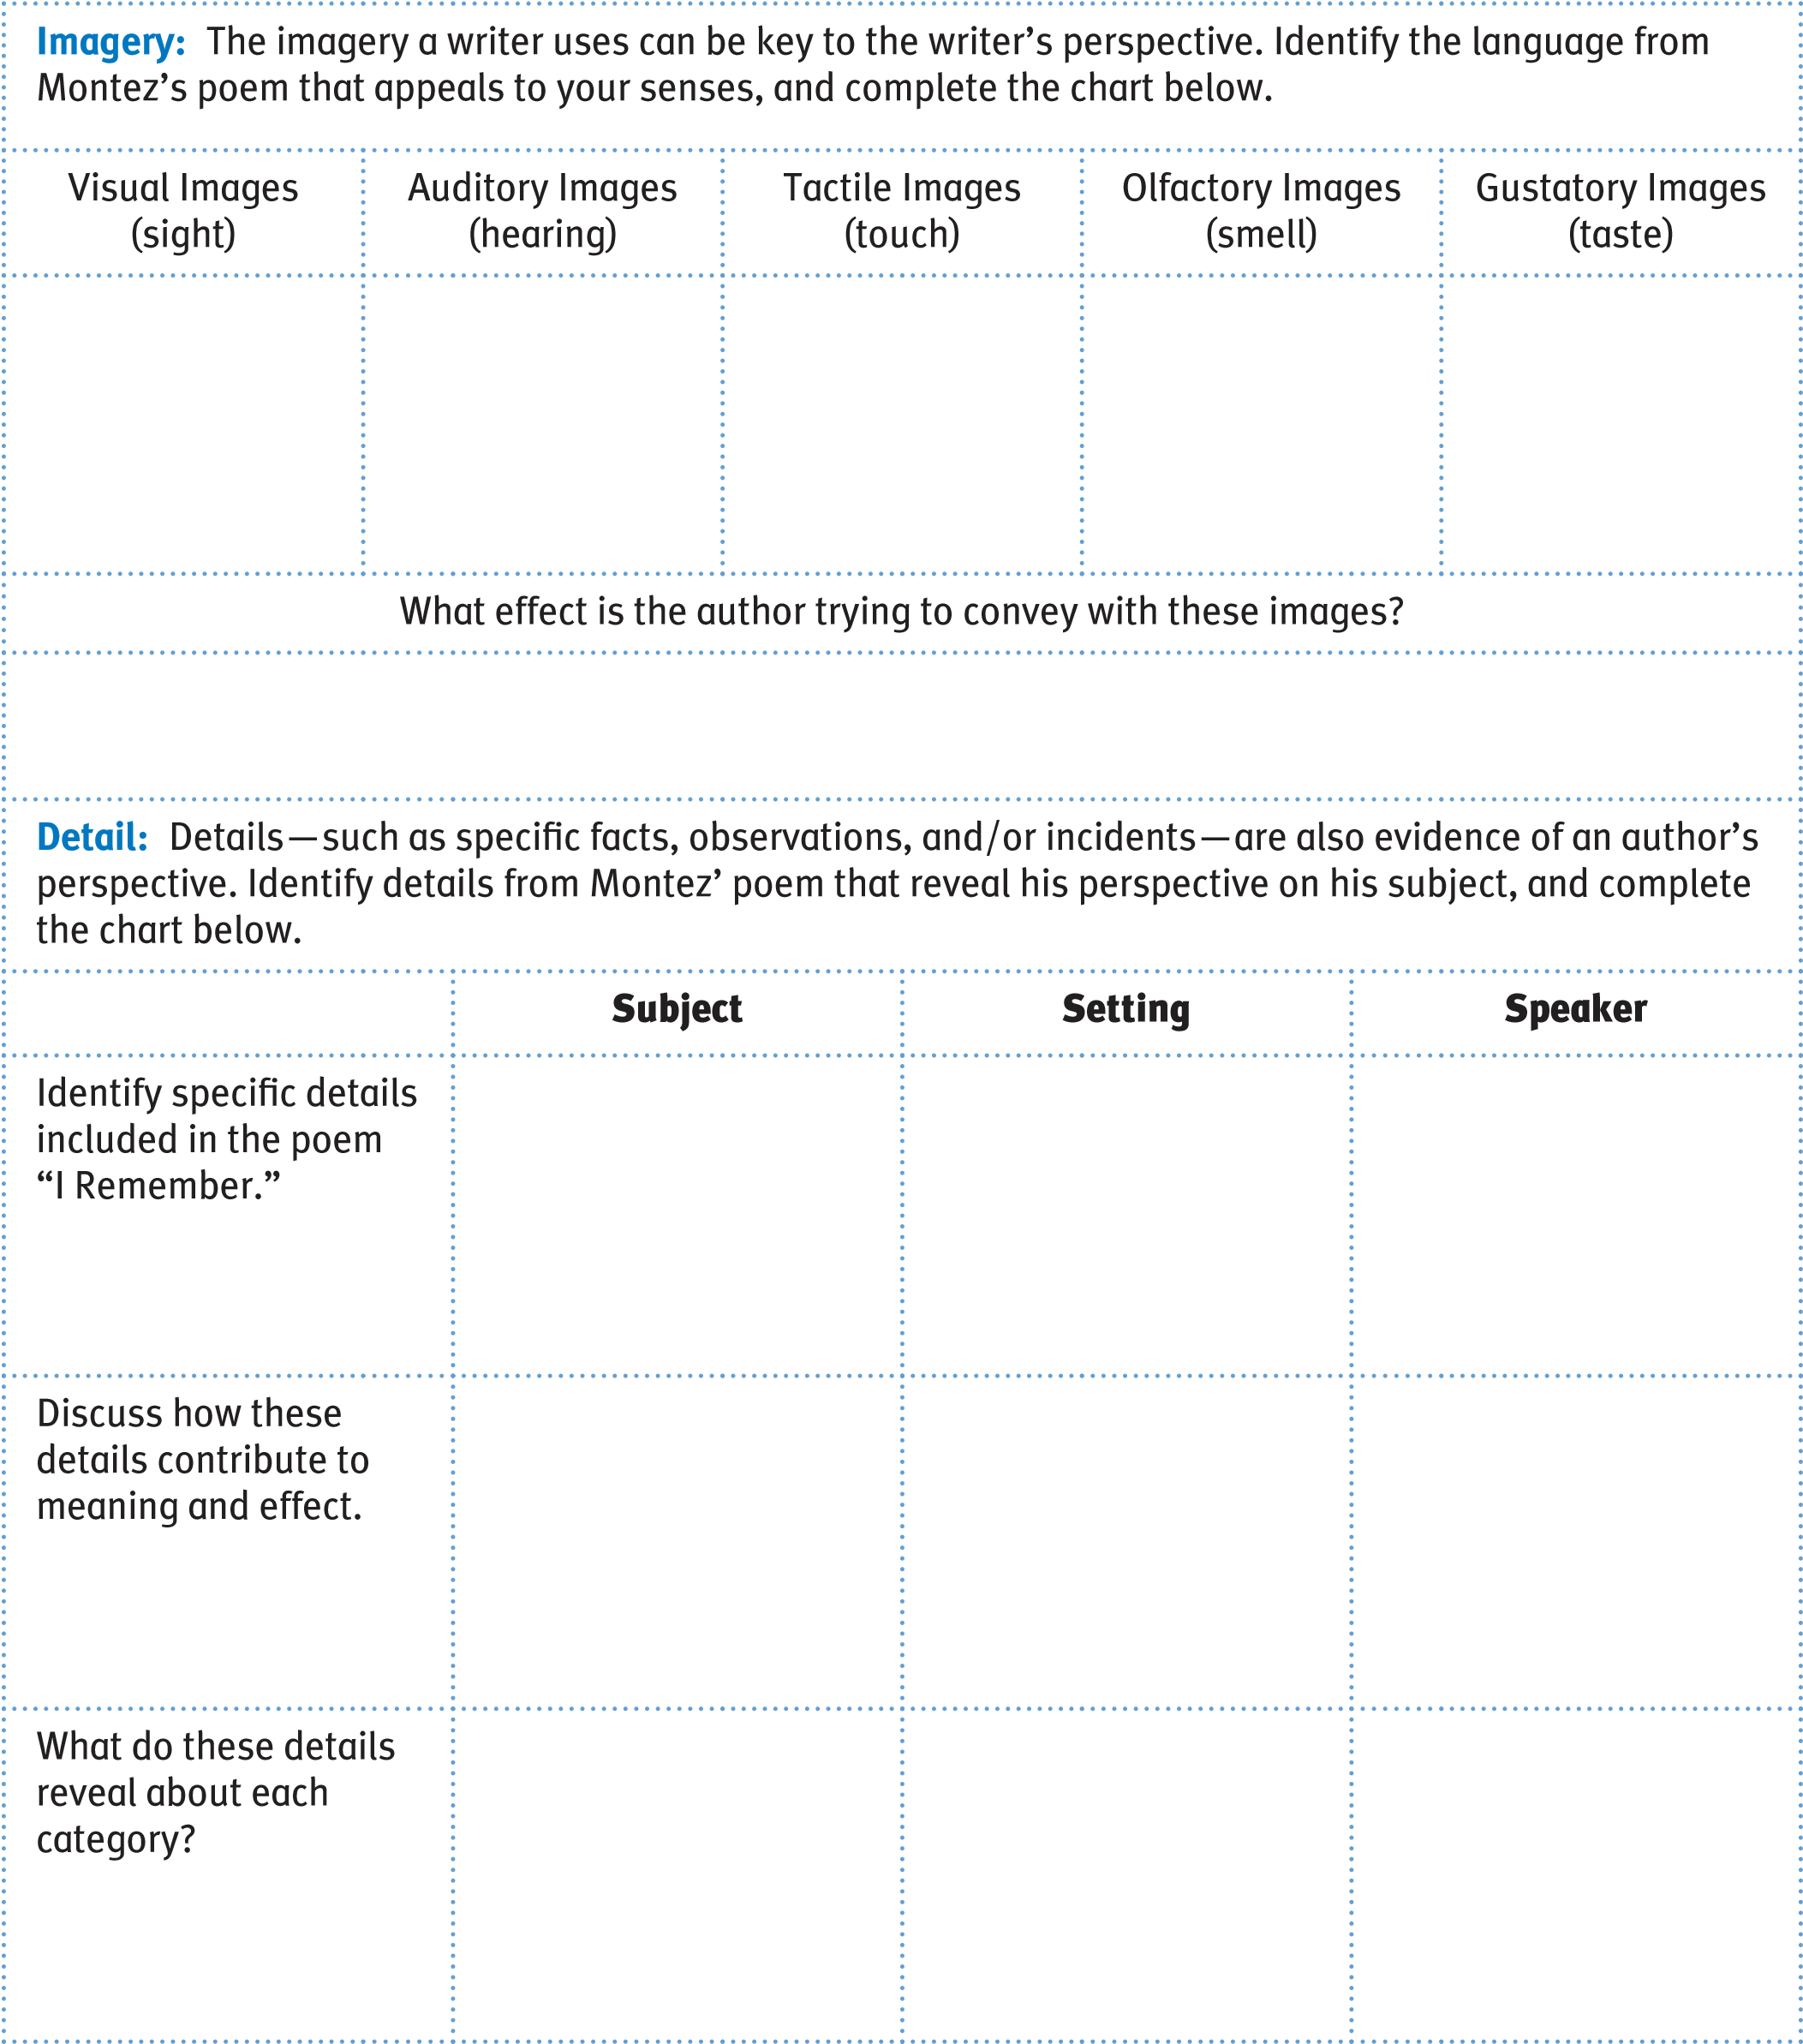
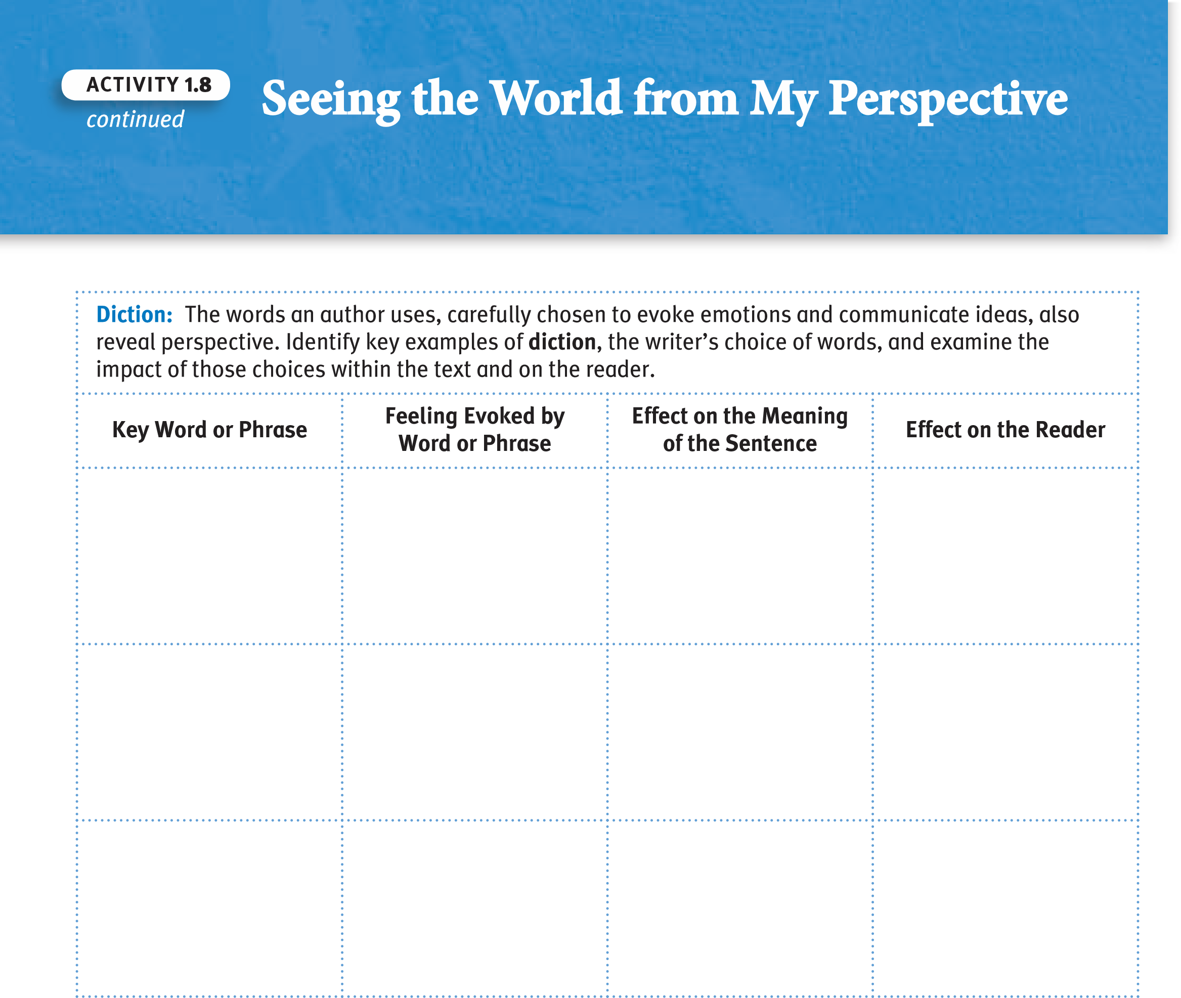
Writing Prompt: revisit your initial free write about a memory from childhood, and revise your drafts to refine your use of imagery, diction, and detail. annotate your drafts, identifying the stylistic techniques you used to create particular effects.
© 2011 College Board.
a
ll rights reserved.

Another Perspective on the World Activity1.9

SUGGESTED LEarninG STraTEGiES: close Reading, Sketching,
Quickwrite, visualizing, Graphic Organizer, Revisiting Prior Work

N o v e l

by Ralph Ellison From Invisible Man
I am an invisible man. No, I am not a spook like those who haunted Edgar Allan Poe; nor am I one of your Hollywood-movie ectoplasms. I am a man of substance, of flesh and bone, of fiber and liquids—and I might even be said to possess a mind. I am invisible, understand, simply because people refuse to see me. Like the bodiless heads you see sometimes in circus sideshows, it is as though I have been surrounded by mirrors of hard, distorting glass. When they approach me they see only my surroundings, themselves, or figments of their imagination—indeed, everything and anything except me.
Nor is my invisibility exactly a matter of a biochemical accident to my epidermis. That invisibility to which I refer occurs because of a peculiar disposition of the eyes of those with whom I come in contact. A matter of the construction of their inner eyes, those eyes with which they look through their physical eyes upon reality. I am not complaining, nor am I protesting either. It is sometimes advantageous to be unseen, although it is most often rather wearing on the nerves. Then too, you’re constantly being bumped against by those of poor vision. Or again, you often doubt if you really exist. You wonder whether you aren’t simply a phantom in other people’s minds. Say, a figure in a nightmare which the sleeper tries with all his strength to destroy. It’s when you feel like this that, out of resentment, you begin to bump people back.
And, let me confess, you feel that way most of the time. You ache with the need to convince yourself that you do exist in the real world, that you’re a part of all the sound and the anguish, and you strike out with your fists, you curse and you swear to make them recognize you. And, alas, it’s seldom successful.
My Notes
Literary terms
a prologue is the introduction or preface to a literary work.

Word
ConneCtions
Ectoplasms contains the
Greek root ecto-, meaning “outside.” This root also appears in other scientific words such as ectoderm and ectothermal. it also contains the Greek suffix –plasm, which refers to the formative part of an animal or vegetable cell. You have probably noticed this suffix in other words such as protoplasm.
continued^{Activity 1.9} Another Perspective on the World

Grammar UsaGe&
Good writing includes variety in sentence length. a series of sentences of more or less the same length becomes monotonous and boring. Such sentences may also lack clarity, failing to show relationships and the progression from one idea to the next. notice the difference in length between the last two sentences in the Prologue to Invisible Man. Consider also the way Ellison conveys relationships among the ideas within the longer sentence (a compoundcomplex sentence) as well as between the two sentences.
A b o u t t h e A u t h o r
Though ralph Ellison’s (1914–1994) novelistic output was small, its influence was huge. Ellison is best known for his novel Invisible Man (1952). in his masterpiece, an unnamed narrator struggles against racism and urban alienation to find an identity. Ellison employs an all-embracing style—combining elements of africanamerican folklore, native american mythology, and classical allusions—which he likened to a jazz musician’s improvisation on traditional themes. Though Ellison detested being labeled a black writer, he accepted the label minority writer, because, as he put it, “the individual is a minority.”
Sketch images: review the sketches you made to capture the images and/or ideas in Ellison’s Prologue. refine and arrange them to capture the essence of Ellison’s Prologue in the space below or on separate paper.

describe your perception of yourself.
i am .
no, i am not ; nor am i
.
i am ,
continued
Activity
1.9
Using the following model of the structure of Ellison’s Prologue,

and –and i

might even be said to
.
Quickwrite: Elaborate on the self-perception you presented above, explaining it to your readers.
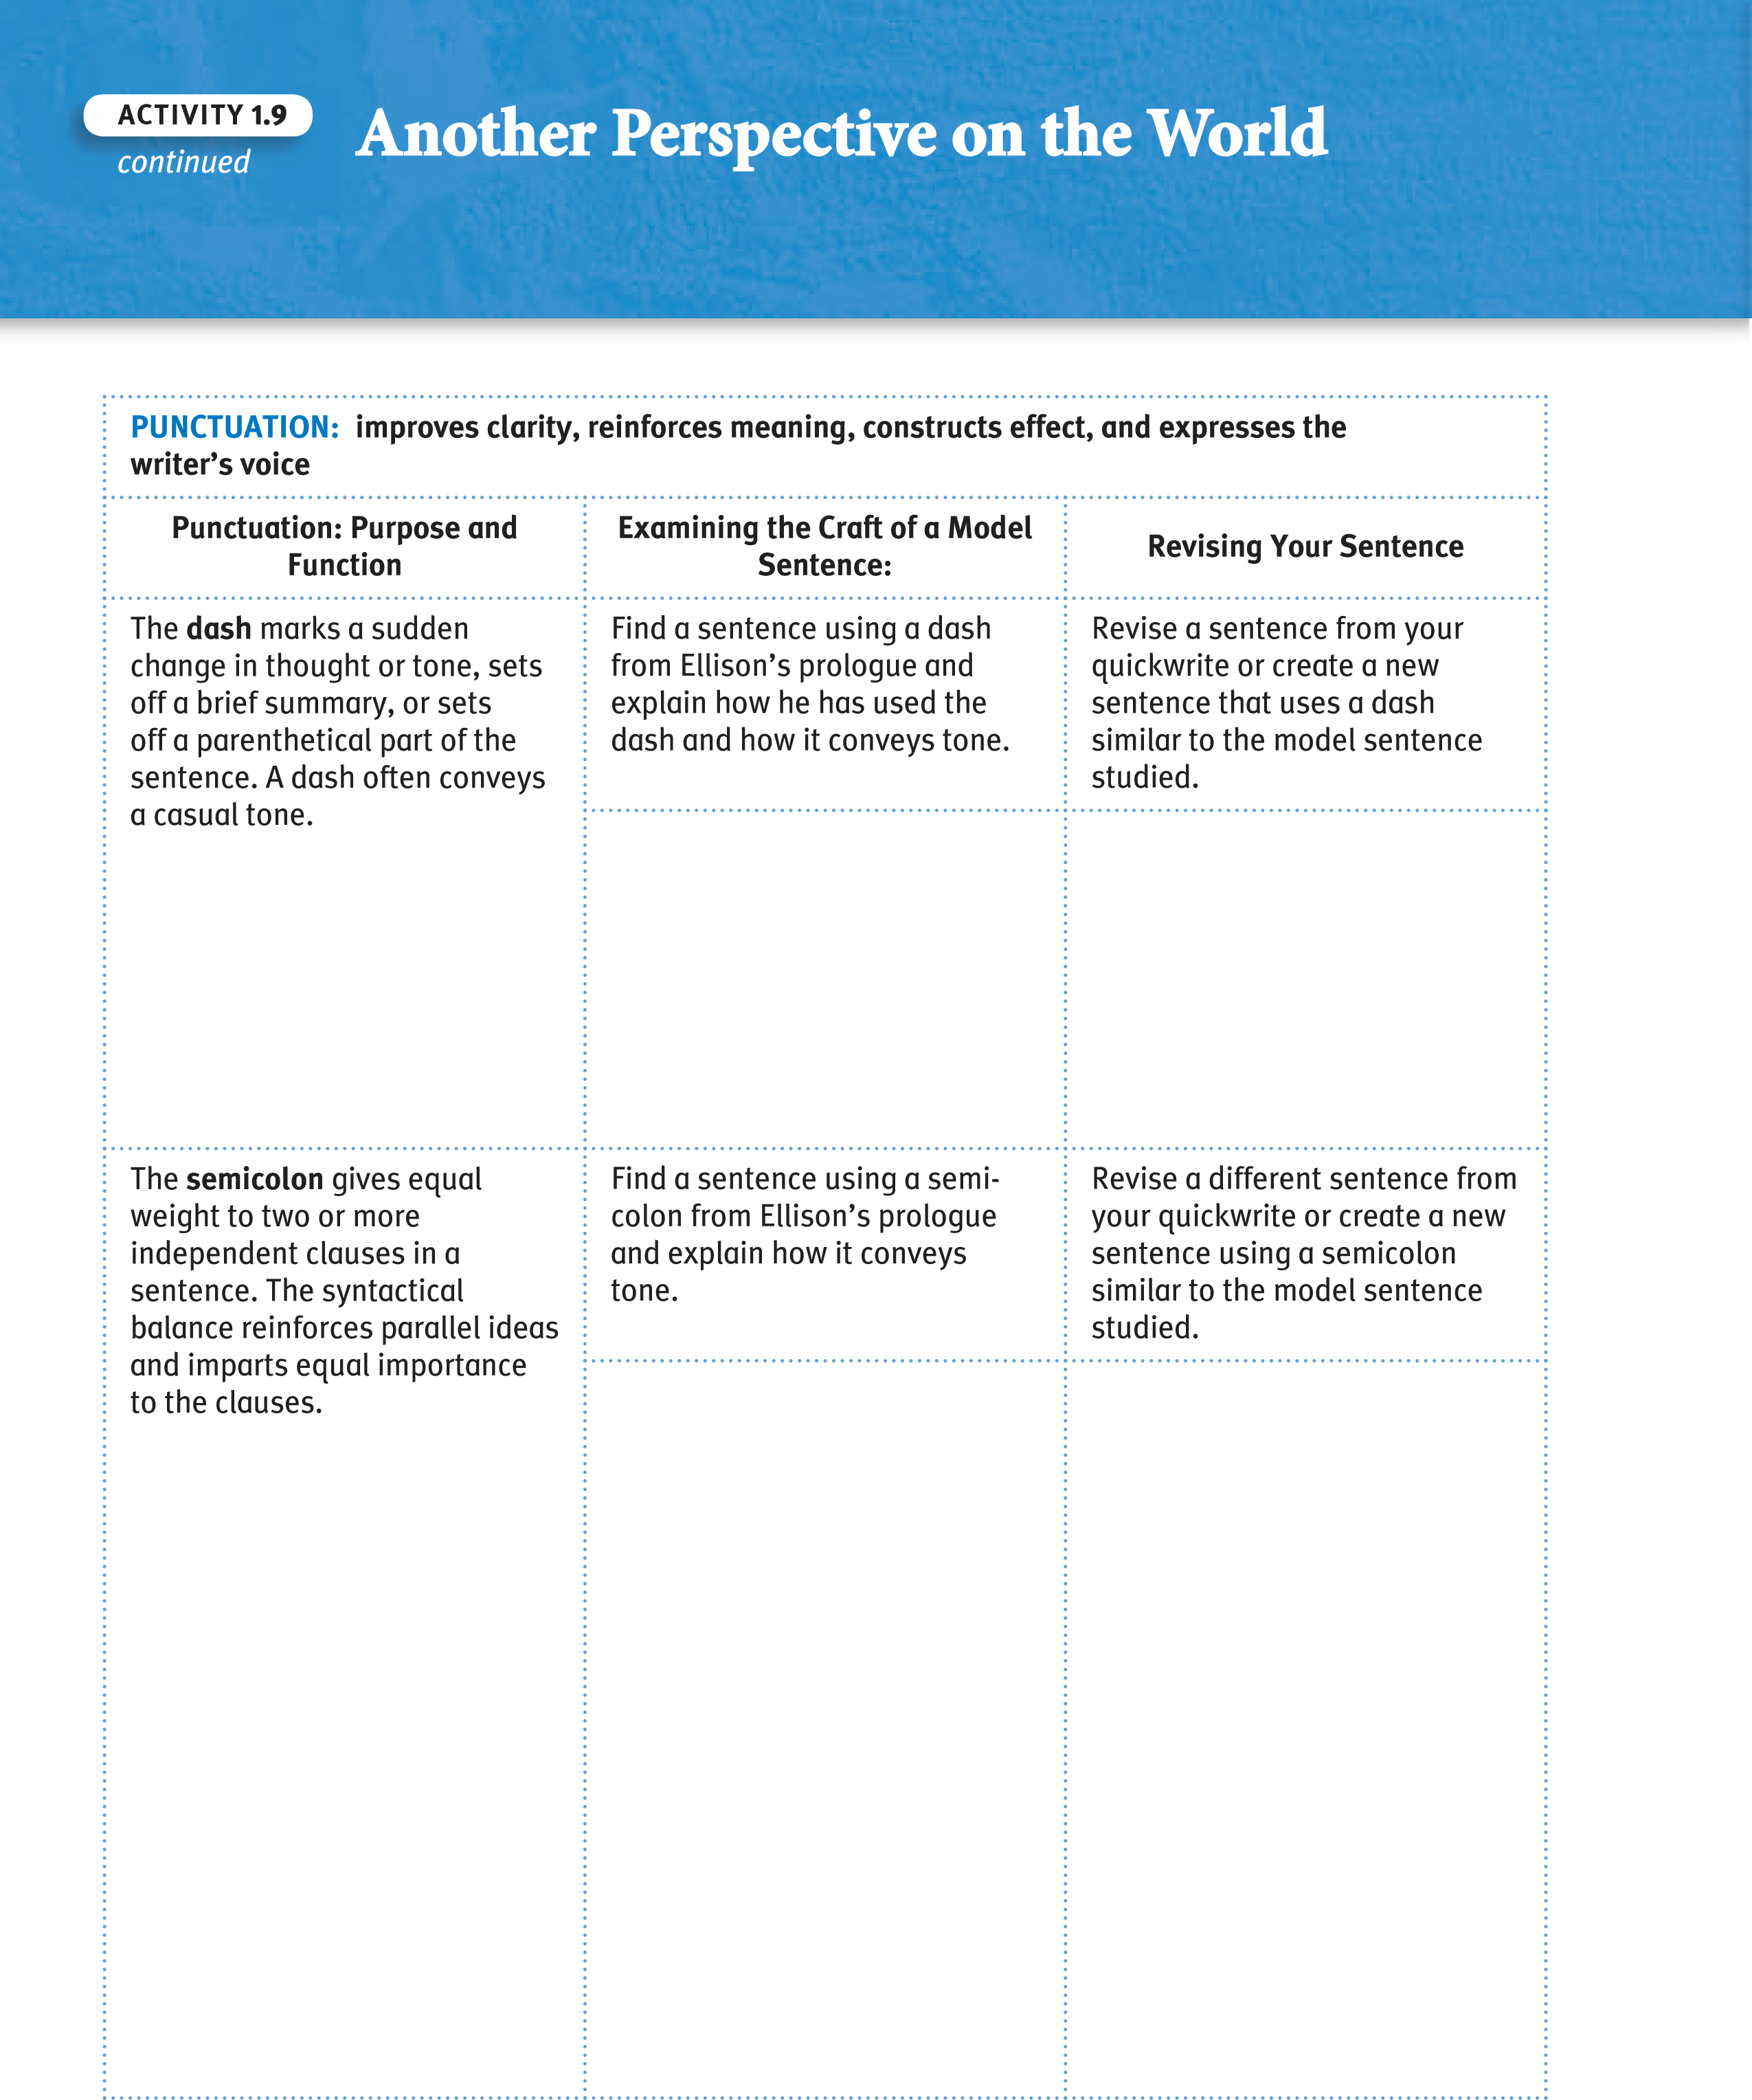

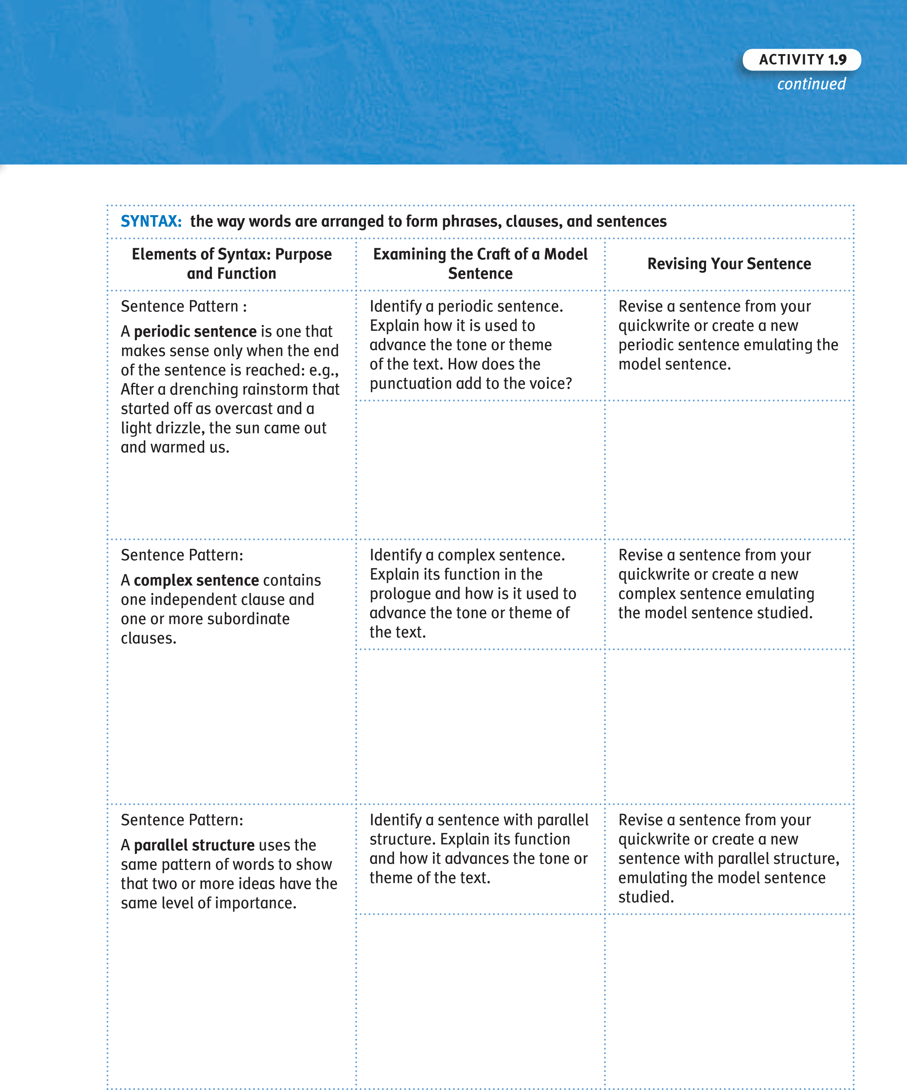
Writing Prompt: Use the space below to revisit your quickwrite and revise it to emulate Ellison’s style.
continued
e
Anoth
e
r P
e
rsp
World
ct
i
v
e
on th
e
Activity
1.9
Create a visual representation of your self-perception. Consider your mise en scène and arrange images strategically to enhance ideas presented in your text.
Writing Prompt: now that you have visual images representing yourself, write an essay that you might use as a college application describing yourself, your preparation for college, and your goals. include convincing reasons why the college should accept you as a student. remember to include relevant questions or other techniques to engage your readers and address their potential misunderstandings or problems with your application. Use word processing software, and format your essay appropriately through your choice of typefaces, use of boldface, use of white space, and headings if appropriate.

A Symbolic Perception of Self Activity1.10

SUGGESTED LEarninG STraTEGiES: visualizing, Brainstorming,
Marking the text, think-Pair-Share, Drafting, Self-Editing/Peer Editing

N o v e l
A b o u t t h e A u t h o r
Born in the Chicago barrio in 1954, Cisneros was the only daughter in a family of seven children. although she was expected to assume a traditional female role in her patriarchal, Mexican-american household, Cisneros successfully struggled to articulate the experience of a Latina woman, publishing the poetry collection Bad Boys (1980) and then gaining international acclaim with her first work of fiction, The House on Mango Street (1983). a graduate of Loyola University and the University of iowa Writers’ Workshop, Cisneros has received fellowships from the national Endowment for the arts and the Macarthur Foundation.
The following passage is a vignette from The House on Mango Street.

by Sandra Cisneros
They are the only ones who understand me. I am the only one who understands them. Four skinny trees with skinny necks and pointy elbows like mine. Four who do not belong here but are here. Four raggedy excuses planted by the city. From our room we can hear them, but Nenny just sleeps and doesn’t appreciate these things.
© 2011 College Board.
a
ll rights reserved.
Their strength is secret. They send ferocious roots beneath the ground. They grow up and they grow down and grab the earth between their hairy toes and bite the sky with violent teeth and never quit their anger. This is how they keep.
Let one forget his reason for being, they’d all droop like tulips in a glass, each with their arms around the other. Keep, keep, keep, trees say when I sleep. They teach.
When I am too sad and too skinny to keep keeping, when I am a tiny thing against so many bricks, then it is I look at trees. When there is nothing left to look at on this street. Four who grew despite concrete. Four who reach and do not forget to reach. Four whose only reason is to be and be.
My Notes
Literary terms
a vignette is a brief visual or written descriptive literary sketch.

Grammar UsaGe&
For many years you have studied the difference between complete sentences and sentence fragments. The accidental sentence fragment usually creates problems for the reader because such a fragment is missing an important element. However, good writers may use sentence fragments rhetorically, to create effective, even eloquent, phrasing. notice the sentence fragments beginning with the word “Four” in the first paragraph of this passage. These fragments also demonstrate effective use of parallel structure, repeating the same form or structure to express an idea.

A visual vignette: Create a visual below that represents a symbolic understanding of Cisneros’s vignette.
Writing Prompt: Write a literary vignette exploring the memory represented by the photo you brought to class. Then transform your vignette into a free verse poem.
continued
Activity
1.10
A
Symbolic P
e
rc
e
ption of Self
© 2011 College Board.
a
ll rights reserved.

Shot: a single piece of film uninterrupted by cuts.
Establishing Shot: often a long shot or a series of shots that sets the scene. it establishes setting and shows transitions between locations. Long Shot (LS): a shot from some distance. if filming a person, the full body is shown. it may show the isolation or vulnerability of the character (also called a Full Shot).
Medium Shot (MS): the most common shot. The camera seems to be a medium distance from the object being filmed. a medium shot shows the person from the waist up. The effect is to ground the story. close Up (cU): the image takes up at least 80 percent of the frame.
Extreme close Up: the image is a part of a whole, such as an eye.
two Shot: a scene between two people shot exclusively from an angle that includes both characters more or less equally. it is used in love scenes where interaction between the two characters is important.

Camera Angles
Eye Level: a shot taken from a normal height; that is, the character’s eye level. ninety to ninety-five percent of the shots seen are eye level, because it is the most natural angle.
Activity
Exploring Perspectives in Visual Art
SUGGESTED LEarninG STraTEGiES:
Discussion Groups, Drafting.
Activating Prior Knowledge, Graphic Organizer
Shots and Framing
1.11
High Angle: a shot taken from above the subject. This angle usually has the effect of making the subject look smaller than normal, giving him or her the appearance of being weak, powerless, and trapped. Low Angle: a shot taken from below the subject. Can make the subject look larger than normal and thus strong, powerful, and threatening.
© 2011 College Board.
a
ll rights reserved.

Lighting
High Key: the scene is flooded with light, creating a bright and openlooking scene.
Low Key: the scene is flooded with shadows and darkness, creating suspense or suspicion.
Bottom or Side Lighting: direct lighting from below or the side, which often makes the subject appear dangerous or evil.
Front or Back Lighting: soft lighting on the actor’s face or from behind gives the appearance of innocence or goodness, or a halo effect. outlined below.
Overview:
Parts:
text/title: interrelationship: conclusion:
continued
Activity
1.11
analyze the print ad provided, using the OPTiC strategy as

Explorin
g
P
e
rsp
e
e
s in Visu
a
l
A
rt
ctiv
© 2011 College Board.
a
ll rights reserved.

Working in small groups, use the graphic organizer to continue your discussion and analysis of the print ad. Be sure to incorporate the vocabulary acquired in the unit thus far (e.g., cinematic techniques, OPTiC, rhetoric of photography) to explain with detail the purpose, intent, and effect of the techniques used.
continued
Activity
1.11
© 2011 College Board.
a
ll rights reserved.
cinematic choices Made by the Artistic Director
Effect of those choices on the viewer
Framing: Long, Short, close Up, Extreme close Up Shot
Angle: Eye Level, High, Low Angles
Strategic Placement of Objects and/or Objects Used as Symbols
Literary terms
a thesis is the main idea or point of an essay or article.
an essay is an interpretive or analytic composition that reveals the author’s perspective on a subject. a photo essay reveals the author’s perspective on the subject through a collection of photographic images. Just as the words and sentences in a written essay are placed in a specific order, so are the images in a photo essay placed in a specific order to express ideas, convey emotions, and show a progression of thoughts or events.

Analyzing a Photo Essay
as your teacher directs, focus on the following topics as you “read” and analyze a photo essay:
- Title
- Sequence of images
- Content of photographs 4. Captions
next, consider how you would use the three elements of reader response Criticism theory to think about the impact of the photo essay.
after your initial analysis, revisit the photo essay and make interpretations based on your inferences.
Activity
1.12
Explor
i
n
g

a
Photo Ess
a
y
SUGGESTED LEarninG STraTEGiES:
think-Pair-Share,

Discussion Groups

© 2011 College Board.
a
ll rights reserved.
- What issues are presented in the photo essay, and what is the author’s position on the issues?
- What is the purpose of this photo essay?
- Who is the target audience for this photo essay?
- How do the images tell a story or progression of events to reveal a particular position?
- What is your interpretation of the photo essay? Discuss how the composition and arrangement of the photos lead to your interpretation.

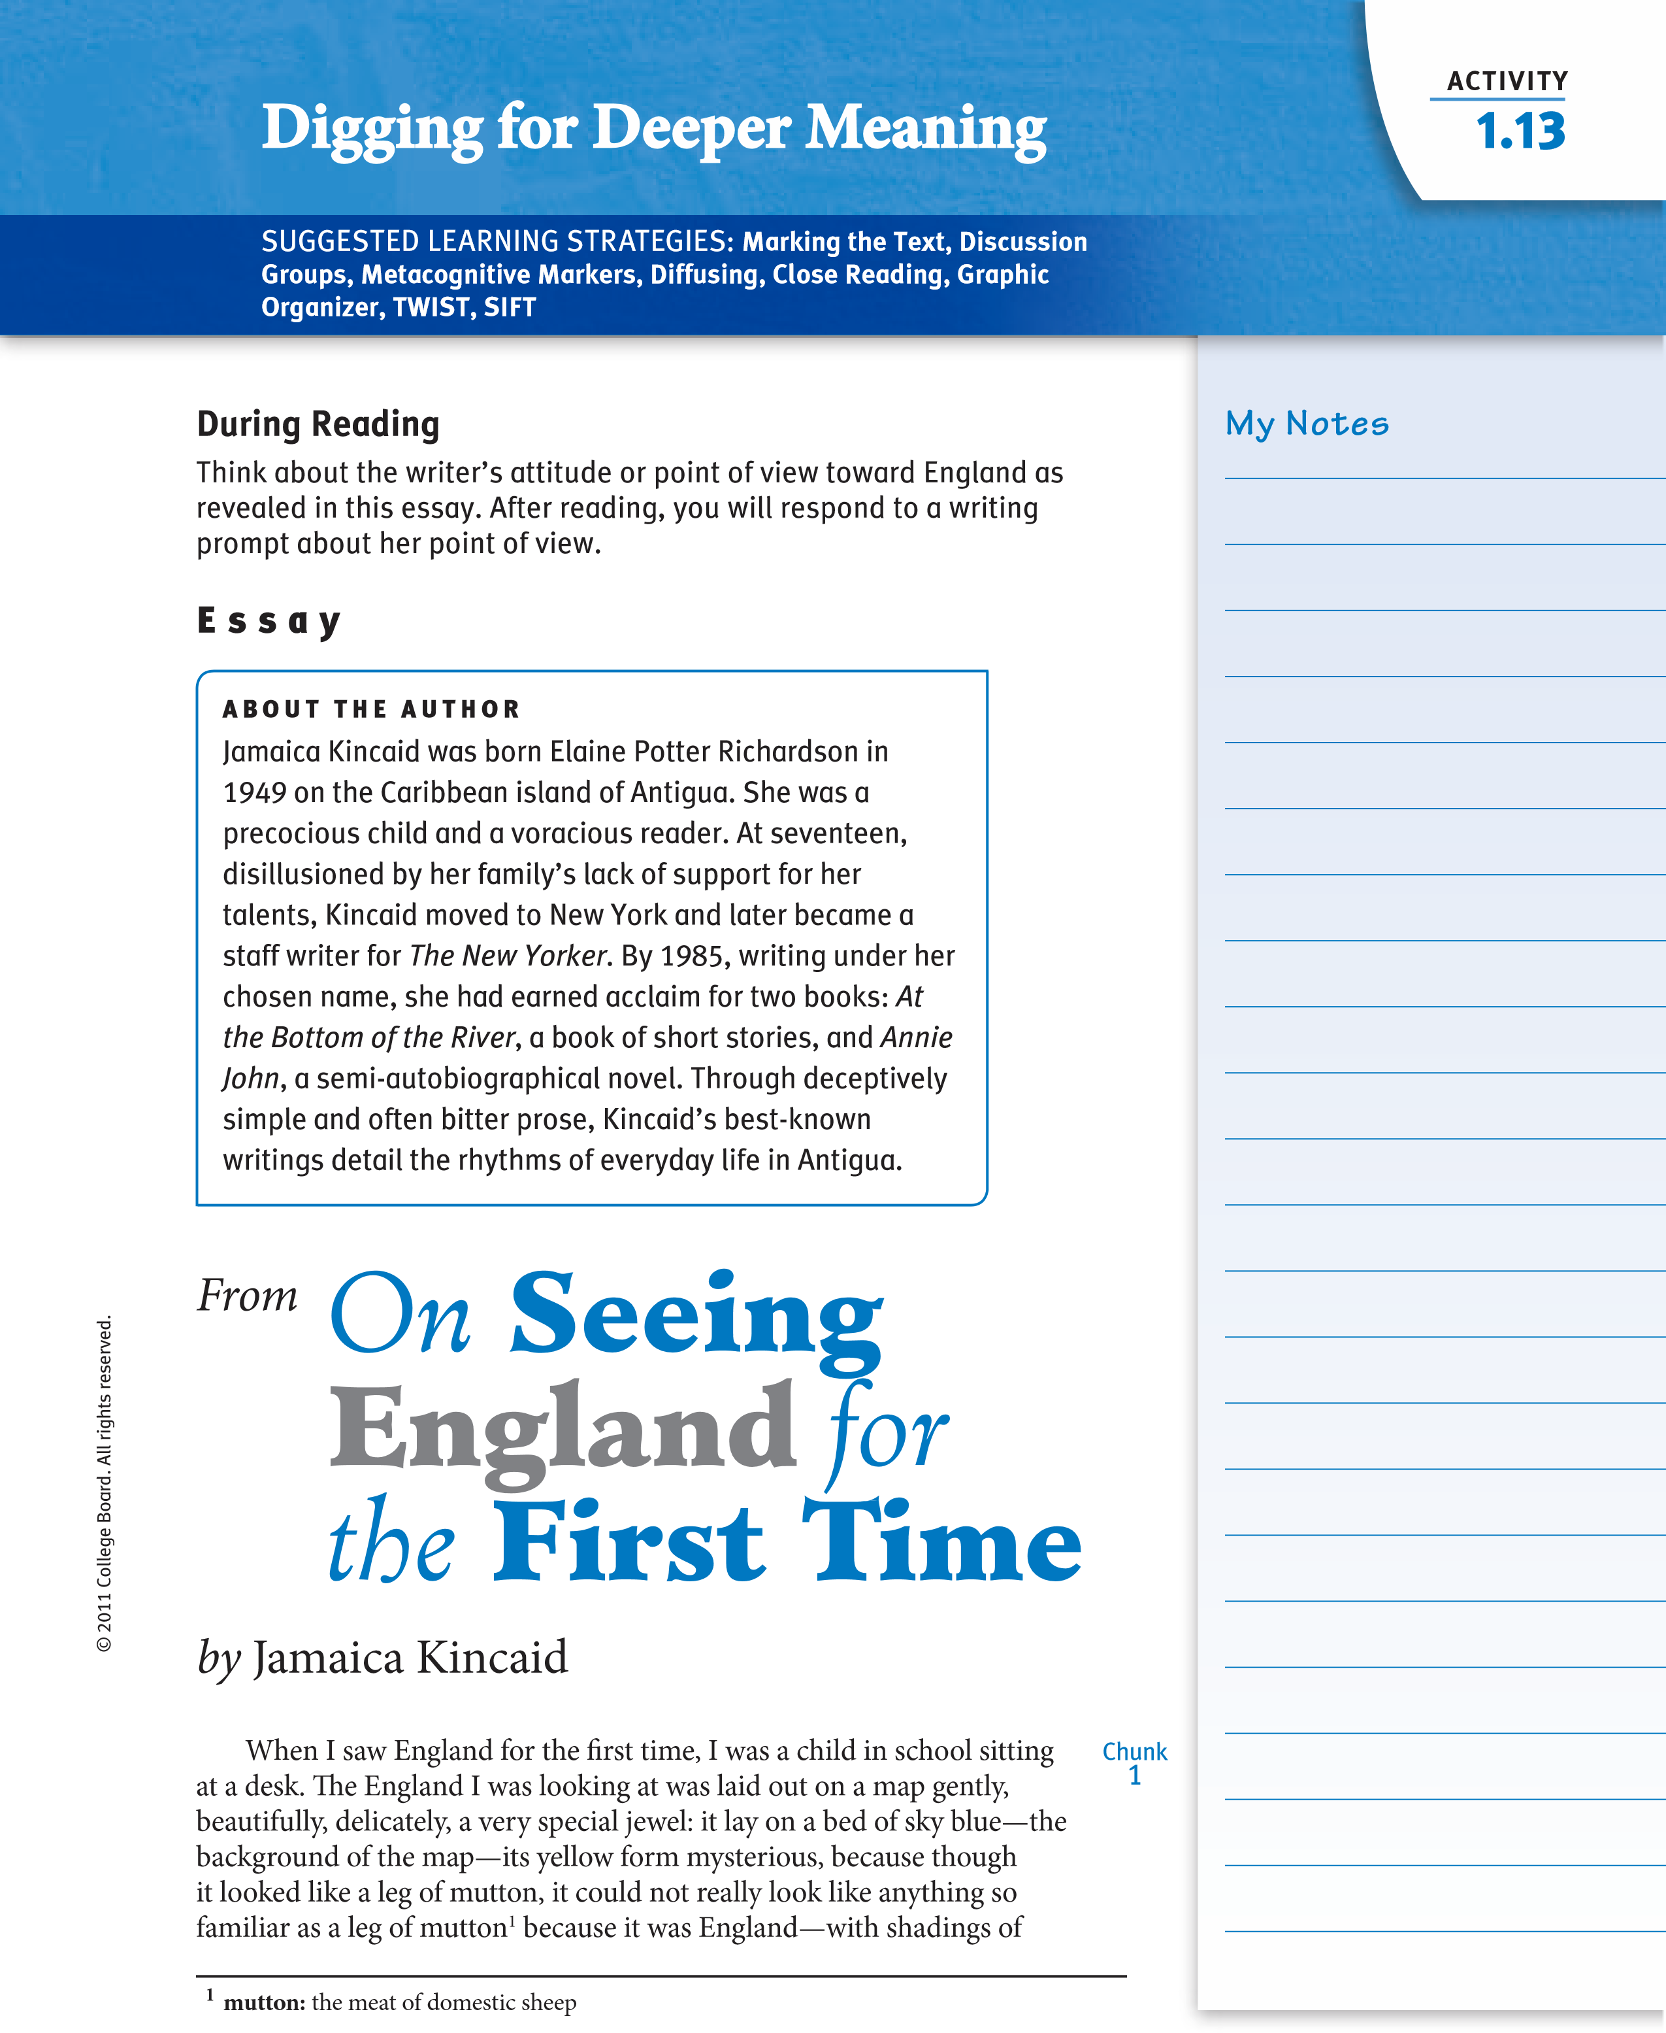

Activity continued1.13 Digging for Deeper Meaning

My Notes

Grammar UsaGe&
Clauses are groups of words that contain a subject and verb. While dependent clauses cannot stand alone—do not make sense by themselves— independent clauses do. notice this sentence from Kincaid’s essay: “My father, who might have sat next to me at breakfast, was a carpenter and cabinet maker.” The dependent clause “who might have sat next to me at breakfast” is an adjective clause that modifies the word “father.” notice that the dependent clause is set off by commas because it is not essential to identify father. We know who father is without this information. a sentence with both an independent clause and a dependent clause is a complex sentence. The use of complex sentences enables writers to create sentence variety and establish relationships among ideas.

pink and green, unlike any shadings of pink and green I had seen before, squiggly veins of red running in every direction. England was a special jewel all right, and only special people got to wear it. The people who got to wear England were English people. They wore it well and they wore it everywhere: in jungles, in deserts, on plains, on top of the highest mountains, on all the oceans, on all the seas, in places where they were not welcome, in places they should not have been. When my teacher had pinned this map up on the blackboard, she said, “This is England”—and she said it with authority, seriousness, and adoration, and we all sat up. It was as if she had said, “This is Jerusalem, the place you will go to when you die but only if you have been good.” We understood then—we were meant to understand then—that England was to be our source of myth and the source from which we got our sense of reality, our sense of what was meaningful, our sense of what was meaningless—and much about own lives and much about the very idea of us headed that last list.
Chunk At the time I was a child sitting at my desk seeing England for the
² first time, I was already very familiar with the greatness of it. Each morning before I left for school, I ate breakfast of half a grapefruit, an egg, bread and butter and a slice of cheese, and a cup of cocoa; or half a grapefruit, a bowl of oat porridge, bread and butter and a slice of cheese, and a cup of cocoa. The can of cocoa was often left on the table in front of me. It had written on it the name of the company, the year the company was established, and the words “Made in England.” Those words, “Made in England,” were written on the box the oats came in too. They would also have been written on the box the shoes I was wearing came in: a bolt of gray linen cloth lying on the shelf of a store from which my mother had bought three yards to make the uniform that I was wearing had written along its edge those three words. The shoes I wore were made in England; so were my socks and cotton undergarments and the satin ribbons I wore tied at the end of two plaits of my hair. My father, who might have sat next to me at breakfast, was a carpenter and cabinet maker. The shoes he wore to work would have been made in England, as were his khaki shirt and brown felt hat. Felt was not the proper material from which a hat that was expected to provide shade from the hot sun should be made, but my father must have seen and admired a picture of an Englishman wearing such a hat in England, and this picture that he saw must have been so compelling that it caused him to wear the wrong hat for a hot climate most of his long life. And this hat—a brown felt hat—became so central to his character that it was the first thing he put on in the morning as he stepped out of bed and the last thing he took off before he stepped back into bed at night. As we sat at breakfast a car might go by. The car, a Hillman or a Zepher, was made in England. The very idea of the meal itself, breakfast, and its substantial quality and quantity was an idea from England; we somehow knew that in England they began the day with this meal called breakfast and a proper breakfast was a big breakfast. No one I knew liked eating so much food so early in the day: it made us feel
© 2011 College Board.
a
ll rights reserved.

Activity 1.13 continued
sleepy, tired. But this breakfast business was Made in England like almost My Notes
everything else that surrounded us, the exceptions being the sea, the sky, and the air we breathed.
At the time I saw this map—seeing England for the first time—I did Chunk not say to myself. “Ah, so that’s what it looks like.” Because there was no ³ longing in me to put a shape to those three words that ran through every part of my life, no matter how small; for me to have had such a longing would have meant that I lived in a certain atmosphere, an atmosphere in which those three words were felt as a burden. But I did not live in such an atmosphere. My father’s brown felt hat would develop a hole in its crown, the lining would separate from the hat itself, and six weeks before he thought that he could not be seen wearing it—he was a very vain man—he would order another hat from England. And my mother taught me to eat my food in the English way: the knife in the right hand, the fork in the left, my elbows held still close to my side, the food carefully balanced on my fork and then brought up to my mouth. When I had finally mastered it, I overheard her saying to a friend, “Did you see how nicely she can eat?” But I knew then that I enjoyed my food more when I ate it with my bare hands, and I continued to do so when she wasn’t looking. And when my teacher showed us the map, she asked us to study it carefully, because no test we would ever take would be complete without this statement: “Draw a map of England.”
© 2011 College Board.
a
ll rights reserved.
I did not know then that the statement “Draw a map of England” was something far worse than a declaration of war, for in fact a flat-out declaration of war would have put me on alert, and again in fact, there was no need for war—I had long ago been conquered. I did not know then that this statement was part of a process that would result in my erasure, not my physical erasure, but my erasure all the same. I did not know then that this statement was meant to make me feel in awe and small whenever I heard the word “England”: awe at its existence, small because I was not from it. I did not know very much of anything then—certainly not what a blessing it was that I was unable to draw a map of England correctly.
Writing Prompt: Write an essay analyzing the author’s point of view about England. Write a thesis statement and support your position with details about the author’s use of stylistic or rhetorical devices (e.g., diction, imagery, figurative language, tone, symbolism) to convey theme. identify and analyze the aesthetic effects of Kincaid’s use of ambiguities, nuances, and complexities in her essay and their effect in conveying meaning to the reader. Be sure to structure your essay to include appropriate embedded quotations and commentary on how the quotations support your analysis.
Plan for a Mock Photo Essay
Based on a thesis About “On First Seeing England”
continued
Activity
1.13
Di
g
g
in
g
for D
e
e
p
e
r M
e
a
nin
g

© 2011 College Board.
a
ll rights reserved.
thesis:
idea for image 1
idea for image 2
idea for image 3
Rationale for image 1
Rationale for image 2
Rationale for image 3
image 4
image 5
image 6
Rationale for image 4
Rationale for image 5
Rationale for image 6
ideas for title and captions

Creating a Photo Essay
SUGGESTED LEarninG STraTEGiES: Free Writing,
Self-Editing/Peer Editing, Sketching, Sharing and Responding, Graphic Organizer

Assignment
Your assignment is to create and present a photo essay revealing your perspective (position) about an issue or topic of importance to you.

Steps
- Select a topic of interest to you, and then free write and loop to explore your position on the issue. if necessary, conduct research to deepen your knowledge of the issue. as you plan your photo essay, consider how you might use it as a proposal to solicit action on the issue or as support for a college application.
- Generate a working thesis that clearly identifies the issue and your position. Use peer response to refine your thesis into a concise statement.
- Use the graphic organizer on page 41 to plan the evidence you will use to assert and support your thesis before presenting your position on the issue.
© 2011 College Board.
a
ll rights reserved.
  - Generate ideas to support the thesis.
C Sketch your proposed photo images (at least ten).
C include notes about film techniques (shots, angles, mise en scène) you want to use in your photos.
C Write a rationale to explain the connection between each proposed photograph and your thesis. Format your thesis and rationales with headings related to each photo. You will include the final document as part of your photo essay.
- Work collaboratively to plan the layout and format of the photo essay so that it advances your argument visually. anticipate potential misunderstandings or problems your readers or viewers may have, and include headings or relevant questions that engage readers/viewers and address their potential misunderstandings or problems.
- Plan the process you will use to create appropriate photos for your essay. Before you take the photographs, identify the following:
  - The format of the photos.
C any resources you will need—equipment, staging, scene development, etc.
C The process for film or digital prints as needed.
C a schedule for creating the photos and the essay.

Creating a Photo Essay
- Once you have your photos in hand, review your original organizational plan. Select and organize your photos to introduce your thesis, provide supporting evidence and details, and provide a conclusion. When citing technical evidence and details to support your position, remember to present them accurately and in language that is accessible and appropriate for your audience.
- Share the draft layout of your photo essay with your peers and make necessary revisions to ensure clarity of ideas, a clear focus on the thesis, and the support of that thesis. if needed, add brief captions to clarify your argument for your viewers.
- next, generate a list of potential titles; select the one that best captures the essence of your photo essay.
- assemble your final photo essay. Be sure to include these elements: C a captivating title.
continued
Embedded
Assessment 1

© 2011 College Board.
a
ll rights reserved.
C a numbered arrangement of photos that corresponds to the numbers on the graphic organizer.
C Your graphic organizer with thesis, description of supporting evidence, and rationale attached to the back of your photo essay.
- review the Scoring Guide on page 43. Use that guide to review your photo essay and make sure you have created a strong presentation.
- On the day of the presentation, you will participate in a gallery walk during which you will use sticky notes to evaluate other photo essays. as you evaluate the essays created by other students, you should attempt to identify the unstated thesis represented in each essay.
- after your presentation, write a reflection in which you consider the reactions of your classmates in relation to your original intent. Consider the elements of reader response Criticism and include any insights you have about how these elements might affect your classmates’ responses. Finally, discuss any changes you would make if you were to do this project again.
continued

Planning Your Photo Essay
Use this graphic organizer to develop a plan for your photo essay. First, write the thesis that you refined in Step 2. Then list the supporting ideas you have generated. For each supporting idea, write a description or draw a sketch of the image you think would communicate or represent that idea. Write a rationale explaining how each image helps support the thesis. You must have at least 10 photos.
© 2011 College Board.
a
ll rights reserved.
Thesis Statement:
Supporting Idea
Description/Sketch
Rationale
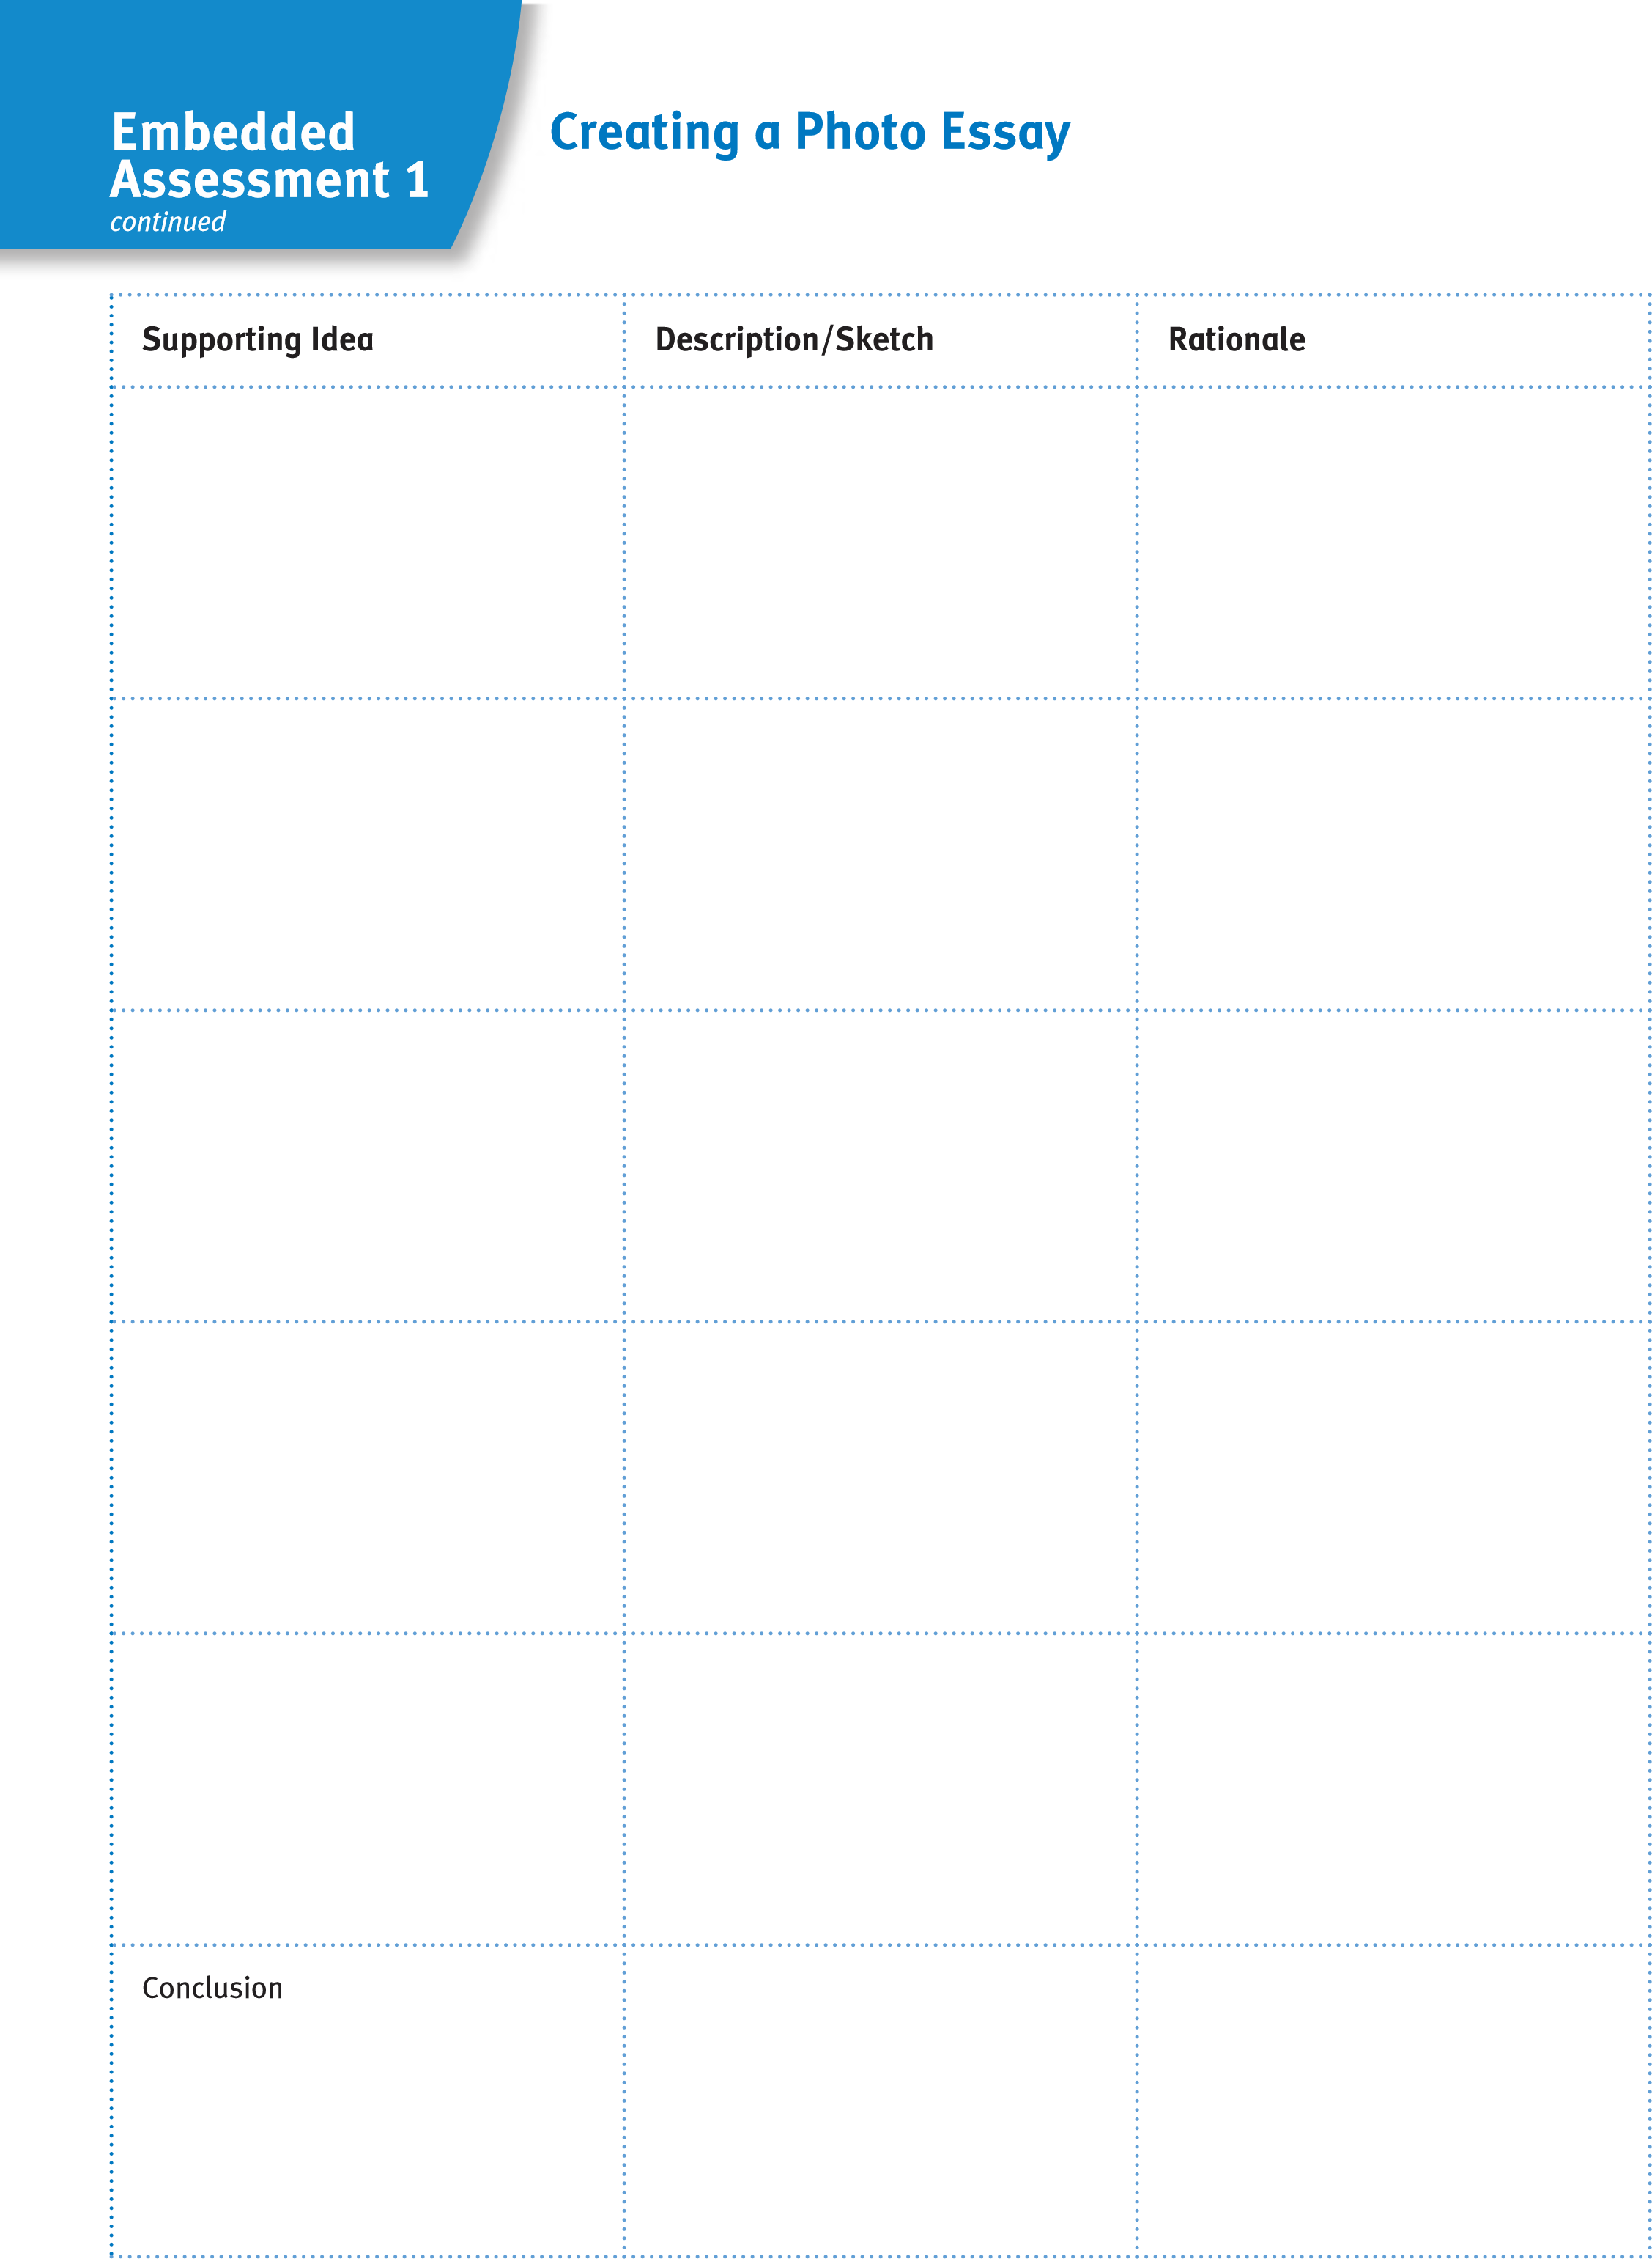
© 2011 College Board.
a
ll rights reserved.
continued

SCORInG GUIDE
© 2011 College Board.
a
ll rights reserved.
Scoring Criteria | Exemplary | Proficient | Emerging
Ideas | at least 10 photo images expertly convey and support the essay’s thesis. Titles and captions creatively convey a clear perspective on the issue. The thesis and rationale graphic organizer is thorough. | at least 10 photo images convey the essay’s thesis. Titles and captions communicate a clear perspective on the issue. The thesis and rationale graphic organizer is complete. | Fewer than 10 photo images attempt to convey the essay’s thesis. at times the thesis may be unclear. if used, titles and captions do little to provide a clear perspective on the issue. The thesis and rationale graphic organizer is incomplete.
Organization | The layout and design of the essay serve to expertly advance the argument and reflect thoughtful planning. | The layout and design of the essay are appropriate for the argument and reflect adequate planning. | The layout and design of the essay attempts, but does little, to enhance the argument and/or reflect advance thought or planning.
Cinematic Techniques | The photographs skillfully The photographs adequately The photographs attempt use a variety of media use a variety of media to use a variety of media production elements that production elements that production elements; vividly reveal the image’s help to reveal the image’s however, the purpose of purpose in connection to the purpose in connection to the the image in connection to  argument. argument. the argument is unclear at  times.
Reflection | The reflective text The reflective text The reflective text demonstrates a thorough demonstrates an adequate demonstrates an inadequate and detailed analysis of the analysis of the audience’s analysis of the audience’s audience’s reactions to the reactions to the photo essay reactions to the photo essay photo essay in relation to its in relation to its original in relation to its original original intent and reader intent and reader response intent and in relation to response Criticism. The Criticism. The reflection reader response Criticism. reflection includes insightful includes clear commentary Commentary on potential commentary on potential on potential revisions. revisions is weak or missing. revisions.
Additional Criteria
Comments:

Reader Response Criticism puts you, the reader, and your experiences, biases, values, and attitudes as the central factor in your interpretation of what you read and see. This subjective perspective is the starting point for interpreting literature. In order to increase your field of vision or perspective, try seeing and understanding from another perspective. Experience with other points of view or perspectives can help you see things more objectively. The more you move from a strictly subjective point of view, the more objective you can be about your interpretation and understanding of texts and events.
Learning Focus:
Perspective and Culture
Cultural Criticism examines how differing religious beliefs, ethnicities, class identifications, political beliefs, and individual viewpoints affect how texts are created and interpreted. This critical perspective asks you to examine texts by focusing on how language and culture shape identity and experience.
© 2011 College Board. All rights reserved.
With this perspective you can begin to understand how culture and language work to include and exclude individuals. This perspective seeks to illuminate the relationship between the individual and the group, between the stranger and the village, and between the dominant culture and the subordinate culture.
Reflecting about yourself within a cultural context helps you gain an awareness of self as the alien, stranger, outsider or as the insider, member, or villager. Such reflection allows you to broaden your perspective to include a consciousness of self within a community.

Cultural Criticism is another critical lens through which any text can be viewed. This form of criticism examines how different religions, ethnicities, class identifications, political beliefs, and views affect the ways in which texts are created and interpreted. Cultural Criticism suggests that being a part of—or excluded from—a specific group or culture contributes to and affects our understanding of texts. The following statements reflect four common assumptions in the use of Cultural Criticism as a lens for understanding literature.
- Ethnicity, religious beliefs, social class, and so on are crucial components in formulating plausible interpretations of text.
- While the emphasis is on diversity of approach and subject matter, Cultural Criticism is not the only means of understanding ourselves and our art.
- An examination or exploration of the relationship between dominant cultures and the dominated is essential.
- When looking at a text through the perspective of marginalized peoples, new understandings emerge.
Since Cultural Criticism examines texts from the position of those individuals who are in some way marginalized or not part of the dominant culture, studying the following poem by Luis Rodriguez will provide insights on this perspective.
ACtivity
1.14
SUGGESTED LEARnInG STRATEGIES:
Discussion Groups, Rereading,
Questioning the text, Oral interpretation, Quickwrite
Cultural Criticism
What Is Cultural Criticism?
© 2011 College Board. All rights reserved.
unit 1
ACADEmiC vOCABulARy
Cultural Criticism focuses on the elements of culture and how they affect one’s perceptions and understanding of texts.

Word
ConneCtions
To marginalize is relegate or confine to a lower or outer limit (as in social standing).

ACtivity
1.14
continued
by
Luis Rodriguez
About the Author
An award-winning poet, journalist, and critic, Luis J.
Rodriguez was born on the U.S./Mexico border, but
grew up in the Watts neighborhood of Los Angeles. As
a youth, he joined a gang to gain a sense of belonging
and protection, but he found salvation in the Chicano
movement and in literature. In prose works like
Always
Running: La Vida Loca, Gang Days in L.A.,
and poetry
collections like
The Concrete River,
Rodriguez deals with
the struggle to survive in a chaotic urban setting.
Poetry
There were no markets in Watts.
There were these small corner stores
we called
marketas

who charged more money
for cheaper goods than what existed
in other parts of town.
The owners were often thieves in white coats
who talked to you like animals,
who knew you had no options;
who knew Watts was the preferred landfill
of the city.
5
10
My Notes
What Is Cultural Criticism?
© 2011 College Board. All rights reserved.

ACtivity
1.14
continued
One time, Mama started an argument
at the cash register.
In her broken English,
speaking with her hands,
she had us children stand around her
as she fought with the grocer
on prices & quality & dignity.
Mama became a woman swept
by a sobering madness;
she must have been what Moses saw
in the burning bush,
a pillar of fire
consuming the still air
that reeked of overripe fruit
and bad meat from the frozen food
section.
She refused to leave
until the owner called the police.
The police came and argued too,
but Mama wouldn’t stop.
They pulled her into the parking lot,
called her crazy…
and then Mama showed them crazy!
They didn’t know what to do
but let her go, and Mama took us children
back toward home, tired of being tired.
Quickwrite:

Use the elements listed as part of the definition of
Cultural Criticism to write about how this lens or perspective might
help you interpret this text.
15
20
25
30
35
My Notes
unit 1
© 2011 College Board. All rights reserved.
Activity
1.15
SUGGESTED LEarninG STraTEGiES:
Graphic Organizer, Predicting,
Discussion Groups, Questioning the text, Quickwrite, SOAPStone
Use the graphic organizer below to explore the concept of
Poetic Conversations
© 2011 College Board.
a
ll rights reserved.
“imperialism.”
Paraphrase, or briefly restate in your own
words, each definition.

1
.
the policy of extending the rule or influence of
a country over other countries or colonies

2
.
the political, military, or economic domination
of one country over another
Explore connections to the concept of
imperialism.
Other Concepts:
Other Ideas:
Other Texts:
Self:
List at least two examples of imperialism.
List at least two non-examples of imperialism.
imperialism
My Notes
Activity
1.15
continued
AbOuT ThE AuThOr
rudyard Kipling was a British author known for his support of British
colonialism and imperialism. Born in Bombay (now Mumbai), india, in
, Kipling was educated in England; but he returned to india where
1865
he worked for seven years as a journalist. Kipling’s poems, novels, and
short stories reflect the anglo-indian experience. Kipling was awarded
the nobel Prize for Literature in 1907. His children’s books, including
Just So Stories
(1902) and
Kim
(1901) are considered classics.
in order to better understand Cultural Criticism, you will examine two
poems. The first poem, by rudyard Kipling, affirms the concept of
imperialism. in contrast, Henry Labouchère’s poem, written in response
shortly after Kipling’s poem was published, questions imperialism. as
you read and discuss the two poems, note how the perspective of the
speaker, the imaginary voice of the author, influences what the speaker
has to say about the concepts of “imperialism” and/or “colonialism.”

1
sullen
moody; sulky
:
Poetry
by
Rudyard Kipling
Mcclure’S

Magazine
(12 FEB. 1899)
Take up the White Man’s burden—
Send forth the best ye breed—
Go bind your sons to exile
To serve your captives’ need;
To wait, in heavy harness,
On fluttered folk and wild—
Your new-caught sullen
1
peoples,
Half devil and half child.
Take up the White Man’s burden—
In patience to abide,
To veil the threat of terror
And check the show of pride;
By open speech and simple,
An hundred times made plain,
To seek another’s profit,
And work another’s gain.
5
10
15
© 2011 College Board.
a
ll rights reserved.
Activity
1.15
continued
My Notes
Take up the White Man’s burden—
The savage wars of peace—
Fill full the mouth of Famine,
And bid the sickness cease;
And when your goal is nearest
(
The end for others sought
)
Watch sloth

2
and heathen
3
Folly
Bring all your hope to naught.
Take up the White Man’s burden—
No tawdry
4
rule of kings,
But toil of serf and sweeper—
The tale of common things.
The ports ye shall not enter,
The roads ye shall not tread,
Go mark them with your living,
And mark them with your dead.
Take up the White Man’s burden—
And reap his old reward:
The blame of those ye better,
The hate of those ye guard—
The cry of hosts ye humour
(
Ah, slowly!) toward the light:—
“Why brought ye us from bondage,
Our loved Egyptian night?”
Take up the White Man’s burden—
Ye dare not stoop to less—
Nor call too loud on Freedom
To cloak your weariness;
By all ye will or whisper,
By all ye leave or do,
The silent, sullen peoples
Shall weigh your God and you.
Take up the White Man’s burden!
Have done with childish days—
The lightly proffered laurel,
5
The easy, ungrudged praise:
Comes now, to search your manhood
Through all the thankless years
Cold, edged with dear-bought wisdom,
The judgment of your peers!
20
25
30
35
40
45
50
55

2

sloth:
laziness

3

heathen:
godless

4

tawdry:
flashy

5

laurel:
honor
Poetic Conversations
© 2011 College Board.
a
ll rights reserved.
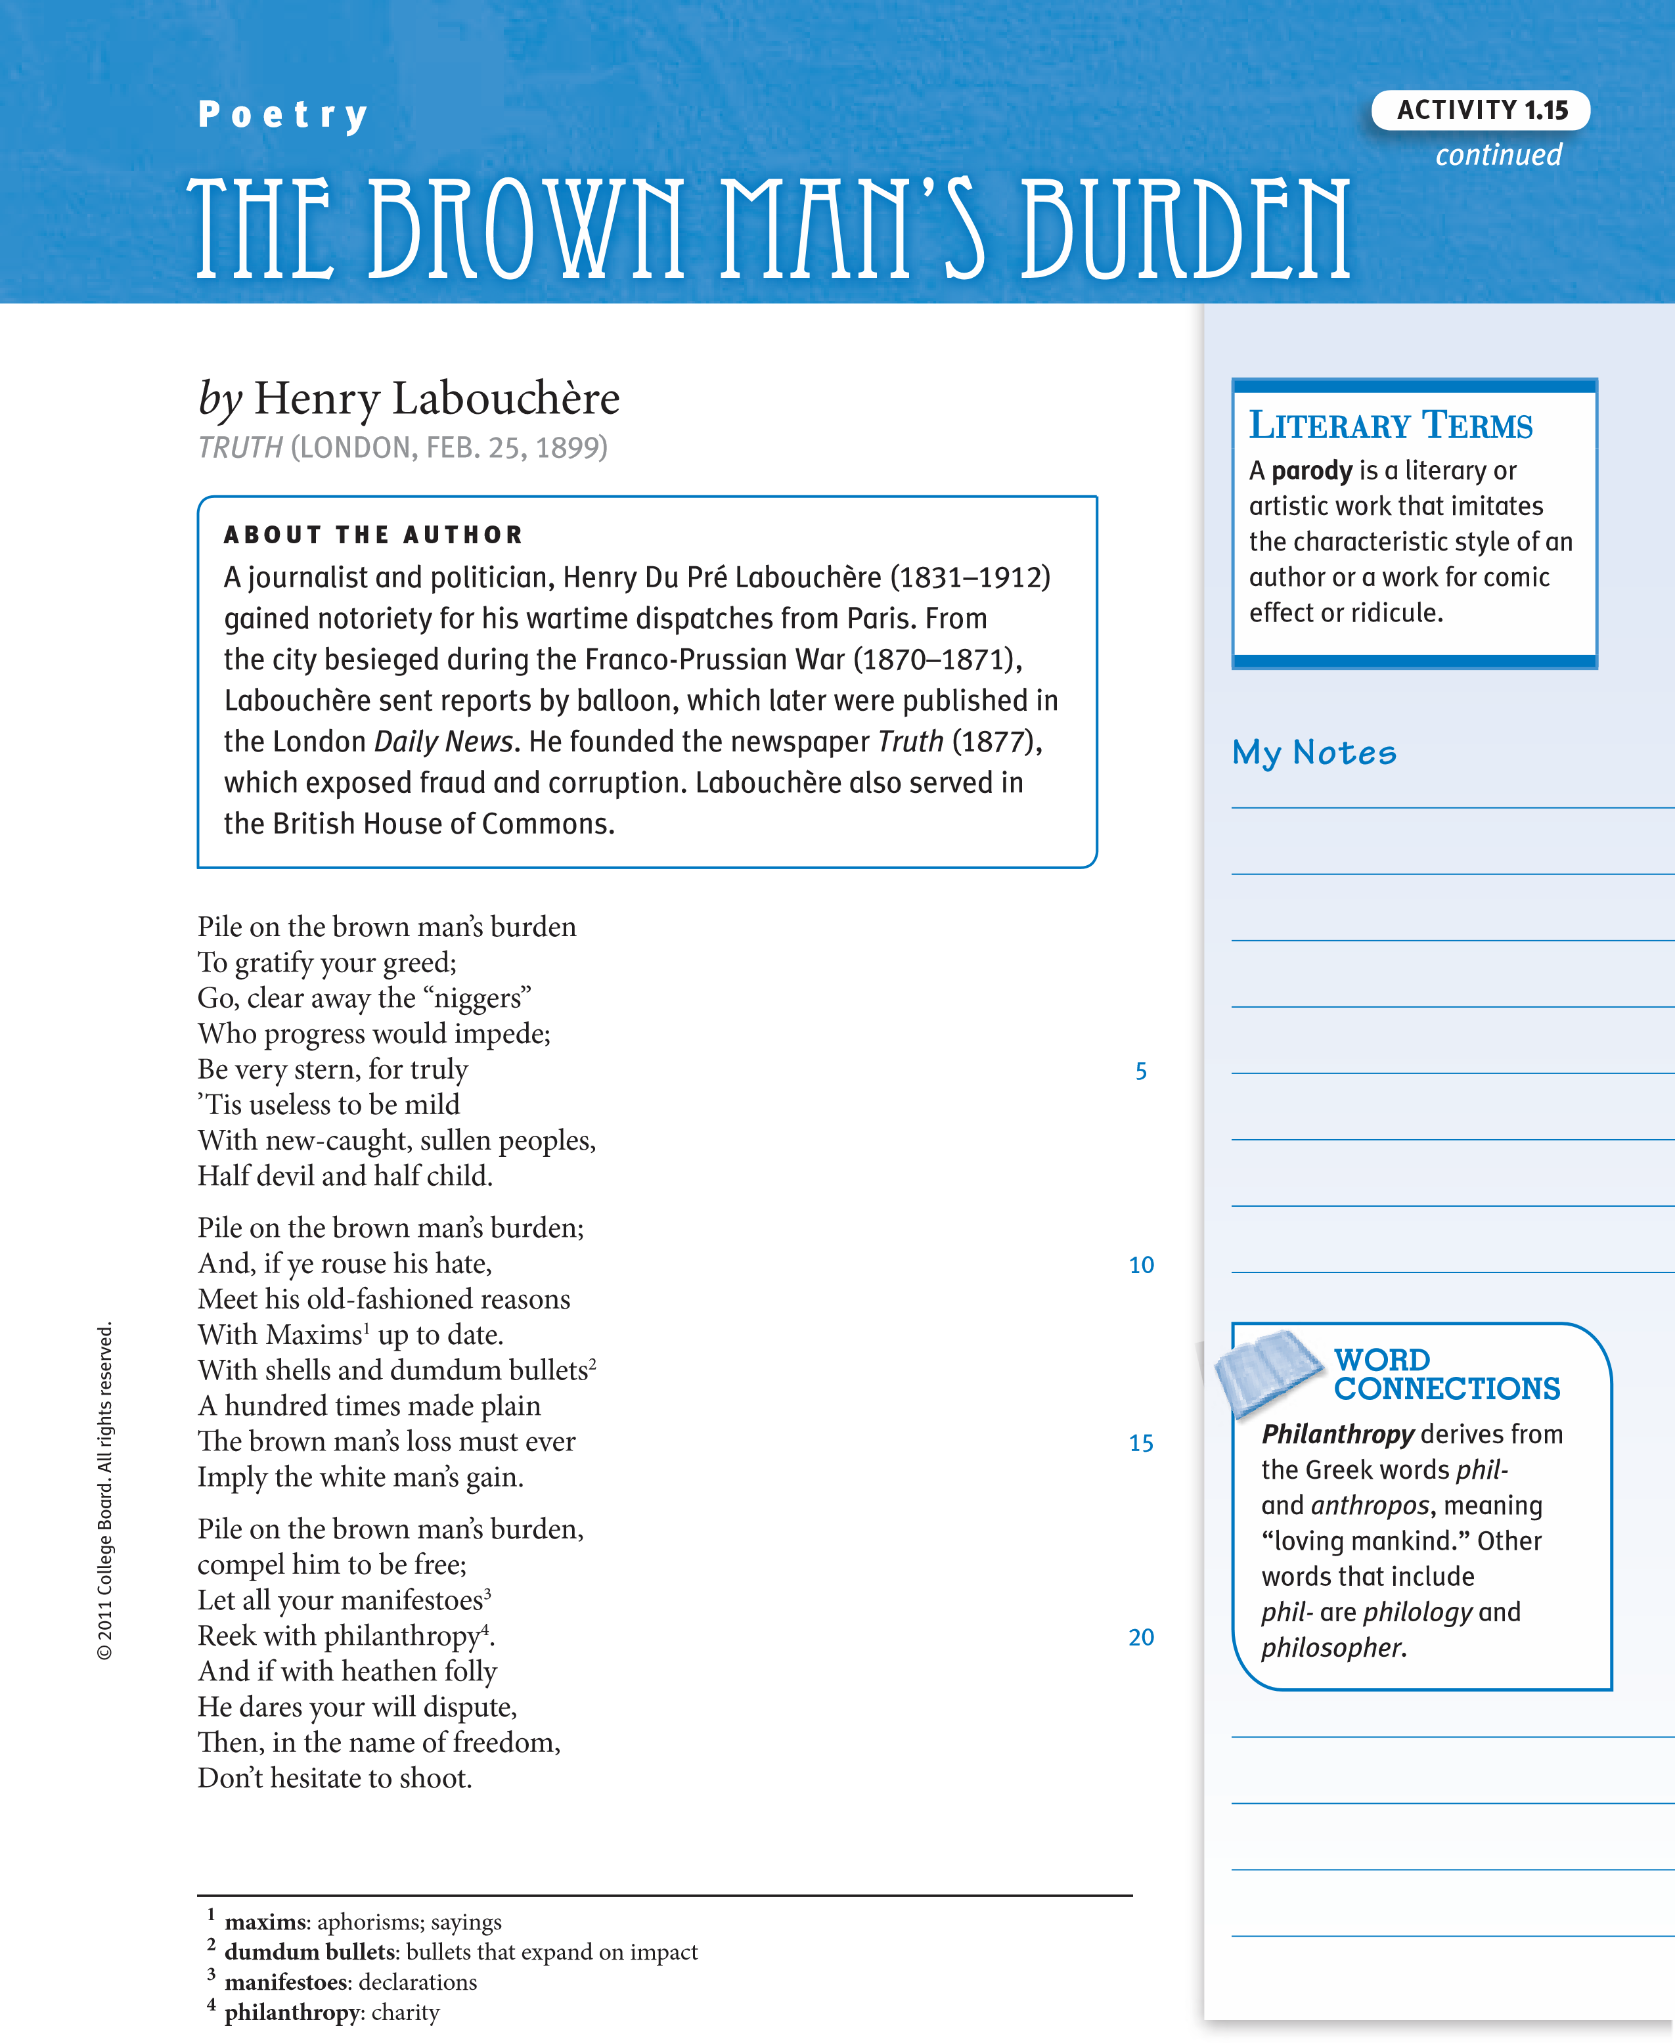
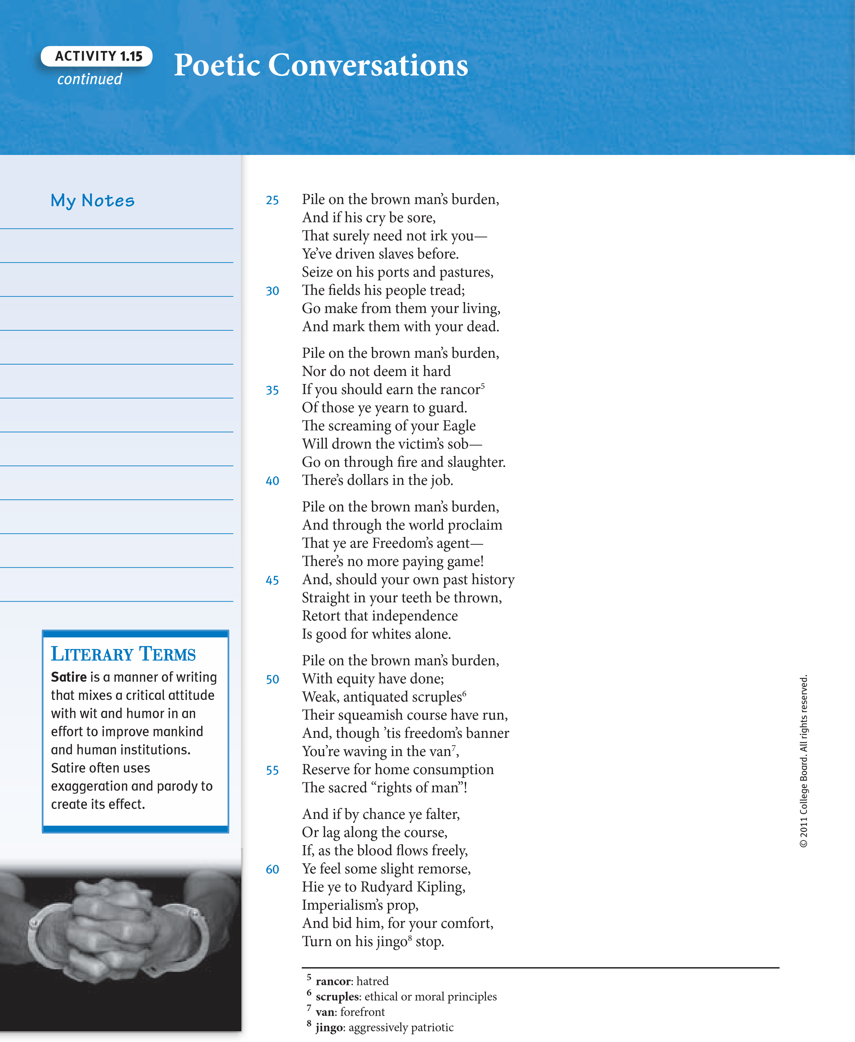

Questions for Consideration in Socratic Seminars
- in what ways does the speaker in Kipling’s poem affirm or refute the concepts of “colonialism” and “imperialism”? Who is his audience?
- Why is the speaker’s attitude in Labouchère’s poem so different from the speaker’s attitude in Kipling’s poem?
- in what ways does Labouchère’s poem respond to Kipling’s poem? How is satire an effective weapon against the self-righteous imperialism of “The White Man’s Burden”?
- What understanding of these poems emerges as you apply the perspective of Cultural Criticism? Who is dominant, and who is marginalized or subordinated?
Activity
1.15
continued
© 2011 College Board.
a
ll rights reserved.
- What new insights about these poems emerge as you apply reader response Theory?
Other Questions for Socratic Seminar:
Writing Prompt: Choose one of the poems and write about how the Cultural Criticism perspective adds to a broader understanding of the writer’s intended or perhaps unintended impact of his poem. Be sure to use a variety of grammatical structures and sentence types and lengths in your response.
Activity
1.16
SUGGESTED LEarninG STraTEGiES:
KWHL chart, think-Pair-Share,
Generating Questions
imperialism
Know
Want to Know
How i Will Learn it
Learning…
A Deeper Understanding

of Imperialism
© 2011 College Board.
a
ll rights reserved.
My Notes
Activity
1.16
continued
Song
by
James Thomson and Thomas

Augustine Arne
When Britain first at Heav’n’s command,
Arose from out the azure main,
Arose, arose, arose from out the azure main
1
,
This was the charter,
The charter of the land,
And guardian angels sang this strain:
(
Chorus
)
Rule, Britannia! Britannia, rule the waves!
Britons never, never, never shall be slaves.
The nations not so blessed as thee,
Must in their turn, to tyrants fall,
Must in their turn, to tyrants fall,
While thou shalt flourish, shalt flourish great and free,
The dread and envy of them all.
)
Chorus
(
Still more majestic shalt thou rise,
More dreadful from each foreign stroke,
More dreadful from each foreign stroke,
As the loud blast that, loud blast that tears the skies,
Serves but to root thy native oak.
)
Chorus
(
Questions for Consideration

.
1
What does this song reveal about the attitude of the British toward
Britain and the rest of the world when the song was chosen as the
national anthem?

.
2
How might someone who came from one of the countries colonized
by Britain view these lyrics?
5
10
15

1
azure main
blue ocean
:
© 2011 College Board.
a
ll rights reserved.

Life experiences often have a significant influence on a writer’s ideas and perception of events. in the next activity, you will be studying George Orwell’s essay, “Shooting an Elephant.” You will examine the essay from a Cultural Criticism lens in relation to the topic of imperialism. To prepare for that reading, it will be helpful to consider the title of the essay and a few details about the writer’s life.

Details about Orwell’s Life
- George Orwell (1903–1950), British citizen, was born in colonial india but educated in England.
- He served with the imperial Police in Burma.
- He became a journalist.
- He was admired for conveying the truth about political events around the world.

Questions
- How does Orwell’s experience appear to relate to the topic of imperialism?
Activity
1.16
continued
PREVIEWING AND CONNECTING

r Und
A
D
e
e
p
e
e
rst
a
ndin
g

e
ri
a
lism
of Imp
- Based upon what you know, including the title of the essay, what do you think Orwell’s point of view would be—affirming imperialism or refuting it?
© 2011 College Board.
a
ll rights reserved.
- What would you like to discover as you read the essay?
Activity

Reading with a Cultural Criticism Lens 1.17
SUGGESTED LEARnInG STRATEGIES: Marking the text, Skimming/
Scanning, Diffusing, think-Pair-Share, Questioning the text

Organizational Structure of a Reflective Essay
You are about to read George Orwell’s “Shooting an Elephant,” a reflective essay. Most reflective essays are structured in similar ways, including three parts that are threaded throughout the piece.
Event or incident: The author describes some incident or set of circumstances.
Response: The author describes his or her feelings and thoughts concerning the encounter. This response describes initial reactions without the benefit of reflection.
Reflection: The author reflects on the incident. This reflection usually occurs some time after the event or incident. In the reflection, the author will often transition from describing a situation unique to him or her to a discussion more universal in nature.
As you read this essay, use a highlighter to identify the various parts (Event, Response, Reflection) of Orwell’s reflective essay that you have been assigned to track.
Response
Reflective

Essay
Event
Reflection
© 2011 College Board. All rights reserved.

R e f l e c t i v e E s s a y
A b O u t t h E A u t h O R
George Orwell (1903–1950) was born Eric Blair in what was then British India, where his father was a government official. After an education in England, Orwell himself worked in the Indian Imperial Police, though he retired at the age of 24 to turn his hand to writing. Throughout his career, Orwell wrote under his pen name about the poor and working classes in Asia, England, and France. Working for the BBC during and after WWII, he wrote his two most famous works: Animal Farm, a satire of collectivism, and 1984, a stinging critique of totalitarianism. Orwell, who famously said, “Good prose is like a window pane,” is considered one of the most influential stylists of the twentieth century. He wrote extensively on the art of prose, which he considered a powerful political tool.
My Notes

by George Orwell
© 2011 College Board. All rights reserved.
Chunk 1 In Moulmein, in lower Burma, I was hated by large numbers of
- people—the only time in my life that I have been important enough for this to happen to me. I was subdivisional police officer of the town, and in an aimless, petty kind of way an anti-European feeling was very bitter. No one had the guts to raise a riot, but if a European woman went through the bazaars alone somebody would probably spit betel juice over her dress. As a police officer I was an obvious target and was baited whenever it seemed safe to do so. When a nimble Burman tripped me up on the football field and the referee (another Burman) looked the other way, the crowd yelled with hideous laughter. This happened more than once. In the end the sneering yellow faces of young men that met me everywhere, the insults hooted after me when I was at a safe distance, got badly on my nerves. The young Buddhist priests were the worst of all. There were several thousands of them in the town and none of them seemed to have anything to do except stand on street corners and jeer at Europeans.

- All this was perplexing and upsetting. For at that time I had already made up my mind that imperialism was an evil thing and the sooner I chucked up my job and got out of it the better. Theoretically—and secretly, of course—I was all for the Burmese and all against their oppressors, the British. As for the job I was doing, I hated it more bitterly than I can perhaps make clear. In a job like that you see the dirty work of Empire at close quarters. The wretched prisoners huddling in the stinking cages of the lockups, the gray, cowed faces of the long-term convicts, the scarred buttocks of men who had been flogged³ with bamboos—all these oppressed me with an intolerable sense of guilt. But I could get nothing into perspective. I was young and ill-educated and I had to think out my problems in the utter silence that is imposed on every Englishman in the East. I did not know that the British Empire is dying, still less did I know that it is a great deal better than the younger empires that are going to supplant it. All I knew was that I was stuck between my hatred of the empire I served and my rage against the evilspirited little beasts who tried to make my job impossible. With one part of my mind I thought of the British Raj as an unbreakable tyranny, as something clamped down, in saecula saeculorum, upon the will of prostrate⁶ peoples; with another part I thought that the greatest joy in the world would be to drive a bayonet into a Buddhist priest’s guts. Feelings like these are the normal by-product of imperialism; ask any AngloIndian official, if you can catch him off duty.
My Notes
W
ord

ConneCtions
Orwell uses the words
close quarters
to mean
very near. Among other
meanings of
quarters
are
coins, four parts, living
space, or a part of a
year. Research this word
to identify additional
meanings.
- One day something happened which in a roundabout way was Chunk enlightening. It was a tiny incident in itself, but it gave me a better ² glimpse than I had had before of the real nature of imperialism—the real motives for which despotic governments act. Early one morning the subinspector at a police station the other end of the town rang me up on the phone and said that an elephant was ravaging the bazaar. Would I please come and do something about it? I did not know what I could do, but I wanted to see what was happening and I got onto a pony and started out. I took my rifle, an old .44 Winchester and much too small to kill an elephant, but I thought the noise might be useful in terrorem. Various Burmans stopped me on the way and told me about the elephant’s doings.
© 2011 College Board. All rights reserved.
It was not, of course, a wild elephant, but a tame one which had gone “must.” It had been chained up, as tame elephants always are when their attack of “must” is due, but on the previous night it had broken its chain My Notes and escaped. Its mahout, the only person who could manage it when it
was in that state, had set out in pursuit, but had taken the wrong direction and was now twelve hours’ journey away, and in the morning the elephant had suddenly reappeared in the town. The Burmese population had no weapons and were quite helpless against it. It had already destroyed somebody’s bamboo hut, killed a cow and raided some fruit stalls and devoured the stock; also it had met the municipal rubbish van and, when the driver jumped out and took to his heels, had turned the van over and inflicted violences upon it.
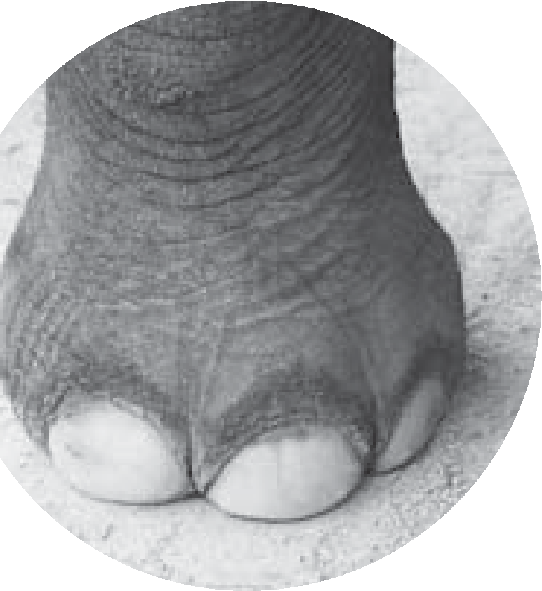
- The Burmese subinspector and some Indian constables were waiting for me in the quarter where the elephant had been seen. It was a very poor quarter, a labyrinth of squalid huts, thatched with palm leaf, winding all over a steep hillside. I remember it was a cloudy, stuffy morning at the beginning of the rains. We began questioning the people where the elephant had gone and, as usual, failed to get any definite information. That is invariably the case in the East; a story always sounds clear enough at a distance, but the nearer you get to the scene of events the vaguer it becomes. Some of the people said that the elephant had gone in one direction, some said that it had gone in another, some professed not even to have heard of any elephant. I had made up my mind that the whole story was a pack of lies, when I heard yells a little distance away. There was a loud, scandalized cry of “Go away, child! Go away this instant!” and an old woman with a switch in her hand came round the corner of a hut, violently shooing away a crowd of naked children. Some more women followed, clicking their tongues and exclaiming; evidently there was something the children ought not to have seen. I rounded the hut and saw a man’s dead body sprawling in the mud. He was an Indian, a black Dravidian coolie¹¹, almost naked, and he could not have been dead many minutes. The people said that the elephant had come suddenly upon him round the corner of the hut, caught him with its trunk, put its foot on his back, and ground him into the earth. This was the rainy season and the ground was soft, and his face had scored a trench a foot deep and a couple of yards long. He was lying on his belly with arms crucified and head sharply twisted to one side. His face was coated with mud, the eyes wide open, the teeth bared and grinning with an unendurable agony. (Never tell me, by the way, that the dead look peaceful. Most of the corpses I have seen looked devilish.) The friction of the great beast’s foot had stripped the skin from his back as neatly as one skins a rabbit. As soon as I saw the dead man I sent an orderly to a friend’s house nearby to borrow an elephant rifle. I had already sent back the pony, not wanting it to go mad with fright and throw me if it smelt the elephant.
© 2011 College Board. All rights reserved.
- The orderly came back in a few minutes with a rifle and five Chunk cartridges, and meanwhile some Burmans had arrived and told us ³ that the elephant was in the paddy fields below, only a few hundred yards away. As I started forward practically the whole population of the quarter flocked out of the houses and followed me. They had seen the rifle and were all shouting excitedly that I was going to shoot the elephant. They had not shown much interest in the elephant when he was merely ravaging their homes, but it was different now that he was going to be shot. It was a bit of fun to them, as it would be to an English crowd; besides they wanted the meat. It made me vaguely uneasy. I had no intention of shooting the elephant—I had merely sent for the rifle to defend myself if necessary—and it is always unnerving to have a crowd following you. I marched down the hill, looking and feeling a fool, with the rifle over my shoulder and an ever growing army of people jostling at my heels. At the bottom, when you got away from the huts, there was a metaled road and beyond that a miry waste of paddy fields a thousand yards across, not yet plowed but soggy from the first rains and dotted with coarse grass. The elephant was standing eight yards from the road, his left side toward us. He took not the slightest notice of the crowd’s approach. He was tearing up bunches of grass, beating them against his knees to clean them, and stuffing them into his mouth.
My Notes
Verbals are verbs that are
used as another part of
speech. In English, two
verbals—
gerunds
and
participles
—are formed
by adding
–ing
to the
base form of the verb.
Gerunds acts as nouns,
and participles act as
adjectives. The title of
this essay, “Shooting an
Elephant,” is a gerund
phrase; all three words
act together as a noun.
When Orwell writes of
the “growing army,” he
is using the participle
“growing” to modify a
noun. When he describes
himself as “looking and
feeling a fool,” he is
using a participial phrase.
Writers use verbals and
verbal phrases to add
action, as well as precise
detail, to their writing.
&
Grammar UsaGe
- I had halted on the road. As soon as I saw the elephant I knew with perfect certainty that I ought not to shoot him. It is a serious matter to shoot a working elephant—it is comparable to destroying a huge and costly piece of machinery—and obviously one ought not to do it if it can possibly be avoided. And at that distance, peacefully eating, the elephant looked no more dangerous than a cow. I thought then and I think now that his attack of “must” was already passing off; in which case he would merely wander harmlessly about until the mahout came back and caught him. Moreover, I did not want in the least to shoot him. I decided that I would watch him a little while to make sure that he did not turn savage again, and then go home.
© 2011 College Board. All rights reserved.
- But at that moment I glanced round at the crowd that had followed Chunk me. It was an immense crowd, two thousand at the least and growing ⁴ every minute. It blocked the road for a long distance on either side. I looked at the sea of yellow faces above the garish clothes—faces all happy and excited over this bit of fun, all certain that the elephant was going to be shot. They were watching me as they would watch a conjurer about to perform a trick. They did not like me, but with the magical rifle in my hand I was momentarily worth watching. And suddenly I realized that I would have to shoot the elephant after all. The people expected it of me and I had got to do it; I could feel their two thousand wills
pressing me forward irresistibly. And it was at this moment, as I stood there with the rifle in my hands, that I first grasped the hollowness, the futility of the white man’s dominion in the East. Here was I, the white man with his gun, standing in front of the unarmed crowd—seemingly the leading actor of the piece; but in reality I was only an absurd puppet pushed to and fro by the will of those yellow faces behind. I perceived in this moment that when the white man turns tyrant it is his own freedom that he destroys. He becomes a sort of hollow, posing dummy, the conventionalized figure of a sahib. For it is the condition of his rule that he shall spend his life in trying to “impress the natives,” and so in every crisis he has got to do what the “natives” expect of him. He wears a mask, and his face grows to fit it. I had got to shoot the elephant. I had committed myself to doing it when I sent for the rifle. A sahib has got to act like a sahib; he has got to appear resolute, to know his own mind and do definite things. To come all that way, rifle in hand, with two thousand people marching at my heels, and then to trail feebly away, having done nothing—no, that was impossible. The crowd would laugh at me. And my whole life, every white man’s in the East, was one long struggle not to be laughed at.
- But I did not want to shoot the elephant. I watched him beating his bunch of grass against his knees, with that preoccupied grandmotherly air that elephants have. It seemed to me that it would be murder to shoot him. At that age I was not squeamish about killing animals, but I had never shot an elephant and never wanted to. (Somehow it always seems worse to kill a large animal.) Besides, there was the beast’s owner to be considered. Alive, the elephant was worth at least a hundred pounds; dead, he would only be worth the value of his tusks, five pounds, possibly. But I had got to act quickly. I turned to the experienced-looking Burmans who had been there when we arrived, and asked them how the elephant had been behaving. They all said the same thing; he took no notice of you if you left him alone, but he might charge if you went too close to him.
Chunk
5
My Notes
© 2011 College Board. All rights reserved.
- It was perfectly clear to me what I ought to do. I ought to walk up to within, say, twenty-five yards of the elephant and test his behavior. If he charged I could shoot; if he took no notice of me, it would be safe to leave him until the mahout came back. But I also knew that I was going to do no such thing. I was a poor shot with a rifle and the ground was soft mud into which one would sink at every step. If the elephant charged and I missed him, I should have about as much chance as a toad under a steam roller. But even then I was not thinking particularly of my own skin, only of the watchful yellow faces behind. For at that moment, with the crowd watching me, I was not afraid in the ordinary sense, as I would have been if I had been alone. A white man mustn’t be frightened in front of “natives”; and so, in general, he isn’t frightened. The thought in my mind was that if anything went wrong those two thousand Burmans would see me pursued, caught, trampled on, and reduced to a grinning corpse like that Indian up the hill. And if that happened it was quite probable that some of them would laugh. That would never do.
- There was only one alternative. I shoved the cartridges into the magazine and lay down on the road to get a better aim. The crowd grew very still, and a deep, low, happy sigh, as of people who see the theater curtain go up at last, breathed from innumerable throats. They were going to have their bit of fun after all. The rifle was a beautiful German thing with cross-hair sights. I did not know then that in shooting an elephant one would shoot to cut an imaginary bar running from earhole to earhole. I ought, therefore, as the elephant was sideways on, to have aimed straight at his earhole; actually I aimed several inches in front of this, thinking the brain would be further forward.
- When I pulled the trigger I did not hear the bang or feel the kick—one never does when a shot goes home—but I heard the devilish roar of glee that went up from the crowd. In that instant, in too short a time, one would have thought, even for the bullet to get there, a mysterious, terrible change had come over the elephant. He neither stirred nor fell, but every line of his body had altered. He looked suddenly stricken, shrunken, immensely old, as though the frightful impact of the bullet had paralyzed him without knocking him down. At last, after what seemed a long time—it might have been five seconds, I dare say—he sagged flabbily to his knees. His mouth slobbered. An enormous senility seemed to have settled upon him. One could have imagined him thousands of years old. I fired again into the same spot. At the second shot he did not collapse but climbed with desperate slowness to his feet and stood weakly erect, with legs sagging and head drooping. I fired a third time. That was the shot that did for him. You could see the agony of it jolt his whole body and knock the last remnant of strength from his legs. But in falling he seemed for a moment to rise, for as his hind legs collapsed beneath him he seemed to tower upward like a huge rock toppling, his trunk reaching skywards like a tree. He trumpeted for the first and only time. And then down he came, his belly toward me, with a crash that seemed to shake the ground even where I lay.
Chunk
6
My Notes
© 2011 College Board. All rights reserved.

Activity 1.17 Reading with a Cultural Criticism Lens
continued
My Notes 12 I got up. The Burmans were already racing past me across the mud.
It was obvious that the elephant would never rise again, but he was not dead. He was breathing very rhythmically with long rattling gasps, his great mound of a side painfully rising and falling. His mouth was wide open—I could see far down into caverns of pink throat. I waited a long time for him to die, but his breathing did not weaken. Finally I fired my two remaining shots into the spot where I thought his heart must be. The thick blood welled out of him like red velvet, but still he did not die. His body did not even jerk when the shots hit him, the tortured breathing continued without a pause. He was dying, very slowly and in great agony, but in some world remote from me where not even a bullet could damage him further. I felt that I had got to put an end to that dreadful noise. It seemed dreadful to see the great beast lying there, powerless to move and yet powerless to die, and not even to be able to finish him. I sent back for my small rifle and poured shot after shot into his heart and down his throat. They seemed to make no impression. The tortured gasps continued as steadily as the ticking of a clock.
© 2011 College Board. All rights reserved.
Chunk 13 In the end I could not stand it any longer and went away. I heard
⁷ later that it took him half an hour to die. Burmans were bringing dahs and baskets even before I left, and I was told they had stripped his body almost to the bones by afternoon.
14 Afterwards, of course, there were endless discussions about the shooting of the elephant. The owner was furious, but he was only an Indian and could do nothing. Besides, legally I had done the right thing, for a mad elephant has to be killed, like a mad dog, if its owner fails to control it. Among the Europeans, opinion was divided. The older men said I was right, the younger men said it was a shame to shoot an elephant for killing a coolie, because an elephant was worth more than any Coringhee coolie. And afterwards I was very glad that the coolie had been killed; it put me legally in the right and gave me a sufficient pretext for shooting the elephant. I often wondered whether any of the others grasped that I had done it solely to avoid looking a fool.
Activity
1.18
Stranger in the village

1

Brainstorm connotative words for “village.”

2

What does it mean to be part of the group
encountering the unfamiliar—to be part of the
village?

3

Brainstorm connotative words for “stranger.”

4

What does it mean to be the unfamiliar one,
the stranger?

5

View the film clip and consider what the
filmmaker does to set the “stranger” apart
from the “village.”

6

Brainstorm a list of film clips with which you
are familiar and for each one discuss: Who
is the “stranger” and who or what is the
“village”?

7

What does it mean to be a stranger in the village?
SUGGESTED LEarninG STraTEGiES:
think-Pair-Share, Graphic
Organizer, Brainstorming
Being a Stranger
© 2011 College Board.
a
ll rights reserved.
Writing Prompt: Think about a time when you were excluded or treated like a stranger. What were your feelings at the time? How did you respond? In what ways did that event shape or change you as an individual? Write an essay in which you examine a time when you were treated like a stranger, explain how you felt at that time, and reflect on the ways in which that event has shaped your life. Begin working on your essay with the activities outlined below.
Webbing to Generate ideas In the space below, create a web of circles, each containing a key word or concept related to the topic and the questions above.
Activity
1.19
SUGGESTED LEArnInG STrATEGIES:
think-Pair-Share, Marking

the text
Two Di
ff
e
r
e
nt Worlds
© 2011 College Board. All rights reserved.
Writing your First Draft On your own paper, write a draft paper in response to the prompt above. Use the information in your web to help you organize your paper.
Reading About a Stranger in a village After completing your first draft, read the following excerpt from The Joy Luck Club.

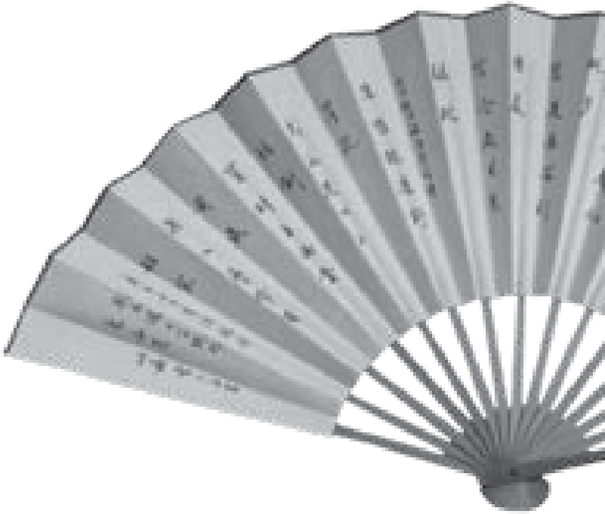
N o v e l
by
Amy Tan
from
The Joy Luck Club
A b o u t t h e A u t h o r
Born in 1952 in Oakland, California, Amy Tan is author
of several critically acclaimed novels like
The Kitchen
God’s Wife
and
The Bonesetter’s Daughter
, as well as
short stories and children’s books. Her first novel,
The
Joy Luck
Club (1989), was an international best-seller
that became an award-winning film. Tan says her first
important piece of writing, however, was a letter she
wrote in the third grade to raise money for a local library.
Tan’s fiction often deals with tensions between Chinese
immigrants and their Americanized children. Praised for
her lucid images and gripping storylines, she believes her
first career as a business writer helped her develop her
simple yet forceful style.
My Notes
Activity
1.19
continued
My daughter wanted to go to China for her second honeymoon, but now
she is afraid.
“What if I blend in so well they think I’m one of them?” Waverly asked
me. “What if they don’t let me come back to the United States?”
“When you go to China,” I told her, “you don’t even need to open your

mouth. They already know you are an outsider.”
“What are you talking about?” she asked. My daughter likes to speak
back. She likes to question what I say.
“Aii-ya,” I said. “Even if you put on their clothes, even if you take off y
our
makeup and hide your fancy jewelry, they know. They know just watching
the
way you walk, the way you carry your face. They know you do not belong.”
My daughter did not look pleased when I told her this, that she didn’t
look Chinese. She had a sour American look on her face. Oh, maybe ten y
ears
ago, she would have clapped her hands—hurray! as if this were good news.

But now she wants to be Chinese, it is so fashionable. And I know it is too
late. All those years I tried to teach her! She followed my Chinese ways onl
y
until she learned how to walk out the door by herself and go to school.

© 2011 College Board. All rights reserved.

Activity continued1.19 Two Different Worlds

My Notes

Grammar UsaGe&
notice the sentences on this page in which Tan uses direct quotations. Writers use direct quotations to develop characters, to further action, and to add life to their writing.
Direct quotations are always set off from the rest of the text with quotation marks. In addition, they may require other punctuation to convey meaning or to clearly distinguish what is quoted from what is not quoted.
Always start a new paragraph for each speaker. notice that the narrator has one paragraph for what she says and another paragraph for what her mother says.

So now the only Chinese words she can say are shsh, houche, chr fan, and gwan deng shweijyau. How can she talk to people in China with these words?
Pee-pee, choo-choo train, eat, close light sleep.
How can she think she can blend in? Only her skin and her hair are Chinese. Inside—she is all American-made.
It’s my fault she is this way. I wanted my children to have the best combination: American circumstances and Chinese character. How could I know these two things do not mix?
I taught her how American circumstances work. If you are born poor here, it’s no lasting shame. You are first in line for a scholarship. If the roof crashes on your head, no need to cry over this bad luck. You can sue anybody, make the landlord fix it. You do not have to sit like a Buddha under a tree letting pigeons drop their dirty business on your head. You can buy an umbrella. Or go inside a Catholic church. In America, nobody says you have to keep the circumstances somebody else gives you.
She learned these things, but I couldn’t teach her about Chinese character. How to obey parents and listen to your mother’s mind. How not to show your own thoughts, to put your feelings behind your face so you can take advantage of hidden opportunities. Why easy things are not worth pursuing. How to know your own worth and polish it, never flashing it around like a cheap ring. Why Chinese thinking is best.
No, this kind of thinking didn’t stick to her: She was too busy chewing gum, blowing bubbles bigger than her cheeks. Only that kind of thinking stuck.
“Finish your coffee,” I told her yesterday. “Don’t throw your blessings away.”
© 2011 College Board. All rights reserved.
“Don’t be so old-fashioned, Ma,” she told me, finishing her coffee down the sink. “I’m my own person.”
And I think, How can she be her own person? When did I give her up?
Revisiting your Draft: reread your initial draft on being a stranger, and identify an appropriate place to revise and add dialogue (e.g., to reveal something about your characters or advance the narrative). Be sure to adhere to the punctuation rules of dialogue.

Understanding the Stranger’s ^{Activity}

Perception of a Village ^{1.20}
SUGGESTED LEARNING STRATEGIES: Previewing, Diffusing, Skimming/ Scanning, Marking the text, think-Pair-Share, Metacognitive Markers

r e f l e c t i v e e s s a y My Notes
A b o u t t h e A u t h o r
James Baldwin (1924–1987) was born in Harlem, into a poor household headed by his rigid and demanding stepfather, a storefront preacher. Though he had planned to follow in his stepfather’s footsteps and had served as a junior minister, he eventually became disillusioned with Christianity and resolved to become a writer. His move to Paris in 1948 helped provide the critical distance he needed to write the autobiographical Notes of a Native Son and his first novel, Go Tell It on the Mountain— powerful works about the African American experience. After returning to the U.S., he became a leading literary voice for civil rights. While his unsparing view of race issues in the U.S. drew criticism from his African American and white peers alike, he is now viewed as one of the most significant U.S. writers of the twentieth century.
© 2011 College Board. All rights reserved.

by James Baldwin, 1955
- From all available evidence no black man had ever set foot in this Chunk tiny Swiss village before I came. I was told before arriving that I would ¹ probably be a “sight” for the village; I took this to mean that people of my complexion were rarely seen in Switzerland, and also that city people are always something of a “sight” outside of the city. It did not occur to me—possibly because I am an American—that there could be people anywhere who had never seen a Negro.
- It is a fact that cannot be explained on the basis of the inaccessibility Chunk of the village. The village is very high, but it is only four hours from Milan ² and three hours from Lausanne. It is true that it is virtually unknown. Few people making plans for a holiday would elect to come here. On the other hand, the villagers are able, presumably, to come and go as they

please—which they do: to another town at the foot of the mountain, with a population of approximately five thousand, the nearest place to see a movie or go to the bank. In the village there is no movie house, no bank, no library, no theater; very few radios, one jeep, one station wagon; and, at the moment, one typewriter, mine, an invention which the woman next door to me here had never seen. There are about six hundred people living here, all Catholic—I conclude this from the fact that the Catholic church is open all year round, whereas the Protestant chapel, set off on a hill a little removed from the village, is open only in the summertime when the tourists arrive. There are four or five hotels, all closed now, and four or five bistros, of which, however, only two do any business during the winter. These two do not do a great deal, for life in the village seems to end around nine or ten o’clock. There are a few stores, butcher, baker, epicerie, a hardware store, and a money-changer—who cannot change travelers’ checks, but must send them down to the bank, an operation which takes two or three days. There is something called the Ballet Haus, closed in the winter and used for God knows what, certainly not ballet, during the summer. There seems to be only one schoolhouse in the village, and this for the quite young children; I suppose this to mean that their older brothers and sisters at some point descend from these mountains in order to complete their education—possibly, again, to the town just below. The landscape is absolutely forbidding, mountains towering on all four sides, ice and snow as far as the eye can reach. In this white wilderness, men and women and children move all day, carrying washing, wood, buckets of milk or water, sometimes skiing on Sunday afternoons. All week long boys and young men are to be seen shoveling snow off the rooftops, or dragging wood down from the forest in sleds.
W
ord

ConneCtions
Baldwin uses an idiom
in paragraph 3: “to take
the waters,” meaning
to immerse oneself in
the water for potentially
healthful benefits.
My Notes
© 2011 College Board. All rights reserved.
- The village’s only real attraction, which explains the tourist season, is the hot spring water. A disquietingly high proportion of these tourists are cripples, or semi-cripples, who come year after year—from other parts of Switzerland, usually—to take the waters. This lends the village, at the height of the season, a rather terrifying air of sanctity, as though it were a lesser Lourdes. There is often something beautiful, there is always something awful, in the spectacle of a person who has lost one of his faculties, a faculty he never questioned until it was gone, and who struggles to recover it. Yet people remain people, on crutches or indeed on deathbeds; and wherever I passed, the first summer I was here, among the native villagers or among the lame, a wind passed with me—of astonishment, curiosity, amusement and outrage. That first summer I stayed two weeks and never intended to return. But I did return in the winter, to work; the village offers, obviously, no distractions whatever and has the further advantage of being extremely cheap. Now it is winter again, a year later, and I am here again. Everyone in the village knows my name, though they scarcely ever use it, knows that I come from America—though this, apparently, they will never really believe: black men come from Africa—and everyone knows that I am the friend of the son of a woman who was born here, and that I am staying in their chalet. But I remain as much a stranger today as I was the first day I arrived, and the children shout Neger!Neger! as I walk along the streets.
- It must be admitted that in the beginning I was far too shocked to Chunk have any real reaction. In so far as I reacted at all, I reacted by trying to ³ be pleasant—it being a great part of the American Negro’s education (long before he goes to school) that he must make people “like” him. This smile-and-the-world-smiles-with-you routine worked about as well in this situation as it had in the situation for which it was designed, which is to say that it did not work at all. No one, after all, can be liked whose human weight and complexity cannot be, or has not been, admitted. My smile was simply another unheard-of phenomenon which allowed them to see my teeth—they did not, really, see my smile and I began to think that, should I take to snarling, no one would notice any difference. All of the physical characteristics of the Negro which had caused me, in America, a very different and almost forgotten pain were nothing less than miraculous—or infernal—in the eyes of the village people. Some thought my hair was the color of tar, that it had the texture of wire, or the texture of cotton. It was jocularly suggested that I might let it all grow long and make myself a winter coat. If I sat in the sun for more than five minutes some daring creature was certain to come along and gingerly put his fingers on my hair, as though he were afraid of an electric shock, or put his hand on my hand, astonished that the color did not rub off. In all of this, in which it must be conceded there was the charm of genuine wonder and in which there was certainly no element of intentional unkindness, there was yet no suggestion that I was human: I was simply a living wonder.
My Notes
© 2011 College Board. All rights reserved.
- I knew that they did not mean to be unkind, and I know it now; it is necessary, nevertheless, for me to repeat this to myself each time that I walk out of the chalet. The children who shout Neger! have no way of knowing the echoes this sound raises in me. They are brimming with good humor and the more daring swell with pride when I stop to speak with them. Just the same, there are days when I cannot pause and smile, when I have no heart to play with them; when, indeed, I mutter sourly to myself, exactly as I muttered on the streets of a city these children have never seen, when I was no bigger than these children are now: Your motherwas a nigger. Joyce is right about history being a nightmare—but it may be the nightmare from which no one can awaken. People are trapped in history and history is trapped in them.
- There is a custom in the village—I am told it is repeated in many villages—of “buying” African natives for the purpose of converting them to Christianity. There stands in the church all year round a small box with a slot for money, decorated with a black figurine, and into this box the villagers drop their francs. During the carnaval which precedes Lent, two village children have their faces blackened—out of which bloodless darkness their blue eyes shine like ice—and fantastic horsehair wigs are placed on their blond heads; thus disguised, they solicit among the villagers for money for missionaries in Africa. Between the box in the church and blackened children, the village “bought” last year six or eight African natives. This was reported to me with pride by the wife of one of the bistro owners and I was careful to express astonishment and pleasure at the solicitude shown by the village for the souls of black folks. The bistro owner’s wife beamed with a pleasure far more genuine than my own and seemed to feel that I might now breathe more easily concerning the souls of at least six of my kinsmen.
Chunk 7 I tried not to think of these so lately baptized kinsmen, of the price
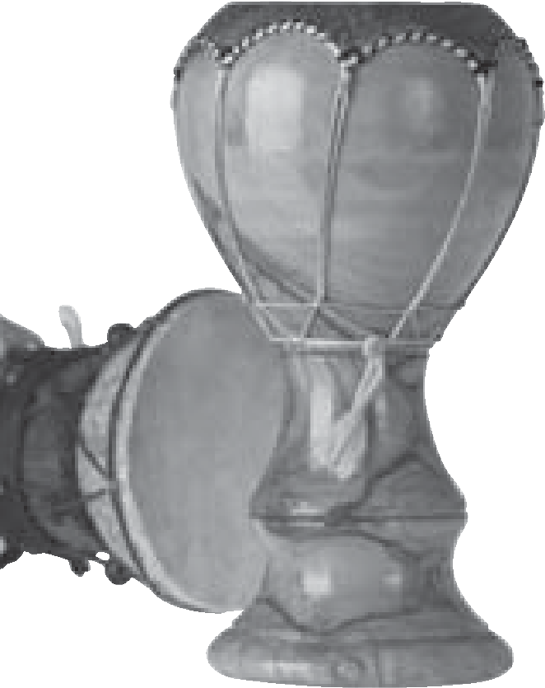
⁴ paid for them, or the peculiar price they themselves would pay, and said nothing about my father, who having taken his own conversion too literally never, at bottom, forgave the white world (which he described as heathen) for having saddled him with a Christ in whom, to judge at least from their treatment of him, they themselves no longer believed. I thought of white men arriving for the first time in an African village, strangers there, as I am a stranger here, and tried to imagine the astounded populace touching their hair and marveling at the color of their skin. But there is a great difference between being the first white man to be seen by Africans and being the first black man to be seen by whites. The white man takes the astonishment as tribute, for he arrives to conquer and to convert the natives, whose inferiority in relation to himself is not even to be questioned; whereas I, without a thought of conquest, find myself among a people whose culture controls me, has even, in a sense, created me, people who have cost me more in anguish and rage than they will ever know, who yet do not even know of my existence. The astonishment with which I might have greeted them, should they have stumbled into my African village a few hundred years ago, might have rejoiced their hearts. But the astonishment with which they greet me today can only poison mine.
My Notes
© 2011 College Board. All rights reserved.
- And this is so despite everything I may do to feel differently, despite my friendly conversations with the bistro owner’s wife, despite their three-year-old son who has at last become my friend, despite the saluts and bonsoirs which I exchange with people as I walk, despite the fact that I know that no individual can be taken to task for what history is doing, or has done. I say that the culture of these people controls me—but they can scarcely be held responsible for European culture. America comes out of Europe, but these people have never seen America, nor have most of them seen more of Europe than the hamlet at the foot of their mountain. Yet they move with an authority which I shall never have; and they regard me, quite rightly, not only as a stranger in their village but as a suspect latecomer, bearing no credentials, to everything they have—however unconsciously—inherited.
- For this village, even were it incomparably more remote and incredibly more primitive, is the West, the West onto which I have been so strangely grafted. These people cannot be, from the point of view of power, strangers anywhere in the world; they have made the modern world, in effect, even if they do not know it. The most illiterate among them is related, in a way that I am not, to Dante, Shakespeare, Michelangelo, Aeschylus, Da Vinci, Rembrandt, and Racine; the cathedral at Chartres says something to them which it cannot say to me, as indeed would New York’s Empire State Building, should anyone here ever see it. Out of their hymns and dances come Beethoven and Bach. Go back a few centuries and they are in their full glory—but I am in Africa, watching the conquerors arrive.
- The rage of the disesteemed is personally fruitless, but it is also Chunk absolutely inevitable: this rage, so generally discounted, so little ⁵ understood even among the people whose daily bread it is, is one of the things that makes history. Rage can only with difficulty, and never entirely, be brought under the domination of the intelligence and is therefore not susceptible to any arguments whatever. This is a fact which ordinary representatives of the Herrenvolk, having never felt this rage and being unable to imagine it, quite fail to understand. Also, rage cannot be hidden it can only be dissembled. This dissembling deludes the thoughtless, and strengthens rage and adds, to rage, contempt. There are, no doubt, as many ways of coping with the resulting complex of tensions as there are black men in the world, but no black man can hope ever to be entirely liberated from this internal warfare—rage, dissembling, and contempt having inevitably accompanied his first realization of the power of white men. What is crucial here is that, since white men represent in the black man’s world so heavy a weight, white men have for black men a reality which is far from being reciprocal; and hence all black men have toward all white men an attitude which is designed, really, either to rob the white man of the jewel of his naïveté or else to make it cost him dear.
W
ord

ConneCtions
In paragraph 10, look at
Baldwin’s use of the word
disesteemed
. Using the
prefix
dis-
adds a layer of
meaning that the prefix
un-

does not, although both
mean “not.”
My Notes
© 2011 College Board. All rights reserved.
- The black man insists, by whatever means he finds at his disposal, that the white man cease to regard him as an exotic rarity and recognize him as a human being. This is a very charged and difficult moment, for there is a great deal of will power involved in the white man’s naïveté. Most people are not naturally reflective any more than they are naturally malicious, and the white man prefers to keep the black man at a certain human remove because it is easier for him thus to preserve his simplicity and avoid being called to account for crimes committed by his forefathers, or his neighbors. He is inescapably aware, nevertheless, that he is in a better position in the world than black men are, nor can he quite put to death the suspicion that he is hated by black men therefore. He does not wish to be hated, neither does he wish to change places, and at this point in his uneasiness he can scarcely avoid having recourse to those legends which white men have created about black men, the most usual effect of which is that the white man finds himself enmeshed, so to speak, in his own language which describes hell, as well as the attributes which lead one to hell, as being as black as night.
- Every legend, moreover, contains its residuum of truth, and the root function of language is to control the universe by describing it. It is of quite considerable significance that black men remain, in the imagination, and in overwhelming numbers in fact, beyond the disciplines of salvation; and this despite the fact that the West has been “buying” African natives for centuries. There is, I should hazard¹⁰, an instantaneous necessity to be divorced from this so visibly unsaved stranger, in whose heart, moreover, one cannot guess what dreams of vengeance are being nourished; and, at the same time, there are few things on earth more attractive than the idea of the unspeakable liberty which is allowed the unredeemed. When, beneath the black mask, a human being begins to make himself felt one cannot escape a certain awful wonder as to what kind of human being it is. What one’s imagination makes of other people is dictated, of course, by the laws of one’s own personality and it is one of the ironies of black-white relations that, by means of what the white man imagines the black man to be, the black man is enabled to know who the white man is.
My Notes
Attribute
comes from the
Latin word
attribuere
,
which means “to assign.”
It is related to the word
tribute
, which comes from
the Latin word
tribuere,
which also means
“to
assign, allot, or pay.”
W
ord

ConneCtions
© 2011 College Board. All rights reserved.
- I have said, for example, that I am as much a stranger in this village today as I was the first summer I arrived, but this is not quite true. The villagers wonder less about the texture of my hair than they did then, and wonder rather more about me. And the fact that their wonder now exists on another level is reflected in their attitudes and in their eyes. There are the children who make those delightful, hilarious, sometimes astonishingly grave overtures of friendship in the unpredictable fashion of children; other children, having been taught that the devil is a black man, scream in genuine anguish as I approach. Some of the older women never pass without a friendly greeting, never pass, indeed, if it seems that they will be able to engage me in conversation; other women look down or look away or rather contemptuously smirk. Some of the men drink with me and suggest that I learn how to ski—partly, I gather, because they cannot imagine what I would look like on skis—and want to know if I am married, and ask questions about my mėtier¹¹. But some of the men have accused lesalenegre—behind my back—of stealing wood and there is already in the eyes of some of them the peculiar, intent, paranoiac malevolence which one sometimes surprises in the eyes of American white men when, out walking with their Sunday girl, they see a Negro male approach.
- There is a dreadful abyss between the streets of this village and the Chunk streets of the city in which I was born, between the children who shout ⁶ Neger! today and those who shouted Nigger! yesterday—the abyss is experience, the American experience. The syllable hurled behind me today expresses, above all, wonder: I am a stranger here. But I am not a stranger in America and the same syllable riding on the American air expresses the war my presence has occasioned in the American soul.
- For this village brings home to me this fact: that there was a day, and not really a very distant day, when Americans were scarcely Americans at all but discontented Europeans, facing a great unconquered continent and strolling, say, into a marketplace and seeing black men for the first time. The shock this spectacle afforded is suggested, surely, by the promptness with which they decided that these black men were not really men but cattle. It is true that the necessity on the part of the settlers of the New World of reconciling their moral assumptions with the fact—and the necessity—of slavery enhanced immensely the charm of this idea, and it is also true that this idea expresses, with a truly American bluntness, the attitude which to varying extents all masters have had toward all slaves. 16 But between all former slaves and slave-owners and the drama which Chunk begins for Americans over three hundred years ago at Jamestown, there ⁷ are at least two differences to be observed. The American Negro slave could not suppose, for one thing, as slaves in past epochs had supposed and often done, that he would ever be able to wrest the power from his master’s hands. This was a supposition¹² which the modern era, which was to bring about such vast changes in the aims and dimensions of power, put to death; it only begins, in unprecedented fashion, and with dreadful implications, to be resurrected today. But even had this supposition persisted with undiminished force, the American Negro slave could not have used it to lend his condition dignity, for the reason that this supposition rests on another: that the slave in exile yet remains related to his past, has some means—if only in memory—of revering and sustaining the forms of his former life, is able, in short, to maintain his identity.
My Notes
© 2011 College Board. All rights reserved.
17 This was not the case with the American Negro slave. He is unique among the black men of the world in that his past was taken from him, almost literally, at one blow. One wonders what on earth the first slave found to say to the first dark child he bore. I am told that there

- mėtier: profession
- supposition: belief
are Haitians able to trace their ancestry back to African kings, but any American Negro wishing to go back so far will find his journey through time abruptly arrested by the signature on the bill of sale which served as the entrance paper for his ancestor. At the time—to say nothing of the circumstances—of the enslavement of the captive black man who was to become the American Negro, there was not the remotest possibility that he would ever take power from his master’s hands. There was no reason to suppose that his situation would ever change, nor was there, shortly, anything to indicate that his situation had ever been different. It was his necessity, in the words of E. Franklin Frazier, to find a “motive for living under American culture or die.” The identity of the American Negro comes out of this extreme situation, and the evolution of this identity was a source of the most intolerable anxiety in the minds and the lives of his masters.
- For the history of the American Negro is unique also in this: that the question of his humanity, and of his rights therefore as a human being, became a burning one for several generations of Americans, so burning a question that it ultimately became one of those used to divide the nation. It is out of this argument that the venom of the epithet Nigger! is derived. It is an argument which Europe has never had, and hence Europe quite sincerely fails to understand how or why the argument arose in the first place, why its effects are so frequently disastrous and always so unpredictable, why it refuses until today to be entirely settled. Europe’s black possessions remained—and do remain—in Europe’s colonies, at which remove they represented no threat whatever to European identity. If they posed any problem at all for the European conscience, it was a problem which remained comfortingly abstract: in effect, the black man, asaman, did not exist for Europe. But in America, even as a slave, he was an inescapable part of the general social fabric and no American could escape having an attitude toward him. Americans attempt until today to make an abstraction of the Negro, but the very nature of these abstractions reveals the tremendous effects the presence of the Negro has had on the American character.
My Notes
© 2011 College Board. All rights reserved.
- When one considers the history of the Negro in America it is of the greatest importance to recognize that the moral beliefs of a person, or a people, are never really as tenuous as life—which is not moral—very often causes them to appear; these create for them a frame of reference and a necessary hope, the hope being that when life has done its worst they will be enabled to rise above themselves and to triumph over life. Life would scarcely be bearable if this hope did not exist. Again, even when the worst has been said, to betray a belief is not by any means to have put oneself beyond its power; the betrayal of a belief is not the same thing as ceasing to believe. If this were not so there would be no moral standards in the world at all. Yet one must also recognize that morality is based on ideas My Notes
and that all ideas are dangerous—dangerous because ideas can only lead to action and where the action leads no man can say. And dangerous in this respect: that confronted with the impossibility of remaining faithful to one’s beliefs, and the equal impossibility of becoming free of them, one can be driven to the most inhuman excesses. The ideas on which American beliefs are based are not, though Americans often seem to think so, ideas which originated in America. They came out of Europe. And the establishment of democracy on the American continent was scarcely as radical a break with the past as was the necessity, which Americans faced, of broadening this concept to include black men.
- This was, literally, a hard necessity. It was impossible, for one thing, for Americans to abandon their beliefs, not only because these beliefs alone seemed able to justify the sacrifices they had endured and the blood that they had spilled, but also because these beliefs afforded them their only bulwark against a moral chaos as absolute as the physical chaos of the continent it was their destiny to conquer. But in the situation in which Americans found themselves, these beliefs threatened an idea which, whether or not one likes to think so, is the very warp and woof of the heritage of the West, the idea of white supremacy.
- Americans have made themselves notorious by the shrillness and the brutality with which they have insisted on this idea, but they did not invent it; and it has escaped the world’s notice that those very excesses of which Americans have been guilty imply a certain, unprecedented uneasiness over the idea’s life and power, if not, indeed, the idea’s validity. The idea of white supremacy rests simply on the fact that white men are the creators of civilization (the present civilization, which is the only one that matters; all previous civilizations are simply “contributions” to our own) and are therefore civilization’s guardians and defenders. Thus it was impossible for Americans to accept the black man as one of themselves, for to do so was to jeopardize their status as white men. But not so to accept him was to deny his human reality, his human weight and complexity, and the strain of denying the overwhelmingly undeniable forced Americans into rationalizations so fantastic that they approached the pathological.
© 2011 College Board. All rights reserved.
- At the root of the American Negro problem is the necessity of the American white man to find a way of living with the Negro in order to be able to live with himself. And the history of this problem can be reduced to the means used by Americans—lynch law and law, segregation and legal acceptance, terrorization and concession—either to come to terms with this necessity, or to find a way around it, or (most usually) to find a way of doing both these things at once. The resulting spectacle,
at once foolish and dreadful, led someone to make the quite accurate observation that “the Negro-in-America is a form of insanity which overtakes white men.”
- In this long battle, a battle by no means finished, the unforeseeable effects of which will be felt by many future generations, the white man’s motive was the protection of his identity; the black man was motivated by the need to establish an identity. And despite the terrorization which the Negro in America endured and endures sporadically until today, despite the cruel and totally inescapable ambivalence of his status in his country, the battle for his identity has long ago been won. He is not a visitor to the West, but a citizen there, an American; as American as the Americans who despise him, the Americans who fear him, the Americans who love him—the Americans who became less than themselves, or rose to be greater than themselves by virtue of the fact that the challenge he represented was inescapable. He is perhaps the only black man in the world whose relationship to white men is more terrible, more subtle, and more meaningful than the relationship of bitter possessed to uncertain possessors. His survival depended, and his development depends, on his ability to turn his peculiar status in the Western world to his own advantage and, it may be, to the very great advantage of that world. It remains for him to fashion out of his experience that which will give him sustenance, and a voice. The cathedral at Chartres, I have said, says something to the people of this village which it cannot say to me; but it is important to understand that this cathedral says something to me which it cannot say to them. Perhaps they are struck by the power of the spires, the glory of the windows; but they have known God, after all, longer than I have known him, and in a different way, and I am terrified by the slippery bottomless well to be found in the crypt, down which heretics were hurled to death, and by the obscene, inescapable gargoyles jutting out of the stone and seeming to say that God and the devil can never be divorced. I doubt that the villagers think of the devil when they face a cathedral because they have never been identified with the devil. But I must accept the status which myth, if nothing else, gives me in the West before I can hope to change the myth.
My Notes
© 2011 College Board. All rights reserved.
- Yet, if the American Negro has arrived at his identity by virtue of the absoluteness of his estrangement from his past, American white men still nourish the illusion that there is some means of recovering the European innocence, of returning to a state in which black men do not exist. This is one of the greatest errors Americans can make. The identity they fought so hard to protect has, by virtue of that battle, undergone a change: Americans are as unlike any other white people in the world as it is possible to be. I do not think, for example, that it is too much to suggest that the American vision of the world—which allows so little reality, generally speaking, for any of the darker forces in human life, which tends until today to paint moral issues in glaring black and white—owes a great deal to the battle waged by Americans to maintain between themselves and black men a human separation which could not be bridged. It is only now beginning to be borne in on us—very faintly, it must be admitted, very slowly, and very much against our will—that this vision of the world is dangerously inaccurate, and perfectly useless. For it protects our moral high-mindedness at the terrible expense of weakening our grasp of reality. People who shut their eyes to reality simply invite their own destruction, and anyone who insists on remaining in a state of innocence long after that innocence is dead turns himself into a monster.
- The time has come to realize that the interracial drama acted out Chunk on the American continent has not only created a new black man, it has ⁸ created a new white man, too. No road whatever will lead Americans back to the simplicity of this European village where white men still have the luxury of looking on me as a stranger. I am not, really, a stranger any longer for any American alive. One of the things that distinguishes Americans from other people is that no other people has ever been so deeply involved in the lives of black men, and vice versa. This fact faced, with all its implications, it can be seen that the history of the American Negro problem is not merely shameful, it is also something of an achievement. For even when the worst has been said, it must also be added that the perpetual challenge posed by this problem was always, somehow, perpetually met. It is precisely this black-white experience which may prove of indispensable value to us in the world we face today.
My Notes
© 2011 College Board. All rights reserved.
This world is white no longer, and it will never be white again.

Writing a Reflective Essay
SUGGESTED LEARNING STRATEGIES: Brainstorming, Drafting, Self-Editing/Peer Editing
Your assignment is to write a reflective essay that illustrates an event in which you or someone you know felt like a “stranger in the village” or was perceived as “strange” by some group.
- Generate a list of events that capture the thematic concept of “stranger in the village” by considering a time in which you felt like an outsider, witnessed someone else who was made to feel like an outsider, and/or made someone else feel like an outsider. Select two or three events from your list to share with a partner, and explain how your event addresses the thematic concept.
- Select the strongest topic of interest to you and use a prewriting strategy to capture ideas and explore your memory of the event.
Embedded
Assessment 2
Assignment
Steps
Prewriting
Revising
© 2011 College Board. All rights reserved.
- Review the organizational structure of a reflective essay (e.g., event, response, and reflection) by revisiting the two literary examples presented in this unit—“Shooting an Elephant” and “Stranger in the Village.” Note the differences between them in terms of the recursive pattern of event, response, and reflection.
- Consider a structure that would work well for your event and create a graphic organizer to generate a rhetorical plan that expands ideas from your prewrite and organizes the information.
- Refine your rhetorical plan by considering your subject, purpose, target audience, and tone.
Drafting
- Use your rhetorical plan to generate a first draft that develops points within the preliminary organizational structure, addresses the thematic concept, and incorporates stylistic devices (e.g., voice, diction, detail, figurative language, syntax, etc.).
- Read through your draft and revise it for clarity, to achieve the rhetorical purpose outlined in the assignment, and to maintain a consistent tone appropriate for your audience.
- Use a strategy to refine ideas, improve organization (e.g., SOAPSTone, marking the text for elements of a reflective essay, annotation, etc.), and achieve consistency of tone within your text before you present it to your peers.
- In a small group, review the Scoring Guide criteria for this assignment. Share your draft and evaluate it using the scoring criteria as a guide for revision (e.g., organizational structure, thematic concept, stylistic techniques). Within your groups, solicit feedback for revision and brainstorm strategies to refine drafts presented.
- Evaluate the revision suggestions from your peers, and consider which ones you want to incorporate in your draft. Revise your essay accordingly, and share changes to your draft with your peers.
continued
Embedded
Assessment 2
© 2011 College Board. All rights reserved.
Publishing
- Compose a title for your piece by generating a list of possible titles stemming from ideas, topics, or words or phrases within your text. Review and rank your list. Select the most gripping title that captures the essence of your text.
- Reread your essay silently and edit it to correct errors in spelling, conventions, grammar, style, and/or formatting. Consult editing tools (spell-check, dictionary, thesaurus, style manual, grammar references, etc.) to create a technically sound text and publish a final draft.

Writing a Reflective Essay
continued
Embedded
Assessment 2
© 2011 College Board. All rights reserved.
ScoRing gUiDE
Scoring criteria | Exemplary | Proficient | Emerging
ideas | The reflective essay thoroughly demonstrates a perceptive understanding of the relationship between the chosen event and thematic concept.  Use of specific and well-chosen details yields incontrovertible support and creates an extraordinarily convincing text. | The reflective essay demonstrates a solid understanding of the relationship between the chosen event and thematic concept.  Use of specific details yields support and creates a convincing text. | The reflective essay demonstrates a superficial understanding of the relationship between the chosen event and thematic concept.  Details are underutilized and do little to create a convincing text.
organization | The essay’s effective organization aptly reinforces the writer’s ideas. Successful use of transitions enhances overall coherence and connects ideas smoothly and comfortably. | The essay’s clear organization supports the ideas. Transitions provide connection between ideas. | The essay’s lack of organization detracts from the ideas, making the essay difficult to follow. It may move too rapidly between ideas and may lack transitions.
Use of Language | Diction, syntax, and Diction, syntax, and Diction, syntax, and other other stylistic devices are other stylistic devices are stylistic devices are less notable and appropriate appropriate for the subject, effective for the subject, for the subject, purpose, purpose, and audience. purpose, and audience. and audience. Few errors Errors in standard writing Errors in standard writing in standard writing conventions, if present, are conventions seriously conventions are present.minor and do not interfere interfere with meaning. with meaning.
Evidence of Writing Process | The writing  demonstrates thoughtful planning,significant revision, and careful editing for grammar and conventions in preparing a publishable draft. | The writing demonstrates planning, revision, and editing for grammar and conventions in preparing a publishable draft. | The writing lacks evidence of planning, revision, and/or editing for grammar and conventions. The draft is not ready for publication.
ScoRing gUiDE
continued
Embedded
Assessment 2
© 2011 College Board. All rights reserved.
Scoring criteria | Exemplary | Proficient | Emerging
Additional criteria
Comments:
Thinking about concepts
- Using specific examples from this unit, respond to the Essential Questions:
  - H ow do writers and artists organize or construct text to convey meaning?
  - What does it mean to be a stranger in the village?
- Consider the new academic vocabulary from this unit (Reader Response criticism and cultural criticism). For each term, answer the following questions:
  - What was your understanding of the word prior to the unit?
  - How has your understanding of the word evolved throughout the unit?
  - How will you apply your understanding in the future?
1
Unit
Reflection
An important aspect of growing as a learner is to reflect on where you have
been, what you have accomplished, what helped you to learn, and how you will
apply your new knowledge in the future. Use the following questions to guide
your thinking and to identify evidence of your learning. Use separate notebook
paper.
© 2011 College Board. All rights reserved.
Thinking about connections
- Review the activities and products (artifacts) you created. Choose those that most reflect your growth or increase in understanding.
- For each artifact that you choose, record, respond, and reflect on your thinking and understanding, using the following questions as a guide:
  - What skill/knowledge does this artifact reflect, and how did you learn this skill/knowledge?
  - How did your understanding of the power of language expand through your engagement with this artifact?
  - How will you apply this skill or knowledge in the future?
- Create this reflection as Portfolio pages—one for each artifact you choose. Use the following model for your headings and commentary on questions.
Thinking About Thinking
Portfolio Entry
Concept:
Description of Artifact:
Commentary on Questions:

ectoplasms: spiritual energy associated with the formation of ghosts
perplexing: puzzling
quarters: range ³ flogged: beaten
supplant: replace
saecula saeculorum: forever and ever ⁶ prostrate: overpowered
in terrorem: in case of fright or terror
must: a condition of dangerous frenzy
mahout: the keeper and driver of an elephant
Dravidian: belonging to an ancient race in India ¹¹ coolie: servant
paddy fields: rice fields
conjurer: magician
sahib: native term for a European gentleman
dahs: bowls
bistro: French, for restaurant
epicerie: French, for grocery store
Lourdes: a place of Christian pilgrimage in France
jocularly: jokingly
Joyce: James Joyce, Irish author of Ulysses
Herrenvolk: German, for master race
dissembled: concealed
naïveté: innocence
residuum: something left over or remaining ¹⁰ hazard: presume
E. Franklin Frazier: American sociologist who studied race relations
bulwark: defense
warp and woof: foundation
heretics: nonbelievers

