Instructions to candidates
Do not open this examination paper until instructed to do so.
- Section A (& B not apply for this exam).
- Only answer one question.
- Question 1 or 2.
- Minimum is 300 words.
- 1 hour to finish this exam.
- Within itslearning (if not available further instructions will follow)
  - For alternative instructions (not on itslearning…Please make sure you that you include your name, period, and date when submitting a word document.
  - Save the document in the following format (classperiod1B or 2B or 4B). Lastname.Firstaneme.doc
    - Example 1A.Perez.Paul.doc - for first period student
    - 2B. Perez.Paul.doc - for 2nd period student…
  - Return as an attachment by end of the day on 10/08/20 to pablo.perez@stisd.net

Answer one question from this section. The question in this section is worth 25 points.
Core theme: Being human.
- Read the following article and develop your response as indicated below.
Grayson Perry is a famous British artist who is also a transvestite. This is an extract from an interview he had with two journalists.
Yet as a transvestite, challenging gender stereotypes is "front and centre" of everything he
(Grayson Perry) does. "You are thinking: 'I'm being compelled to dress up in the wrong clothes, so there must be something going on here'. I don't think it gives me any insight into being a woman but it makes me question masculinity•. He is convinced that traditional maleness as
it is popularly understood is now redundant - "the physical prowess, aggression, territorial aggrandizement, competitiveness", he says. "A lot of people are nostalgic for old-school masculinity. They think that you only have to peel off this veneer of civilization and men can be men and women can be women and it can all go back to normal. I want to say it won't be like that. You have to redefine masculinity to fit in with democracy. “
(Source: adapted from www.thetimes.co.uk (2016))
With explicit reference to the stimulus and your own knowledge, discuss a philosophical issue related to the question of what it means to be human.

Begin your response after this line.

- Look at the following picture and develop your response as indicted below.

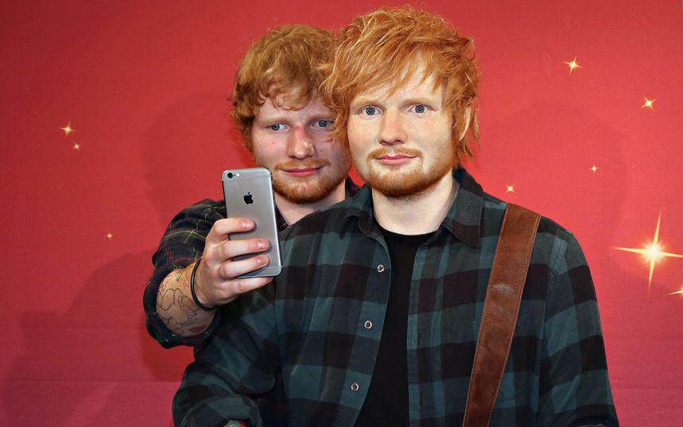

(Source www.scoopnest.com, accessed 10/07/20)

With explicit reference to the stimulus and your own knowledge, discuss a philosophical issue related to the question of what it means to be human.

Begin your response after this line.

