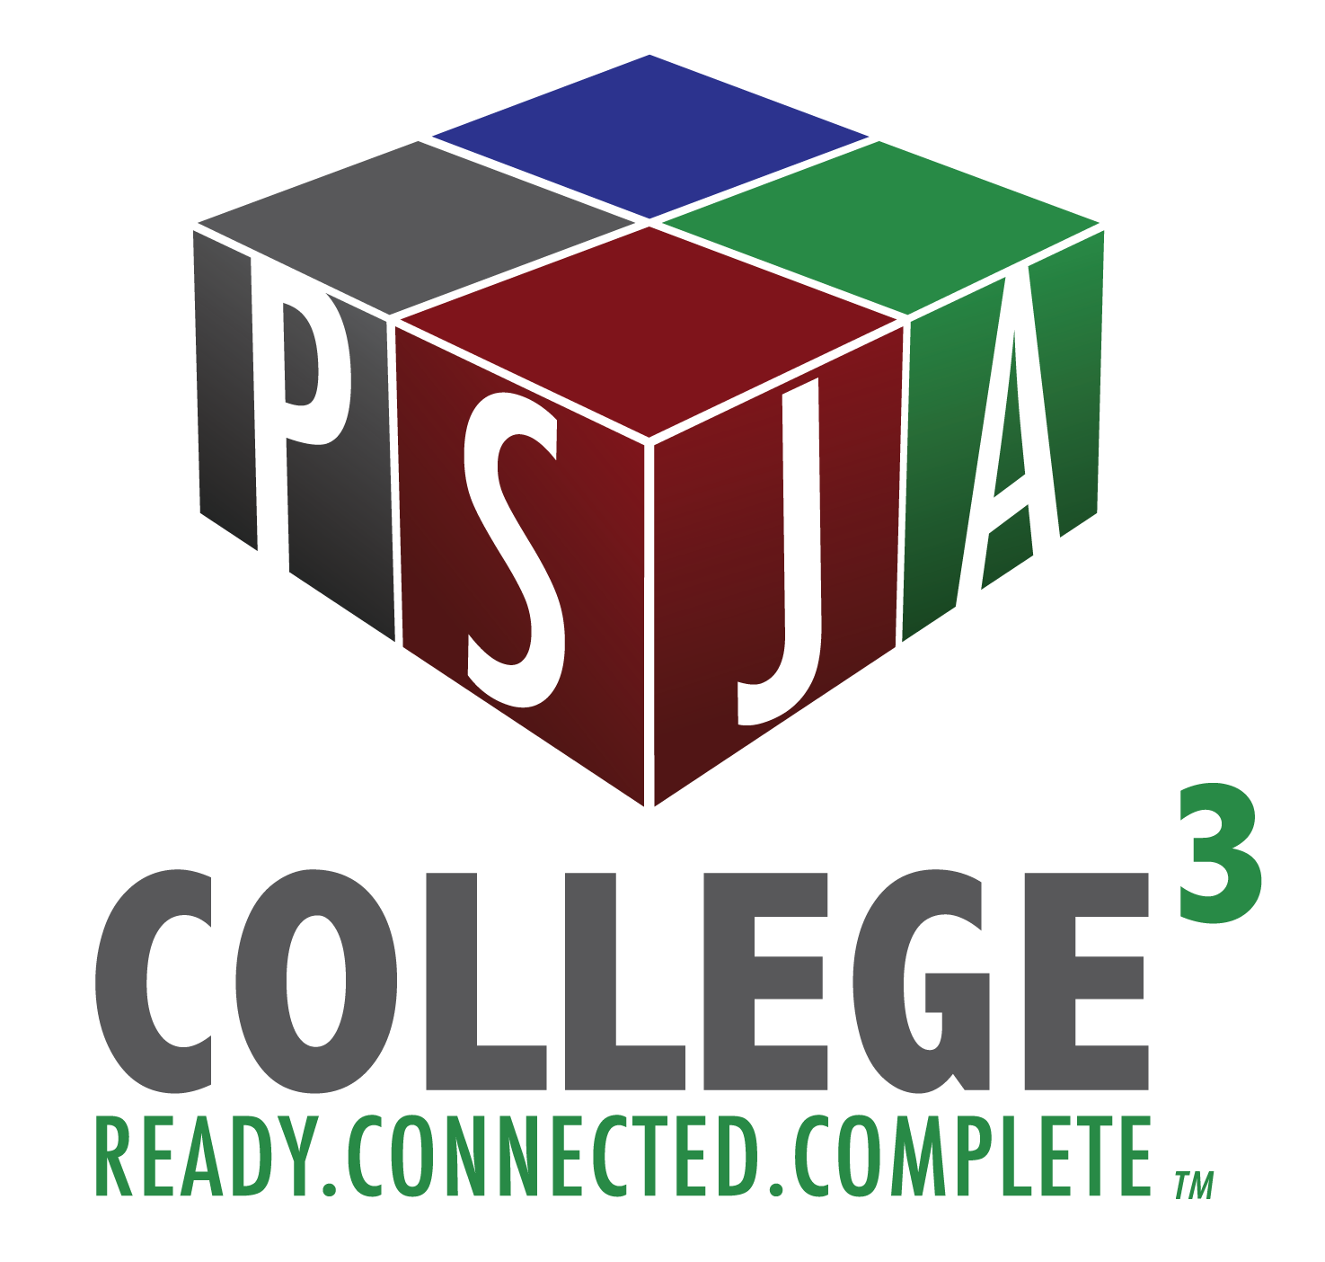
STC/PSJA
ENGL Composition
Summer I 2018
Assignment IC, IIC, IIIC, & IVC: Peer Review

Peer’s Name: __________________________________________________________________

You will conduct a peer review on the first version (#B) of each essay using the same rubric that your teacher and instructor will use when they assess your final version (#D). Doing so ensures that you know ahead of time exactly which elements you will be graded on, and makes certain that you get advice for improving each element before your final submission is due.

Reviewer’s Name: _____________________________________________________________

Reviewers do not need to answer every one of the italicized questions below. But you should use those questions to guide you as you generally consider the extent to which your peer’s essay accomplishes the stated goals of each content element. More importantly, you need to offer specific evidence of where in the essay your peer can do more work to accomplish those goals. It needs to be clear to you (so you can make it clear to your peer) why you gave them the score you did. You can use the following chart to help you determine what each score means:

10 Perfect
9 – 8 Very Effective
7 – 6 Effective
5 – 4 Somewhat Effective
3 – 2 Ineffective
1 Not Addressed/Missing

Instructions

1. Read the rubric below so you will know what you are looking for in the essay.

2. Now, read the essay. Feel free to make notes that will help you complete the rubric.

3. Give a score from 1 to 10 for each of the ten content elements.

4. For each element, explain in a few complete sentences why you gave each score.

5. For each element, copy one instance in the essay where your peer can make revisions.

I. Context: Audience and Situation

Was there a clearly defined situation appropriate to the audience? Was the audience continuously foregrounded in the essay? Was the situation followed through?

10 ___ 9 ___ 8 ___ 7 ___ 6 ___ 5___ 4___ 3 ___ 2___ 1 ___

Why did you give that score? _____________________________________________________

______________________________________________________________________________

______________________________________________________________________________

______________________________________________________________________________

Where can they make revisions? __________________________________________________

______________________________________________________________________________

______________________________________________________________________________

______________________________________________________________________________

II. Introduction: Purpose and Position

Was there a clearly defined purpose for the argument appropriate to the audience and situation? Do the opening paragraph(s) effectively introduce the argument, take a position, and capture the reader’s interest? Does a thesis identify the writer’s central claim and supporting reasons? Is the writer’s thesis clear or confusing?

10 ___ 9 ___ 8 ___ 7 ___ 6 ___ 5___ 4___ 3 ___ 2___ 1 ___

Why did you give that score? _____________________________________________________

______________________________________________________________________________

______________________________________________________________________________

______________________________________________________________________________

Where can they make revisions? __________________________________________________

______________________________________________________________________________

______________________________________________________________________________

______________________________________________________________________________

III. Appeals to Logic (logos)

What reasoning does the writer provide in support of his/her thesis? Is the writer’s reasoning, use of evidence, and treatment of counterarguments valid and convincing? Do direct quotations and paraphrases help or hinder the writer’s establishment of logos? Does the writer’s use of logos overshadow other appeals, or has the writer productively balanced their use of logos with the others? Is the use of logos appropriate for the identified audience?

10 ___ 9 ___ 8 ___ 7 ___ 6 ___ 5___ 4___ 3 ___ 2___ 1 ___

Why did you give that score? _____________________________________________________

______________________________________________________________________________

______________________________________________________________________________

______________________________________________________________________________

Where can they make revisions? __________________________________________________

______________________________________________________________________________

______________________________________________________________________________

______________________________________________________________________________

IV. Appeals to Emotions and Values (pathos)

Does the writer appeal to any emotions and values throughout the essay? If so, do these appeals strengthen or weaken his/her argument? Does the writer’s use of pathos overshadow other appeals, or has the writer productively balanced their use of pathos with the others? Is the use of pathos appropriate for the identified audience?

10 ___ 9 ___ 8 ___ 7 ___ 6 ___ 5___ 4___ 3 ___ 2___ 1 ___

Why did you give that score? _____________________________________________________

______________________________________________________________________________

______________________________________________________________________________

______________________________________________________________________________

Where can they make revisions? __________________________________________________

______________________________________________________________________________

______________________________________________________________________________

______________________________________________________________________________

V. Appeals to Credibility (ethos)

Has the student presented his/her argument in such a way as to establish himself/herself as a credible author, i.e., a careful writer who makes an informed and thoughtful contributions appropriate to the situation? Is the writer’s ethos enhanced by her/his use of the sources? Is the use of ethos appropriate for the identified audience?

10 ___ 9 ___ 8 ___ 7 ___ 6 ___ 5___ 4___ 3 ___ 2___ 1 ___

Why did you give that score? _____________________________________________________

______________________________________________________________________________

______________________________________________________________________________

______________________________________________________________________________

Where can they make revisions? __________________________________________________

______________________________________________________________________________

______________________________________________________________________________

______________________________________________________________________________

VI. Stylistic Strategies and Rhetorical Voice

Does the writer employ any other especially effective or ineffective rhetorical and stylistic strategies? Does the writer demonstrate special facility with language, creativity, sensitivity to his/her audience, nuance of thought, etc.? Are choices employed consistently throughout?

10 ___ 9 ___ 8 ___ 7 ___ 6 ___ 5___ 4___ 3 ___ 2___ 1 ___

Why did you give that score? _____________________________________________________

______________________________________________________________________________

______________________________________________________________________________

______________________________________________________________________________

Where can they make revisions? __________________________________________________

______________________________________________________________________________

______________________________________________________________________________

______________________________________________________________________________

VII. Synthesis, Quotations, and Citation of Sources

Has the writer made effective use sources? Has s/he used an appropriate number of sources (2), including at least one as clear counterargument? Has the writer effectively distinguished his/her ideas from the sources? Does the write use quotations appropriately, and in ways that promote his/her position? Are quotations given adequate explanation? Does the essay follow the MLA format with parenthetical citations and a Works Cited section?

10 ___ 9 ___ 8 ___ 7 ___ 6 ___ 5___ 4___ 3 ___ 2___ 1 ___

Why did you give that score? _____________________________________________________

______________________________________________________________________________

______________________________________________________________________________

______________________________________________________________________________

Where can they make revisions? __________________________________________________

______________________________________________________________________________

______________________________________________________________________________

______________________________________________________________________________

VIII. Organization, Clarity and Transitions, Length

Does the organizational structure work for the essay? Is it always clear where the essay is going? Between paragraphs? Within paragraphs? Within sentences? Does the essay offer ‘signposts’ for readers? Is the arrangement of the essay appropriate for the situation and audience? Is the essay long enough to present a complete argument?

10 ___ 9 ___ 8 ___ 7 ___ 6 ___ 5___ 4___ 3 ___ 2___ 1 ___

Why did you give that score? _____________________________________________________

______________________________________________________________________________

______________________________________________________________________________

______________________________________________________________________________

Where can they make revisions? __________________________________________________

______________________________________________________________________________

______________________________________________________________________________

______________________________________________________________________________

IX. Grammar and Mechanics, Editing and Revisions
Is the essay free of grammatical and mechanical errors? Are sentences clear and articulate?

10 ___ 9 ___ 8 ___ 7 ___ 6 ___ 5___ 4___ 3 ___ 2___ 1 ___

Why did you give that score? _____________________________________________________

______________________________________________________________________________

______________________________________________________________________________

______________________________________________________________________________

Where can they make revisions? __________________________________________________

______________________________________________________________________________

______________________________________________________________________________

______________________________________________________________________________

X. Overall Persuasiveness, esp. Use of Counterarguments

Given the writer’s strategies, stated purpose, and identified audience, has the writer crafted a potentially persuasive argument? Particularly, has the writer engaged with people whose positions differ from his/her own in a way that is transparent and fair? Is this treatment of other arguments beneficial to the writer’s own argument? Is the treatment more than cursory?

10 ___ 9 ___ 8 ___ 7 ___ 6 ___ 5___ 4___ 3 ___ 2___ 1 ___

Why did you give that score? _____________________________________________________

______________________________________________________________________________

______________________________________________________________________________

______________________________________________________________________________

Where can they make revisions? __________________________________________________

______________________________________________________________________________

______________________________________________________________________________

